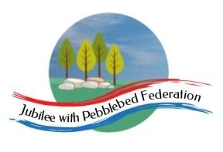
Year 5
Learning from Home

Year:  Week beg:  22/3/2021 | Lesson One | Lesson Two | Lesson Three | Lesson Four
Monday | Science  Make a simple wet compass.  Watch the video and follow the instructions.  https://youtu.be/SvWNWr7pPno  Magnetize the needle. Hold the needle, and take your magnet and stroke it down the length of your needle 50 times.  Magnetize the other end with the reverse.  Prepare the cork, straw, or other.  Insert the needle.  Fill a bowl with water.  Test the compass!  Extra fun! | Get your heartrate up! Try some PE with Joe Wicks  https://www.youtube.com/watch?v=WhnRJbSNyfM | Maths  https://classroom.thenational.academy/lessons/recognising-the-place-value-of-each-digit-in-a-4-digit-number-cgup6r | English  https://classroom.thenational.academy/lessons/to-explore-simple-and-compound-sentences-74r3cr
Tuesday | English  https://classroom.thenational.academy/lessons/to-explore-complex-sentences-70u66d | Maths  Spend some time working on your times tables you can do this using TT Rockstars or Hit the Button.  https://www.topmarks.co.uk/maths-games/hit-the-button | PE  Try some Yoga!  Cosmic Kids – https://www.youtube.com/watch?v=VWIt7mVwbD0 | PSHE  https://classroom.thenational.academy/lessons/food-glorious-food-64vkec  Eat Well Live Well Lesson 2
Wednesday | English  https://classroom.thenational.academy/lessons/to-revise-complex-sentences-cct34c | Maths  https://classroom.thenational.academy/lessons/identifying-the-place-value-of-digits-in-5-digit-numbers-cgwkct | Spelling  https://classroom.thenational.academy/lessons/to-explore-word-class-68tkjc | Art  Colourful Easter Bunnies (with cool glasses) Draw a bunny (or use the template). Split it into sections and fill each with a different pattern. If you want to you could cut it out and stick it onto coloured or painted paper. Add some funky glasses too – you could add foil, sequins or even feathers to them!  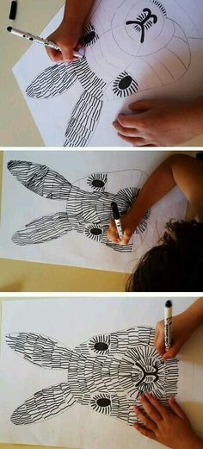  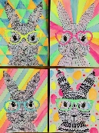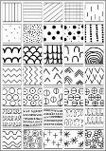
Thursday | English  https://classroom.thenational.academy/lessons/to-explore-relative-clauses-6xjp4c | Maths  https://classroom.thenational.academy/lessons/identifying-the-place-value-of-the-digits-in-6-digit-numbers-6hh62c | Project work  Look at the inside of the lighthouse, think about the different rooms and the items inside them. Create a detailed sketch of the inside of a light house, annotate around the outside what you have included and why.
Friday | English  https://classroom.thenational.academy/lessons/to-develop-knowledge-of-relative-clauses-6mu6ae | Maths  https://classroom.thenational.academy/lessons/representing-decimals-c9gpat | Reading  Choose your favourite book, what did you like about it? Write a blurb about the book that would make it even more appealing to a reader. | ICT  https://classroom.thenational.academy/units/web-page-creation-0205  If you have not looked at this unit yet start on Lesson 1, if you have been working though these during lockdown today’s lesson is Follow the Breadcrumbs.
Reading
This week I would like you to read for 20 minutes every day. You can read a book at home or you can access a book through
https://www.getepic.com/
If you have not already logged in the code is: Jla6766
Click on your character and explore the books in your AR band, have fun!

Please be aware that your home filter may allow unsuitable links to pop up when watching any YouTube videos.

Please remember to send in your work to the year 5 email address: Y5Teacher@littleham.devon.sch.uk

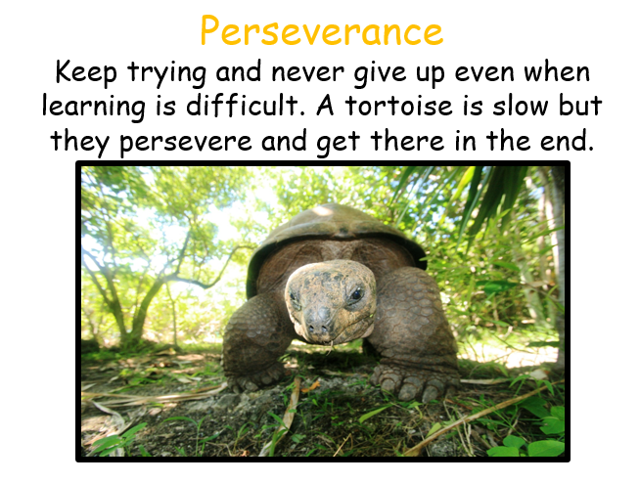
This week’s learning animal is the tortoise. The tortoise keeps on trying and never gives up even when the learning is difficult. Look for times when you are learning like a tortoise!

