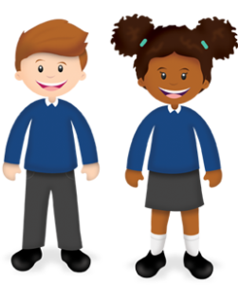
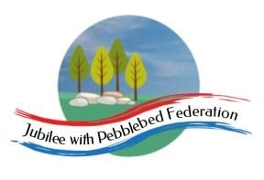
Learning
from Home

Year: 5  Wk beg: 23.11.2020 | Lesson One | Lesson Two | Lesson Three | Lesson Four
Monday | SPAG  https://classroom.thenational.academy/lessons/to-explore-simple-and-compound-sentences-6hk3ed  practise some of your own sentences  EXTRA-CREATE COMPOUND SENTENCES LINKED TO EITHER OUR SCIENCE, OR ANCIENT EGYPTIAN TOPIC | MATHS  https://classroom.thenational.academy/lessons/rounding-2-and-3-digit-numbers-to-the-nearest-10-6gu3er  Create problems to solve.  Practice your next times table. Remember the sort of games in class we do. | SCIENCE  www.bbc.co.uk/bitesize/clips/zsjd7ty  Watch the clip and try out some of the suggestions. What is going on? Be prepared to talk about what you have found out in class. | PE  Create your own workout programme, which you can present to the class, as a warm up session. E.g. Different pathways, star jumps, an imaginative 1 minute aerobic exercise. A stopping and starting routine. Be creative! There is always Joe Wicks to follow.  .
Tuesday | SPELLING  https://classroom.thenational.academy/lessons/to-investigate-suffixes-able-and-ible-69h6at | ENGLISH  https://www.bbc.co.uk/bitesize/articles/zhxdg7h | MATHS  https://classroom.thenational.academy/lessons/using-and-explaining-addition-and-subtraction-strategies-6hk38c | HISTORY  https://www.bbc.co.uk/teach/class-clips-video/history-social-studies-ks2-mummification-in-ancient-egypt/zdcrkmn  What would you ask an ancient Egyptian about the mummification process?
Wednesday | SPELLING  https://classroom.thenational.academy/lessons/to-practise-and-apply-knowledge-of-suffixes-able-and-ible-including-test-cmwkcd | ENGLISH  Plan your own newspaper article about a UFO encounter. Read the example to give you some ideas, then use the paragraph planner to plan. | MATHS  https://www.bbc.co.uk/bitesize/topics/zy2mn39/articles/z3kmrwx  Make up your own addition calculations – these can be up to 5 digit + 5 digit | MUSIC  https://classroom.thenational.academy/lessons/to-imitate-world-percussion-using-sound-sources-found-in-the-home-c5gk4c
Thursday | READING  https://classroom.thenational.academy/lessons/to-develop-reading-for-pleasure-through-book-recommendations-cgr34c | ENGLISH  Draft your newspaper report of the UFO encounter use the First News Top Tips and the recount features to help you. | MATHS  https://classroom.thenational.academy/lessons/choosing-appropriate-subtraction-strategies-6nh3gc | GEOGRAPHY  https://classroom.thenational.academy/lessons/why-are-rivers-important-to-people-6cv3cd?
Friday | READING  Think about the books that you have read so far this term. Which has been your favourite? Why? Which has been your least favourite? Why? | ENGLISH  Edit and improve your newspaper report – you can write it up in neat when you have finished! | MATHS  https://classroom.thenational.academy/lessons/subtracting-using-the-column-method-6xj32d | RE  https://classroom.thenational.academy/lessons/what-are-the-five-pillars-of-islam-70t6cd

