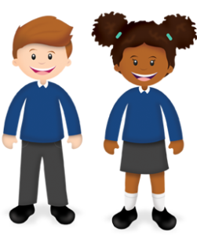
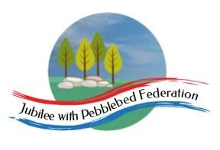

Year: 6  Wk beg: 4/1/21 | Lesson One | Lesson Two | Lesson Three | Lesson Four |  |  | Lesson Five
Monday | Reading – Own book.  Spellings – From Year 5/6 list  https://cdn.oxfordowl.co.uk/2019/08/29/13/56/09/5a42eb6a-f57f-4dc4-a66e-bd4c5e27e4b7/SpellingWordList_Y5-6.pdf  LO – To know complex and compound sentences  https://classroom.thenational.academy/lessons/to-revise-our-understanding-of-simple-compound-and-complex-sentences-74t64d | Maths  LO Know the order of operations  https://classroom.thenational.academy/lessons/understanding-which-operations-have-equal-priority-c4t6ce  PRACTISE TABLES |  | Science – Darwin’s Delights  HISTORY  Who was Darwin? When did he live? Where did he live? What did he do? How did he do it?  GEOGRAPHY  Where are the Galapagos Islands? Find their latitude and longitude?  How did they form?  To which country do they belong?  What are the names of the islands?  What are the vegetation zones?  https://www.bbc.co.uk/bitesize/topics/z3fycdm/articles/zk9cxyc
Tuesday | Reading – Own book.  Spellings – sheet taken home  To understand the function of apostrophes  https://classroom.thenational.academy/lessons/to-understand-the-two-functions-of-apostrophes-68vk6t | Maths  LO Know the order of operations 2  https://classroom.thenational.academy/lessons/order-of-operations-ctk3et  PRACTISE TABLES |  | RE  Hinduism  Quick research on Hinduism.  Where?  When?  What/Who are their Gods?  Main festivals.  http://www.primaryhomeworkhelp.co.uk/religion/hinduism.htm#text | MFL  I am learning greetings, recapping on numbers to 31, days, months and seasons.  Primary resources website.  https://www.primaryresources.co.uk/mfl/mfl_french.htm
Wednesday | Reading – Own book.  Spellings – sheet taken home  To use the apostrophe for singular possession  https://classroom.thenational.academy/lessons/to-introduce-apostrophes-for-singular-possession-6wr66d | Maths  LO To consolidate order of operations  https://classroom.thenational.academy/lessons/consolidating-order-of-operations-68t34d  PRACTISE TABLES |  | Computing  Use research skills to help find out about Darwin, The Galapagos Islands and Hinduism.  Check several websites to validate your findings.  Are there any differences between websites?  Do you trust some more than others?
Thursday | Reading – Own book.  Spellings – sheet taken home  LO – To use the apostrophe for plural possession  https://classroom.thenational.academy/lessons/to-explore-using-apostrophes-for-plural-possession-cgvk2d | Maths  LO To know linear number sequences  https://classroom.thenational.academy/lessons/linear-number-sequences-6ct66t  PRACTISE TABLES AND DIVISION RELATED TO THEM |  | PSHE |  | PE  Fitness – push-ups, squats, leg drives, star jumps, shuttle runs.
Friday | Reading – Own book.  Spellings – sheet taken home  Test yourself on the spellings from this week and previous weeks.  Recap on the use of the apostrophe for contraction and for possession.  https://classroom.thenational.academy/lessons/to-revise-apostrophes-for-contraction-and-singular-possession-c9j64c | Maths  Transum algebra  Search Transum  PRACTISE TABLES |  | Darwin’s Delights  HISTORY  Who was Darwin? When did he live? Where did he live? What did he do? How did he do it?  GEOGRAPHY  Where are the Galapagos Islands? Find their latitude and longitude?  How did they form?  To which country do they belong?  What are the names of the islands?  What are the vegetation zones?  https://www.bbc.co.uk/bitesize/topics/z3fycdm/articles/zk9cxyc

