Hub Weekly Challenges 1
Week beginning 13th April 2020
Get Building Challenge  Blast off! Can you build a bottle rocket? Record how high each attempt goes? What is your highest score? | Arty Crafty Challenge  Can you design a logo for our Hub Weekly Challenge sheet? I will display the winning one on the Challenge sheet next week.
The Tasty Challenge  Can you make a cake that contains a vegetable? Show me pictures or write the recipe for me to share with the others. Remember to tell me what you thought of the taste! | Keep Fit Challenge  Count how many pictures of rainbows you can spot on your daily walk.
Can you find out Challenge?  Explore this statement: Chickens are the only animals that lay eggs. | Pass the Parcel Challenge  I’m going to give you the start of a story, the start of a newspaper article, the start of a poem etc. You need to write the next paragraph or verse ONLY and then email it back to me. Each week, I’ll pass the stories around….amongst the adults as well! Our writing will grow each week. Look on the next page for your starting points.
Grill a Teacher Challenge  This week’s teacher is Mrs Clark.  Email any questions you would like to ask her and I’ll give you the answers next week. Make sure you are polite! | Your turn!  Would you like to set any of the challenges next week? Email me any of your ideas. Maybe you would like to set a Tasty Challenge or the next Keep Fit Challenge. Be creative!

I will email this out to you on a Monday. Please send me an email once a week with any of your responses, pictures etc. Send me an email to keepintouch@littleham.devon.sch.uk

Alex:
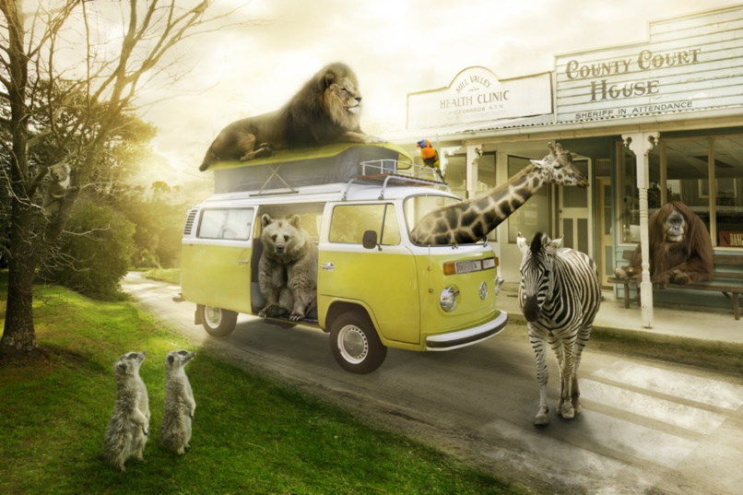
Most visitors are a little shocked (to put it mildly) when they arrive at Animal Town. Despite the fact that the name of the town gives a slight indication to passers-by that the inhabitants of the town are ‘not normal’, it’s as if people don’t believe things until they see them with their own eyes!
Once you get used to being in Animal Town – or so they say – seeing an orangutan behind a desk in a sheriff’s office and upholding the law to an impeccably high standard becomes relatively ‘normal’…

Mrs Clark
There was an old man with a beard
Who said, “It’s just how I feared!
Two owls and a hen
Four larks and a wren
Have all built their nests in my beard

There was a………

Harry: (You have the headline below. Can you begin the newspaper article?)
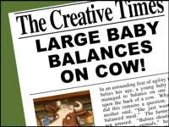

Mrs Jones
I wish there was a law that said………
Freddie:
In six days there will be no more chocolate in the world….ever! That’s what it said on The Seven Show. Jelly had nearly reached the next level of Zombie Puppy Dash, but hearing this made her plunge the pink puppy into a huge tank of zombie dog food. “Woah! What was that about chocolate….”
Miss Hitchcock
Dear Diary,
Today, the doorbell rang, and I eagerly ran down the stairs. By the time I had opened the door, the delivery driver had vanished, but a giant box had been left on my doorstep.

Mrs Cambridge
Bleary-eyed, I went downstairs for breakfast, the house was empty, even the furniture had gone…

