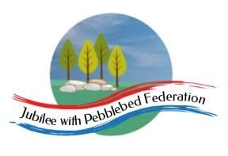
Learning
from Home

Year: Reception & Year 1  Wk beg: 3/5/2021 | Lesson One | Lesson  Two | Lesson  Three | Lesson  Four | Lesson  Five
Tuesday 4th May | Name Practice  Practice writing your name either on a piece of paper or your name card.  Please encourage correct pencil hold – ‘nip, flip and grip’.  Make sure your child can form every letter correctly and without a visual.  Extension Encourage your child to write the letters smaller and on a line. Once they can do this help your child to learn to write their surname also. | Reading  Log onto Bug Club and pick a book to read to your grown up. Ask your child questions about the story and to sound talk the words.  https://www.activelearnprimary.co.uk/login?c=0  Practice reading some of the sound button words in their home learning pack.  e.g. h-u-ff huff  Or read and write the tricky words on their key ring. | Maths  Practice writing numbers correctly.  https://www.youtube.com/watch?v=DzKqCmjVXLI  Show 7 pegs on a coat hanger. Split into 6 and 1. Turn hanger round to show that 6 and 1 makes 7, as well as 1 and 6.  Repeat for 5 and 2, 4 and 3.  Ask your child to close their eyes whilst you hide 2 pegs with a cloth. Open their eyes. Show me 7 fingers. Now show me how many pegs you can see on the hanger. How many fingers did you fold down? That's how many are hiding! Record 5 + □ = 7. Agree 2 goes in the empty box. Remove cloth to check.  Repeat hiding other numbers of pegs.  Extension  Repeat but with 10 or more pegs. | Phonics  Review all letter sounds learnt so far – see flash cards in home learning pack. Focus on learning the digraphs and trigraphs qu ch sh th ng ai ee igh oa oo(long) oo(short) ar ur ow oi ear air ure er  Revisit the sound oi  https://www.youtube.com/watch?v=iemIhNNSybw  Then practise reading/writing these words:  now  owl  clown  coin  coil  boil  join  We have learnt all the sounds in these words so see if your child can sound talk them e.g. j-oi-n join | Literacy  Use the word bank to write a sentence about each picture.  E.g. The sandcastle has shells and flags on it.  The boat is near the lighthouse.  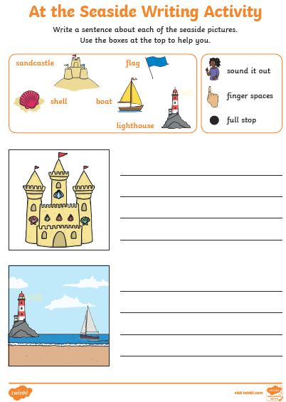  Try to encourage your child to leave spaces between words and use capital letters and full stops.
Wednesday 5th May | Name Practice  Practice writing your name either on a piece of paper or your name card.  Please encourage correct pencil hold – ‘nip, flip and grip’.  Make sure your child can form every letter correctly and without a visual.  Extension Encourage your child to write the letters smaller and on a line. Once they can do this help your child to learn to write their surname also. | Reading  Log onto Bug Club and pick a book to read to your grown up. Ask your child questions about the story and to sound talk the words.  https://www.activelearnprimary.co.uk/login?c=0  Practice reading some of the sound button words in their home learning pack.  e.g. h-u-ff huff  Or read and write the tricky words on their key ring. | RE  Talk about what we you are good at (practical skills or values) and how we can help/serve others by using them.  Draw a picture of something you are good at and write a sentence to go with the picture.  E.g. I am good at singing.  I am good at helping Mummy.  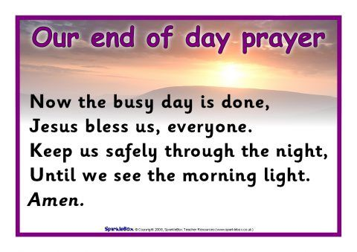  Finally, practise the prayer below. | Phonics  Review all letter sounds learnt so far – see flash cards in home learning pack. Focus on learning the digraphs and trigraphs qu ch sh th ng ai ee igh oa oo(long) oo(short) ar ur ow oi ear air ure er  Revisit the sound ear  https://www.youtube.com/watch?v=9eIe4BHR4_s  Then practise reading/writing these words:  soil  joint  oil  coins  dear  fear  hear  beard  We have learnt all the sounds in these words so see if your child can sound talk them e.g. h-ear hear | Literacy  Look together at any photos you have of your child at the beach. Talk about what they are doing or what they did whilst at the beach that day.  If you can’t find any photos you may want to draw a picture of something fun you could do at the beach.  Now support your child to write a sentence or two. E.g. I can dig in the sand.  I can splash in the sea.  Try to encourage your child to leave spaces between words and use capital letters and full stops.  Extension  Add adjectives to your sentences. E.g. I can dig in the golden sand. I can splash in the cold sea.
Thursday 6th  May | Name Practice  Practice writing your name either on a piece of paper or your name card.  Please encourage correct pencil hold – ‘nip, flip and grip’.  Make sure your child can form every letter correctly and without a visual.  Extension  Encourage your child to write the letters smaller and on a line. Once they can do this help your child to learn to write their surname also. | Reading  Log onto Bug Club and pick a book to read to your grown up. Ask your child questions about the story and to sound talk the words.  https://www.activelearnprimary.co.uk/login?c=0  Practice reading some of the sound button words in their home learning pack.  e.g. h-u-ff huff  Or read and write the tricky words on their key ring. | Maths  Practice drawing different shapes  https://www.youtube.com/watch?v=w7-teTDLgvc  Have a go at looking at pairs with a total of 6 or 7.  Using dominoes find all the pairs with a total of 6 or 7 spots.  - How many different dominoes can you find that have a total of 6 spots?  - Do you think there will be more dominoes with 7 spots or not?  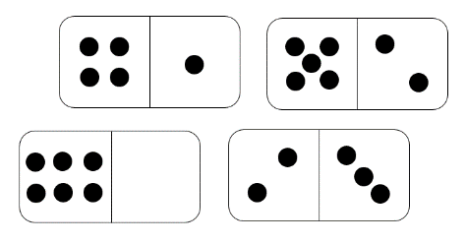  Extend by also writing your findings as number sentences, e.g. 4 +3 = 7 | Phonics  Review all letter sounds learnt so far – see flash cards in home learning pack. Focus on learning the digraphs and trigraphs qu ch sh th ng ai ee igh oa oo(long) oo(short) ar ur ow oi ear air ure er  Revisit the sound air  https://www.youtube.com/watch?v=T3rWZYN5jno  Then practice reading/writing these words:  year  ear  clear  earring  air  pair  hair  stair | Handwriting  Help your child to practice writing some of the long ladder letters l i t j y u  Try to encourage your child to hold the pen/pencil correctly.  Extend by encouraging your child to write the letters on the line when needed.
Friday 7th May | Name Practice  Practice writing your name either on a piece of paper or your name card.  Please encourage correct pencil hold – ‘nip, flip and grip’.  Make sure your child can form every letter correctly and without a visual.  Extension Encourage your child to write the letters smaller and on a line. Once they can do this help your child to learn to write their surname also. | Reading  Log onto Bug Club and pick a book to read to your grown up. Ask your child questions about the story and to sound talk the words.  https://www.activelearnprimary.co.uk/login?c=0  Practice reading some of the sound button words in their home learning pack.  e.g. h-u-ff huff | Maths  Practice drawing different shapes  https://www.youtube.com/watch?v=w7-teTDLgvc  Provide your child with a selection of 5, 6 or 7 farm/ zoo animals and pretend pens.  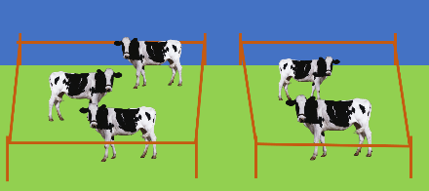  Ask your child to find different ways of partitioning the animals into the two pens.  Extend by writing as number sentences, 3+4 =7 | Phonics  Review all letter sounds learnt so far – see flash cards in home learning pack. Focus on learning the digraphs and trigraphs qu ch sh th ng ai ee igh oa oo(long) oo(short) ar ur ow oi ear air ure er  Revisit the sound ure  https://www.youtube.com/watch?v=YwCzf71flBA  Then practice reading/writing these words:  fair  airport  stairs  chair  cure  manure  lure  insure | Art  Make a beach scene on a paper plate or piece of paper cut into the shape of a circle. Use any crafts you have at home to help your child get creative!  Use your child’s ideas – what can you see at the beach? Crabs? Seaweed?..  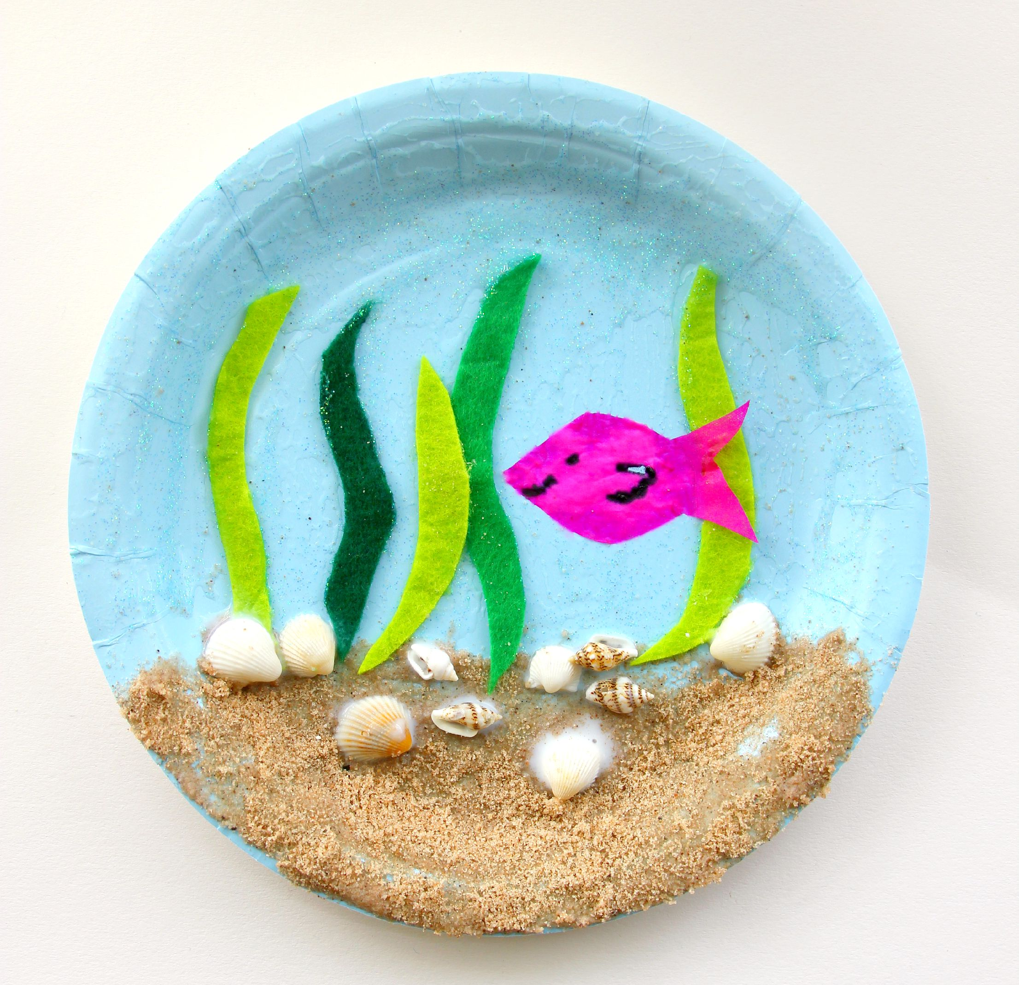
Please be aware that your home filter may allow unsuitable links to pop up when watching any YouTube video.

We would love to see any photos of the learning you are doing at home. Please send these to YRteacher@littleham.devon.sch.uk
Please let us know if you need any additional resources to help your child to complete their home learning with you at home.

