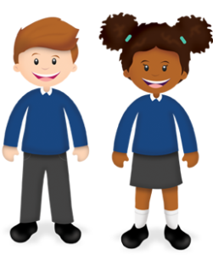
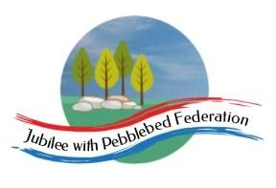
Learning from Home

Year: 3  Wk beg:  25.1 | Lesson One  (Look at this week’s reading comprehension activity on google classroom) | Lesson Two | Lesson Three | Lesson Four | Lesson Five
Monday | Reading  Read library book or allocated bug club books | English  Go to google classroom  Monday 25th January  Final Project  You can collect A3 paper from school if needed. | Maths  Go to google classroom  Monday 25th January  LO: I can subtract by counting larger gaps. | Science  Go to google classroom  Monday 25th January  What adaptations do nocturnal animals have? | PE  Go to google classroom  Monday 25th January  PE with Joe-Youtube
Tuesday | Reading  Read library book or allocated bug club books | English  Go to google classroom  Tuesday 26th January  Final Project | Maths  Go to google classroom  Tuesday 26th January  LO: I can subtract by counting on or counting back. | RE  Go to google classroom  Tuesday 26th January  Where do Muslims worship? | Collective Worship  Go to google classroom  25.1.2021  Questioning
Wednesday | Reading  Read library book or allocated bug club books | English  Go to google classroom  Wednesday 27th January  Final Project | Maths  Go to google classroom  Wednesday 27th January  LO: I can double 2-digit numbers. | History  Go to google classroom  Wednesday 27th January  What was Athenian democracy? | PE  Go to google classroom  Wednesday 27th January  PE with Joe-Youtube
Thursday | Reading  Read library book or allocated bug club books | English  Go to google classroom  Thursday 28th January  Final Project | Maths  Go to google classroom  Thursday 28th January  LO: I can partition to halve even 2-digit numbers. | Geography  Go to google classroom  Thursday 28th January  What are some of Europe’s most important human characteristics? | Mental Health  Go to google classroom  Thursday 28th January  Being proud of your very being
Friday | Reading  Read library book or allocated bug club books | English  Go to google classroom  Friday 29th January  Final Project | Maths  Go to google classroom  Friday 29th January  Doubling and halving quiz | History/Art  Go to google classroom  Friday 29th January  LO: I can read about and draw a Greek god or goddess. | PE  Go to google classroom  Friday 29th January  PE with Joe-Youtube
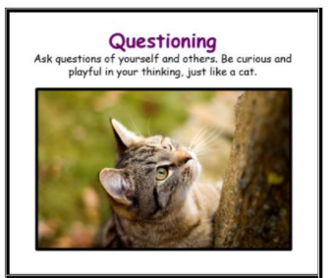
This working our learning animal is the cat.
Please can your adult look for times when you are showing this learning behaviour.
If possible, your adult could email any examples of your questions to me. I will add them to our class display.
Miss Plumridge

