Learning
from Home

Year: 4  Wk beg:  8.3.21 | Lesson One | Lesson Two | Lesson Three | Lesson Four
Monday  The theme for this week’s learning behaviour is  Our learning animal this week is a parrot  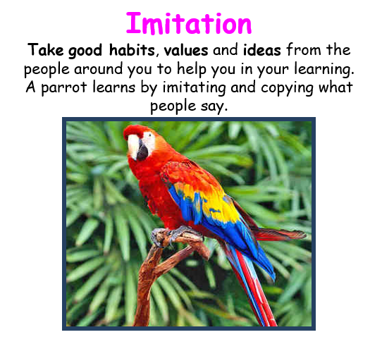 | English  Wellbeing unit  Felix After the Rain  Recognising, naming and expressing feelings  Listen to a story. Make a paper-folded model.  Expressive arts focus: paper sculpture and drawing  https://www.youtube.com/watch?v=hH7FgcaJpSo&ab_channel=TinyOwl)  Listen to a story Felix after the rain. Discuss the following points:  - What do you think the book is about?  - What do you notice?  - What would you like to ask Felix?  - What do we find out is in the suitcase?  The suitcase is symbolic of the feelings he is carrying around.  Activity  Make a model of Felix’s suitcase and add three of children’s own symbols to represent sadness. | Maths  Key skills  Power point  Bubble bonds  Recall number pairs to 100  Find pairs of bubbles that total 100 and shade same colour | Art  Create a colourful picture of favourite activities, hobbies, ideas and dreams  Cut out a printed out photo and mount onto a plain background.  Create 5 colour section blocks and then draw pictures related to what makes you feel good, what you would like to achieve or something you’d like to try.  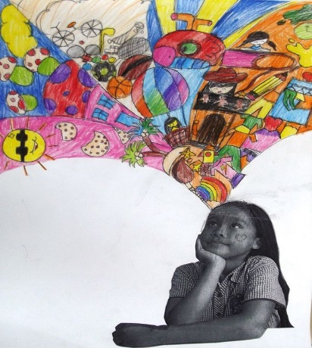 | Mental health  Thinking about ways to cope with big emotions  Watch the link  https://www.youtube.com/watch?v=S-8WezbUkq4  Children can write down three or four of the suggested activities to help to cope with big emotions.  Activity  Make a stress ball  https://youtu.be/ndp2gq6wveM
Tuesday | English  SPAG  LO: To revise our knowledge of word class  Follow this link for the online lesson.  https://classroom.thenational.academy/lessons/to-revise-our-knowledge-of-word-class-c9k6ct?activity=video&step=1 | Maths  Key skills  Multiply and divide by 10 and 100  Power point Movement multiplication  Create actions for moving for multiplying and dividing by 10 and 100  Start with a 2 digit number and carry out a movement. Build up to do two or three movements. Activity  Chn choose a number from a pack and in pairs create movement multiplications | PSHCE  sp | PE  SP
Wednesday | English  Wellbeing unit  Felix After the Rain  Talk about a story. Making tree artwork.  Expressive arts focus: painting, printing or collage  Display scenes from the story  Discuss these points  - What happened before?  - How is Felix feeling?  - How would you feel?  Using the suggested music  Sad  We Float – Dustin O’Halloran  https://www.youtube.com/watch?v=jjD0G-u-SwE&ab  Stormy  Richard Strauss – Thunder and Storm  https://www.youtube.com/watch?v=hnF87fo4NQo&ab  Happy  West Indian Flower – Snorre KirkQuartet  https://www.youtube.com/watch?v=v0Z1VWaSXfo&ab  Calm  Fracture by Stephan Moccio  https://www.youtube.com/watch?v=hYH80WGPet8&ab  Activity  individuals devise short movements about the four scenes – response to music and artwork. | Maths  Key skills  Create sculpture 3dshapes with nets  Look at Power point  Look at Anthony Gormley’s sculpted figures  Discuss any feelings that we can associate to the figures  Activity  In pairs, chn create a sculpture using net shapes | Topic Art & Design Traders and Raiders  LO: To create a model Anglo- Saxon house  Look at the links below and watch the clip of the reconstructed Anglo-Saxon site at West Stow in Suffolk.  Go to Google classroom and look at the example models I have put on there. There are some other attachments which show Anglo Saxon buildings and an information sheet about building materials  Task  Create a small model Anglo Saxon house. You could use twigs that you have found in your own garden or out on a walk. You could cut up an old cereal box or use any piece of cardboard. You will need scissors, glue and tape. If you have paint, you could use this too! I look forward to seeing what you have created!  https://www.youtube.com/watch?v=n09vrVfI168  https://kidadl.com/articles/saxon-homes-fact-file-for-kids  https://www.weststow.org/Anglo-Saxon-Village/introductory-video.cfm
Thursday | English  Wellbeing unit  Felix After the Rain  Talk about a story. Making tree artwork.  Expressive arts focus: painting, printing or collage  Listen to the story again  Display the talking points. In pairs, children share their answers  Discuss the colour use in the story – how does it reflect Felix’s feelings?  Activity  Make tree art work inspired by the book illustration. | Maths  Drawing and music  Heiroglyph place value  Powerpoint  Discuss how ancient Egyptians used symbols for sound in words and symbols for 1-10, 100,1000. Show how different numbers could be written  Activity  Chn choose a symbol and and write the number on the back once decoded. | Drama  Simple drama games  Movement/space games  - Stop, walk, clap, jump  Tongue twisters  - Betty Botter  - Red lorry, yellow lorry  - Peter Piper  - She sells sea shells  Pairs  - Mirror image  - Sculpting  - 1,2,3 game | SPAG  LO: To understand how we use possessive apostrophes for singular and plural nouns.  https://www.bbc.co.uk/bitesize/topics/zvwwxnb/articles/zx9ydxs  Go to Google classroom and find a sheet to practise using the possessive apostrophe  LO: To understand the past perfect tense  https://www.youtube.com/watch?v=7GAjEdOiNaI
Friday | English  Wellbeing unit  Felix After the Rain  Listen to a poem. Think about colour symbolism. Make a portrait.  Expressive arts focus: collage, painting and drawing  Read the poem The sky is the colour of Grandma’s hair  Discuss :  What reminds the narrator of their Grandma?  What colours remind you of someone special? Why?  Children think of a person and colour associate with them.  Activity  Create the background by mixing paints, then make blocks of colour, cut and arrange to make a background. Then draw or paint a portrait of their chosen person and mount onto the background | Maths  Key skills  Regular and irregular 2d shapes  Power point  Look at Kandinsky’s Black and Violet  Discuss what shapes chn can see and how some shapes are irregular  Activity  Make network of intersecting straight lines using tape wo create lines then paint over the tape on paper.  Dry and then remove the tape | PE  Outdoor games | Game Time  TT Rockstars  Ict games

