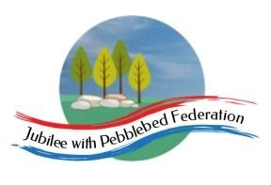
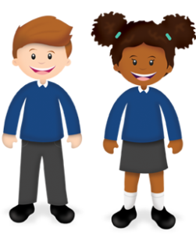
Year 2
Learning from Home Grid

Week Beg: 11/01/21 | Lesson 1 | Lesson 2 | Lesson 3 | Lesson 4 | Lesson 5 | Lesson6
Monday | Reading  Login to bug club and read a book from your ‘library’  https://www.activelearnprimary.co.uk/login?c=0 | Phonics  Sound ay as in play  https://youtu.be/WpvquS6c5vk | English  Non chronological Report  Go to Google Classroom | Maths  Fractions and Multiplication  Go to Google Classroom | Science  https://classroom.thenational.academy/lessons/what-are-the-different-parts-of-the-human-body-70uk6d | PE  Joe Wickes PE  https://youtu.be/  sX05HHni9Wk
Tuesday | Reading  Login to bug club and read a book from your ‘library’  https://www.activelearnprimary.co.uk/login?c=0 | Phonics  Sound a-e as in make  https://youtu.be/q4jz3U25Xjk | English  Non chronological Report  Go to Google Classroom | Maths  Fractions and Multiplication  Go to Google Classroom | Computing  Take a Virtual Tour of Windsor Castle. Talk with a grown up about what makes it a castle. You could draw and label the drawing and share your drawing with your teacher through Google Classrooms. | Music  https://classroom.thenational.  academy/lessons/rhythm-and-pulse-c4tker
Wednesday | Reading  Login to bug club and read a book from your ‘library’  https://www.activelearnprimary.co.uk/login?c=0 | Phonics  Sound ai ,  https://youtu.be/WOGmKeYoUNU | English  Non chronological Report  Go to Google Classroom | Maths  Fractions and Multiplication  Go to Google Classroom | RE  Week 2: What are the five pillars of Islam? https://classroom.thenational.academy/lessons/what-are-the-five-pillars-of-islam-70t6cd | PE  Joe Wickes PE  https://youtu.be/  Y2AkYD10d7Q
Thursday | Reading  Login to bug club and read a book from your ‘library’  https://www.activelearnprimary.co.uk/login?c=0 | Phonics  Sound ea as in meat  https://youtu.be/bLr4TXq58jw | English  Non chronological Report  Go to Google Classroom | Maths  Fractions and Multiplication  Go to Google Classroom | DTEC  Can you make a castle ? You could make it from junk modelling you may have or you could make a castle big enough to play in with a washing airer or cushions. Take a photo and send it to your teacher if you can.
Friday | Reading  Login to bug club and read a book from your ‘library’  https://www.activelearnprimary.co.uk/login?c=0 | Phonics  Sound e-e  https://youtu.be/e7gRajegO9M | English  Non chronological Report  Go to Google Classroom | Maths  Fractions and Multiplication  Go to Google Classroom | Geography  Google search these famous towers:  Big Ben, CN Tower, The Shard, Leaning Tower of Pisa, Eiffel Tower, Tokyo Skytree.  Draw a picture of your favourite and email it to Mrs Hooper through Google Classroom can she guess which one it is ? She will let you know ! | PSHE  Recognising coins  Look at a set of coins.  How are they the same and how are they different ?  Talk to your grown up about how many 1ps they are the same as for example a 10p coin is the same as 10 one p coins.

