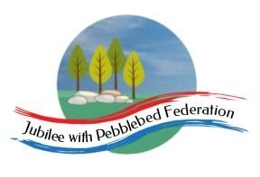

Year 2 Learning from Home Grid
Week Beginning 01.02.21
https://www.getepic.com/book/8799122/cinderella-and-the-beanstalk?utm_source=t2t&utm_medium=link&utm_campaign=content&share=31358231643
Think about how we can develop your child’s learning behaviours. This week we are looking at when to work with others and when to work alone.  Tell Mrs Hooper how your child has shown this behaviour this week either by email or returning the slip. | 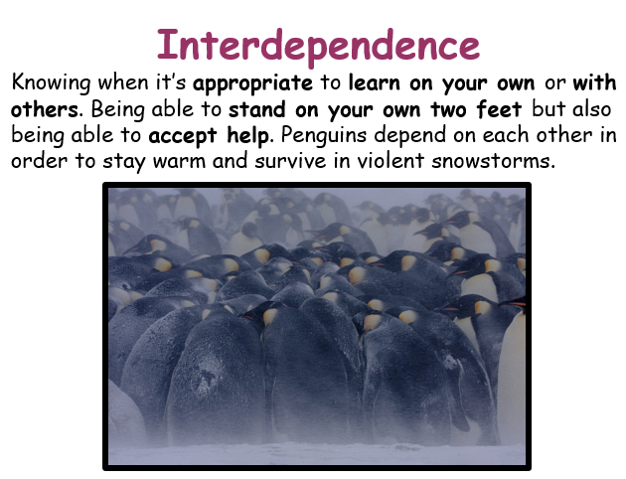
Monday | Reading (30 Mins)  Read the book you have been sent in your home learning pack, these are the sounds you are working on. There is also a book specific to you on Bug Club as well as phonic games you can play.  Phonics (30 Mins)  Sound ew as in chew watch the video link below and then complete the activity.  https://youtu.be/pfxxCYBPMyM  Worksheet 1 from the pack you have been given or online in bug club, If you can’t type on the sheet online you can write the answers in a list and send it to me by email at Y2Teacher@littleham.devon.sch.uk  English (30 Mins)  Look at the BBC Bitesize link https://www.bbc.co.uk/bitesize/articles/zpd8ng8  There are games you can play to practise and then looking at the picture of Snow White from the text we would have been reading in school, write a list of nouns you can see.  Maths (30 Mins)  If you have year 1 activities look at the slides or printed slides about finding ways to pay amounts upto 20p. Then complete the sheet you have been given for Monday by drawing 1p and 10p coins to show how to pay for each item.  If you have year 2 activities look at the slides or the printed slides for Monday about finding totals using different coins, then complete the activity you have been set. There are 2 sheets , you can choose one or do both ! Go on I dare you !  RE (30 Mins)  Watch: https://www.bbc.co.uk/bitesize/clips/z74wmp3 this clip shows you Muslims praying at a Mosque.  Task:  - Write a sentence explaining why prayer is so important to Muslims.  Mental Health (30 Mins)  Session 1 the ten a day and mindfulness  https://www.loom.com/share/00caec8a03b240acba31519074f7325b
Tuesday | Reading (30 Mins)  Read the book you have been sent in your home learning pack, these are the sounds you are working on. There is also a book specific to you on Bug Club as well as phonic games you can play.  Phonics (30 Mins)  Sound ue as in blue watch the video link below and then complete the activity on sheet 2 of your phonics pack.  https://youtu.be/AtH5Do7PaHk  English (30 Mins)  Today you will be writing noun phrases about the picture you saw yesterday. First watch the video link here : https://www.bbc.co.uk/bitesize/topics/zrqqtfr/articles/zpd8ng  Don’t do the activity the lady says but instead can you think of two adjectives to describe your nouns from the picture yesterday. I have given an example on the sheet.  Maths (30 Mins)  Year 1 : Look at the slides or prints.  Choose two items and use number facts or the 0-20p money line to work out the total cost. Try at least five additions with five different pairs of toysYou can write on the sheet or an extra piece of paper.  Year 2: Look at the slides or prints. Spider goes up and down in straight lines and fly goes side to side – your child might remember this .  Follow the directions on the sheet and complete. You can do this on separate piece of paper or in the blue book I sent you and send me a photo.  Science (30 Mins)  https://classroom.thenational.academy/lessons/how-do-our-bodies-change-as-we-get-older-6nhk2d  Music (30 Mins)  https://classroom.thenational.academy/lessons/notating-songs-74wkad
Wednesday | Reading (30 Mins)  Read the book you have been sent in your home learning pack, these are the sounds you are working on. There is also a book specific to you on Bug Club as well as phonic games you can play.  Phonics (30 Mins)  Sound u-e as in tube. Watch the video link below and then complete the activity on sheet 3 of your phonics pack.  https://youtu.be/AtH5Do7PaHk  English (30 Mins)  If you are able to watch the power point https://www.twinkl.co.uk/resource/t-l-53601-year-1-using-and-to-join-words-and-clauses-warm-up-powerpoint  This will help you to understand that we use and in sentences to add extra information. Now complete the worksheet.  Maths (30 Mins)  Year 1 : Look at the slides which will help to remind you about how we add 10 using money. Complete the sheet using what you know about adding 10p and then 20p.  Year 2: The slides are to talk about how to know when to add or takeaway to solve a problem. Your child can answer some or all of the questions as appropriate. There is a 100 square attached to support thinking. Work can be done on a separate sheet but please encourage your child to number their questions so I know which ones they have tried.  DTEC (45 Mins)  Tunnelling. Work outside if possible to build a tunnel with sticks and twigs or indoors with cushions or a table and sheet. Read a story in your tunnel or look at bug club if you have a device. Take a photo to send for us to see.  Collective Worship (15 Mins)  Please log into you Google classrooms account to view the Collective Worship from Mrs Padbury.
Thursday | Reading (30 Mins)  Read the book you have been sent in your home learning pack, these are the sounds you are working on. There is also a book specific to you on Bug Club as well as phonic games you can play.  Phonics (30 Mins)  Sound u as in bull and oul as in would. Watch the video link below and then complete the activity on sheet 4 of your phonics pack.  https://youtu.be/Z5u1kNa3kAY  Worksheet 4 in the pack you have been given.  English (30 Mins)  Today you are learning about other words we can use to join parts of sentences together. Please watch the link : https://youtu.be/HKrRe9EdLf4  Now complete the worksheet about using and , or, or but.  Maths (30 Mins)  Year 1: The slides explain how we can count up in ones to find out how much change is needed of to find the difference. On the sheet count up from the price of the toy to 10p to find the change.  Year 2: You have been given a sheet of problem solving and reasoning questions, how much can your child do of this on their own ?  Geography (30 Mins)  World Famous Tunnels  Think about what a tunnel is, what it could be made from, why and how they are used. Google search images of tunnels such as the Channel Tunnel, Bund Sightseeing tunnel in Shanghai and the Hadron Collider Tunnel.  PSHE ( 30 Mins)  Understand the need and reason for saving money.  Talk to your grown up why it is good to save money, think about what you would like to save for , small or large.  Complete the 1decision activity either uploaded to Google or in your pack.
Friday | Reading (30 Mins)  Read the book you have been sent in your home learning pack, these are the sounds you are working on. There is also a book specific to you on Bug Club as well as phonic games you can play.  Phonics (30 Mins)  Enjoy the assessment game assigned to you in Bug Club using the log on code you have been given. There is also a sheet to complete to revise the sounds from this week.  English (30 Mins)  Look at the cards you have been given on your pack. What order do you think they could go in to make a story ? Try to make up a story that you can tell to a grown up or a brother or sister. Enjoy !  Maths (30 Mins)  Year 1 : Look at the slides this is more practise of counting up to give change. The instructions for the activities are printed at the end of the slides for today.  Year 2: You have another problem solving and reasoning activity, see how much you can do on your own.  Computing (30 Mins)  Go back to the castle you started and saved last week . Can you add colour and texture to your castle to improve it? Save the changes. You will be able to email these to me next week.

