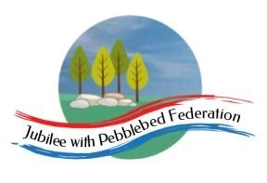
Year 5
Learning from Home

Year:  Week beg:  17/5/21 | Lesson One | Lesson Two | Lesson Three | Lesson Four
Monday | Spelling  Ough  https://classroom.thenational.academy/lessons/to-investigate-letter-strings-ough-ear-ou-au-ice-c8u34d | PE  Cosmic Yoga  Yoga for Gratitude  https://www.youtube.com/watch?v=fJY3bMOGjR4 | Science  https://classroom.thenational.academy/lessons/what-are-the-parts-and-functions-of-a-plant-69gk8d?from_query=parts+of+a+plant+AND+is_sensitive%3Afalse | RE  https://classroom.thenational.academy/lessons/who-was-jesus-6mv66c?from_query=jesus+AND+is_sensitive%3Afalse
Tuesday | Spelling  Ough  https://classroom.thenational.academy/lessons/to-practise-and-apply-knowledge-of-letter-strings-ough-ear-ou-au-ice-including-test-c9hpcc | English  Instruction Writing  https://www.bbc.co.uk/bitesize/articles/zyk4ydm  Activity 1 | Maths  Division  https://classroom.thenational.academy/lessons/solving-problems-involving-division-with-remainders-part-1-cgt68c | Allotment  Where does your food come from?  https://www.bbc.co.uk/bitesize/topics/zjr8mp3/articles/zhc7kty  Watch the clip and read the article, then complete the quiz.  After think about other foods that you eat, find out where they come from. How far do they have to travel to reach you?
Wednesday | Grammar  https://www.bbc.co.uk/bitesize/articles/znpbgwx  Activity 1 | English  Instruction Writing  https://www.bbc.co.uk/bitesize/articles/zyk4ydm  Activity 2 | Maths  Division  https://classroom.thenational.academy/lessons/solving-problems-involving-division-with-remainders-part-2-6muk4d | PE  Get your heartrate up! Try some PE with Joe Wicks  https://www.youtube.com/watch?v=mhHY8mOQ5eo
Thursday | Grammar  https://www.bbc.co.uk/bitesize/articles/znpbgwx  Activity 2 | English  Instruction Writing  https://www.bbc.co.uk/bitesize/articles/zyk4ydm  Activity 3 | Maths  Decimals  https://classroom.thenational.academy/lessons/applying-mental-calculation-strategies-to-adding-and-subtracting-decimals-cgr3ce?from_query=adding+and+subtracting+decimals+AND+is_sensitive%3Afalse | Allotment  Farming in the UK  https://www.bbc.co.uk/bitesize/clips/zydmpv4  Watch the clip and think about how the farm has changed to fit with the needs of people around them.  Design a poster that shows the changes.
Friday | Grammar  https://www.bbc.co.uk/bitesize/articles/znpbgwx  Activity 3 | English  Instruction Writing  https://www.bbc.co.uk/bitesize/articles/zyk4ydm  Use what you have learnt to write a set of instructions that another person can follow for something of your choice – it could be a recipe, a how to guide for making a Lego model etc. | Maths  Multiplying by 10, 100 and 1000  https://classroom.thenational.academy/lessons/multiply-and-divide-by-10-100-and-1000-involving-decimals-64wk6r?from_query=multiplying+by+10%2C+100+and++AND+is_sensitive%3Afalse | ICT  Variables in Games – Lesson 5  Design to Code  https://classroom.thenational.academy/lessons/design-to-code-74u3cd
Reading
This week I would like you to read for 20 minutes every day. You can read your reading book, a book at home or you can access a book through
https://www.getepic.com/
If you have not already logged in the code is: Jla6766
Click on your character and explore the books in your AR band, have fun!

Please be aware that your home filter may allow unsuitable links to pop up when watching any YouTube videos.

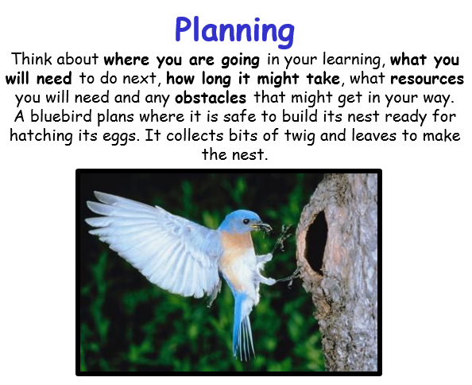
This week’s learning animal is the bluebird. The bluebird is great at thinking about where it is going, what it needs to do next, what resources it will need and any obstacles it might encounter. Look for times when you are learning like a bluebird!

