This document is what your children would be doing with Nursery adults for 15 minutes maximum every day. The warm up is a short 2-5 minutes and the activity no longer than 10 minutes.
The activities are explained well but if you need to make adaptations at home feel free. The mirror play activity is simple and hopefully you all have a mirror somewhere at home! Please use any and every household item you can find for your sound box and stick to one sound. In school we will do /s/, /a/, /t/, /p/, /n/. over the five days. So for example Monday’s sound box will have stick, sock, sunglasses, snake, spoon, string. Tuesdays will be apple, ant, arrow, alligator, ambulance, axe and so on.

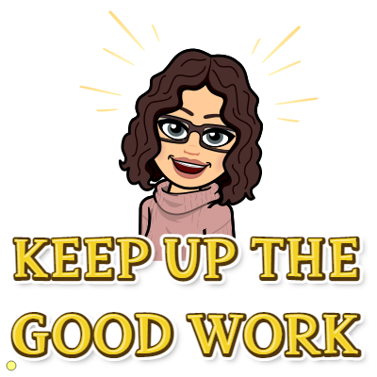
Feel free to use the space provided to jot down notes of how well they get on. The “look listen and note” section is really to tell you what the children should be doing and what you need to look out for as evidence of learning.

Most importantly have fun! ~Mrs P

Aspect 5: Alliteration
Look, listen and note
Look, listen and note how well children:
] can articulate speech sounds clearly; ] select an extended range of words that start with the same sound.
Look, listen and note how well children:
] can recall the list of objects beginning with the same sound; ] Can offer their own sets of objects and ideas to end the story ] Discriminate between the sounds and match to the objects correctly.
Week 2  Warm up  Activity | Mirror play: Provide a mirror for each child or one large enough for the group to gather in front of. Play at making faces and copying movements of the lips and tongue. Introduce sound making in the mirror and discuss the way lips move, for example, when sounding out ‘p’ and ‘b’, the way that tongues poke out for ‘th’, the way teeth and lips touch for ‘f’ and the way lips shape the sounds ‘sh’ and ‘m’.
Our sound box/bag:
Make collections of objects with names beginning with the same sound. Create a song, such as ‘What have we got in our sound box today?’ and then show the objects one at a time. Emphasise the initial sound (e.g. s-s-s-snake, s-s-s-sock, s-s-s-sausage)

