Year 5
Learning from Home

Year:  Week beg:  3/5/21 | Lesson One | Lesson Two | Lesson Three | Lesson Four
Monday | Bank Holiday Monday
Tuesday | Spelling  Suffixes  https://classroom.thenational.academy/lessons/to-investigate-suffixes-plurals-64r36d | English  Punctuating sentences using commas  https://classroom.thenational.academy/lessons/to-revise-complex-sentences-cct34c?from_query=commas+AND+is_sensitive%3Afalse | Maths  Short Multiplication  https://classroom.thenational.academy/lessons/short-multiplication-c8v64c | Art  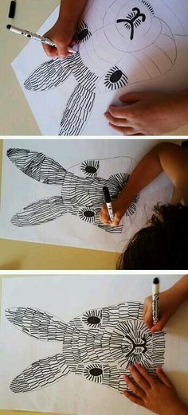  Look at any plants, fruits, vegetables or flowers that you have at home. Sketch them carefully, looking at the patterns and textures and then colour them using coloured pencils.
Wednesday | Spelling  Suffixes  https://classroom.thenational.academy/lessons/to-practise-and-apply-knowledge-of-suffixes-plurals-including-test-cgwket | English  Punctuating speech  https://classroom.thenational.academy/lessons/to-practise-speech-punctuation-rules-cdj34e?from_query=speech++AND+is_sensitive%3Afalse | Maths  Division  https://classroom.thenational.academy/lessons/using-multiples-to-divide-6cw3gd | PE  Get your heartrate up! Try some PE with Joe Wicks  https://www.youtube.com/watch?v=WhnRJbSNyfM
Thursday | Spelling  Suffixes  https://classroom.thenational.academy/lessons/to-investigate-suffixes-ate-en-ify-ise-6xj62t | English  Paragraphs  https://www.bbc.co.uk/bitesize/articles/zc6ftrd  Activity 1 | Maths  Division  https://classroom.thenational.academy/lessons/short-division-6gt64d | Allotment  Where does your food come from? Look at different food suppliers e.g. supermarket, market, greengrocer. Where do they source their fruit and vegetables from? Look at the labels of some food that you have at home, where do they come from? Find put where your fresh vegetables and fruit come from.
Friday | Spelling  https://classroom.thenational.academy/lessons/to-practise-and-apply-knowledge-of-suffixes-ate-en-ify-ise-suffixes-including-a-test-60r30e | English  https://www.bbc.co.uk/bitesize/articles/zc6ftrd  Activities 2 and 3 | Maths  Division  https://classroom.thenational.academy/lessons/division-with-remainders-ccwk6r | ICT  Variables in Games – Lesson 3  Improving a game  https://classroom.thenational.academy/lessons/improving-a-game-70wkcd
Reading
This week I would like you to read for 20 minutes every day. You can read your reading book, a book at home or you can access a book through
https://www.getepic.com/
If you have not already logged in the code is: Jla6766
Click on your character and explore the books in your AR band, have fun!

Please be aware that your home filter may allow unsuitable links to pop up when watching any YouTube videos.

Please remember to send in your work to the year 5 email address: Y5Teacher@littleham.devon.sch.uk

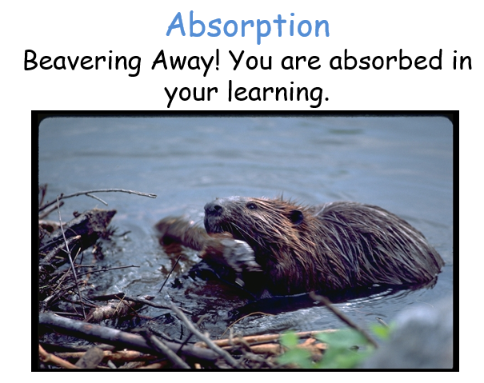
This week’s learning animal is the beaver. The beaver is absorbed in its work! Look for times when you are learning like a beaver!

