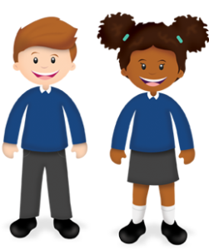
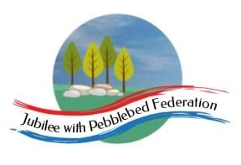

Year: 6  Wk beg: 23/11/20 | Lesson One | Lesson Two | Lesson Three | Lesson Four |  |  | Lesson Five
Monday | Reading – Own book.  Spellings – sheet taken home  https://classroom.thenational.academy/lessons/to-identify-the-features-of-an-explanation-text-6tgk2r  To know features of an explanation text. | Maths  I can multiply a decimal by a whole number.  https://classroom.thenational.academy/lessons/multiply-a-decimal-number-by-a-whole-number-6mwpcd  PRACTISE TABLES |  | Science – Light  To know what light is.  https://classroom.thenational.academy/lessons/what-is-light-c4w30d  To know what a reflection is.  https://classroom.thenational.academy/lessons/what-is-reflection-and-how-can-we-use-it-6mt3gd
Tuesday | Reading – Own book.  Spellings – sheet taken home  https://classroom.thenational.academy/lessons/to-explore-compound-words-6wwpat  To know what compound words are.  https://classroom.thenational.academy/lessons/to-explore-using-apostrophes-for-plural-possession-cgvk2d  To know the plural possession | Maths  I can multiply numbers using known and derived facts.  https://classroom.thenational.academy/lessons/solve-multiplication-problems-using-known-and-derived-facts-6ngk2t  PRACTISE TABLES |  | RE  Why do some people believe in God and others don’t?  Try to think of some reasons for this. | MFL  I am learning Spanish numbers  https://www.youtube.com/watch?v=8fPF1eGvLLM  I know Spanish greetings  https://www.primaryresources.co.uk/mfl/mfl_spanish.htm
Wednesday | Reading – Own book.  https://classroom.thenational.academy/lessons/to-understand-and-sequence-how-bees-make-honey-cgwk2c?activity=video&step=1  To know how bees make honey. | Maths LO  Use efficient strategies to multiply numbers.  https://classroom.thenational.academy/lessons/use-efficient-strategies-to-multiply-numbers-including-decimals-6rr3at  PRACTISE TABLES |  | Computing  If you can access Scratch, create a game similar to one you did earlier last year.
Thursday | Reading – Own book.  Spellings – sheet taken home  LO – To orally explain a process  https://classroom.thenational.academy/lessons/to-orally-explain-a-process-6mt3gd | Maths LO  Practise multiplication and division skills  https://classroom.thenational.academy/lessons/practise-multiplication-and-division-skills-64vp2e  PRACTISE TABLES AND DIVISION RELATED TO THEM |  | PSHE  https://classroom.thenational.academy/lessons/community-care-cctp8c |  | PE  Fitness – push-ups, squats, leg drives, star jumps, shuttle runs.
Friday | Reading – Own book.  Spellings – sheet taken home  To plan an explanation text  https://classroom.thenational.academy/lessons/to-plan-an-explanation-text-69hpcr | Maths  Transum Arithmetic  Multiplication  Division  PRACTISE TABLES |  | Light cont  BBC Bitesize Light and Dark  https://www.bbc.co.uk/bitesize/topics/zbssgk7  Research how shadows form, how light is reflected and how light can be split up into its component colours.

