Year 5 Learning from Home Grid
Week Beginning 25.01.21
Learning Behaviours
In school we are really thinking about:
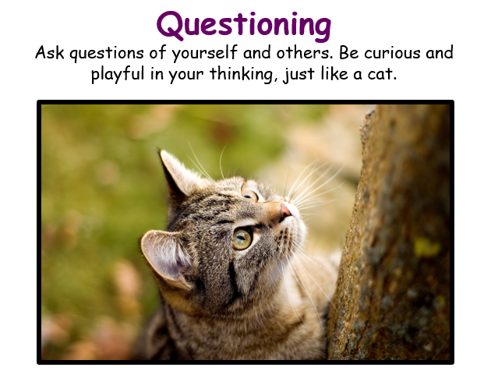
Please ensure that you monitor any YouTube clips for ads and ensure that your children only click on the links to the videos that I have included.
Monday | Collective Worship:  Follow the link to Mrs Padbury’s Collective Worship on Google Classroom  PE:  If you can get outside to ‘Get Active,’ all to the good. If not try last Friday’s Joe Wick’s workout. https://youtu.be/ke04O2ma7eI  Alternatively, some of the links here, which will be attached to Google Classroom.  The 25minute Body workout. Can you stay the distance?  https://youtu.be/qtX_Frk0buU  Reading  Share a book, or individually. Remember to read with expression and talk about the main character’s, or key points of the text. Try the ‘Inference’ Reading activity as an alternative.  Maths:  Concentrate on your Times Tables and complete the Times Table wheel as quickly as you can. (See Google classroom). TT Rock Stars is also there to help you.  Living things and their habitats:  In school we will be starting on our booklets, or power points. Make sure that you have your information gathered, with plenty of labelled illustrations and diagrams. Photos, if you are making a power point. Remember to focus on Life Cycles of your creature(s). We will be continuing with this until half-term. Do carry on taking notes if you need to. We are excited to see what you come up with!  Science:  Understand how a pulley works.  Use the sheet as a basis for the experiment and record findings. Focus on Prediction, method and results.  Where else might you find pulleys?  Why are they useful? Look around at home where pulleys are used. Research where pulleys have been used too. ( PDF on Google classroom).  French:  To learn the parts of the body. (The face).  Watch the video. ( More than once if you like).  https://youtu.be/UNCEy-g8qEM  On a piece of paper, draw your face and see if you can label the different parts in French?  Then watch the video again.
Tuesday | Reading:  The Demon Dentist  https://classroom.thenational.academy/lessons/to-engage-with-the-text-6mu32d  English:  To plan a double page spread in the style of Inside the Villains  https://www.loom.com/share/a78f0a60d6544d5a94471478bd415229  Maths:  Use short multiplication to multiply 3-digit numbers by single digit-numbers including amounts of money.  Go to Google classroom or find the information in your pack.  History:  Go to Google Classroom or find the information in your pack. Look at the cards about Anne Boleyn, they are a timeline but they are not in the correct order! Use these cards to write a short biography of her life starting from her birth and ending with her death. A biography is when an author writes about the life of another person, I would start like this:  Anne Boleyn is one of Henry VIII’s most infamous wife’s, who is most known for having her head chopped off! It is not clear when Anne was born but it is believed to be between 1501 and 1507. She was born in…  Tudor Dance:  https://bbc.co.uk/bitesize/clips/zt4kjxs  Watch the Tudor Dance – Go to Google Classroom or find the information in your pack and fill in the grid with your observations.
Wednesday | Reading:  The Demon Dentist  https://classroom.thenational.academy/lessons/to-answer-questions-on-the-text-part-1-ccrp2d  English:  To write an introduction in the style of Inside the Villains  https://www.loom.com/share/e41f5c4215574a06a862d1f8f333b64b  Collective Worship:  Exmouth Coastal Churches  https://www.youtube.com/watch?v=ibcdh2V0VtQ&list=PLqWt6-qhTKHF_Yb18Npn-Ni0kRTQ-9-yp  Look at the playlist on the side for the Collective Worship for this week  Maths:  Converting between millilitres and litres.  Go to Google classroom or find the information in your pack.  Art:  Work through the PowerPoint on Google Classroom and create your own miniature backing.  PSHE:  Follow the presentation on Google Classroom Family Mental Health and Wellbeing
Thursday | Reading:  The Demon Dentist  https://classroom.thenational.academy/lessons/to-analyse-characters-cmu3gd  English:  To write a fairy tale in the style of Inside the Villains  https://www.loom.com/share/b5696d3daa9e49348f083c267cc0481f  Collective Worship:  ICE Exeter  https://youtu.be/owcTOt_34uU  Maths:  Converting between miles and kilometres  Go to Google classroom or find the information in your pack.  Outdoor Learning:  Go to Google Classroom (or your paper pack) and follow the instructions to make your own binoculars for investigating wildlife. How easy are the instructions to follow, how could you adapt them to make them clearer?  You could also do some cooking with your grown up – we will be making pancakes in our outdoor learning time. If you can make something at home (you could even help with cooking lunch or dinner!), please take a photo and send it in to us at Y5Teacher@littleham.devon.sch.uk
Friday | Reading:  The Demon Dentist  https://classroom.thenational.academy/lessons/to-answer-questions-on-the-text-part-2-75j3je  English:  To publish your story and share it with your family. Today I would like you to publish (write up in best) your work from this week in the style of Inside the Villains, think carefully about the layout and the illustrations. You could even draw your main character with pop up/fold out parts. (See the phots below for ideas!) When you have completed this work share it with your family and remember if you can please take a photo of your work and send it to Y5Teacher@littleham.devon.sch.uk  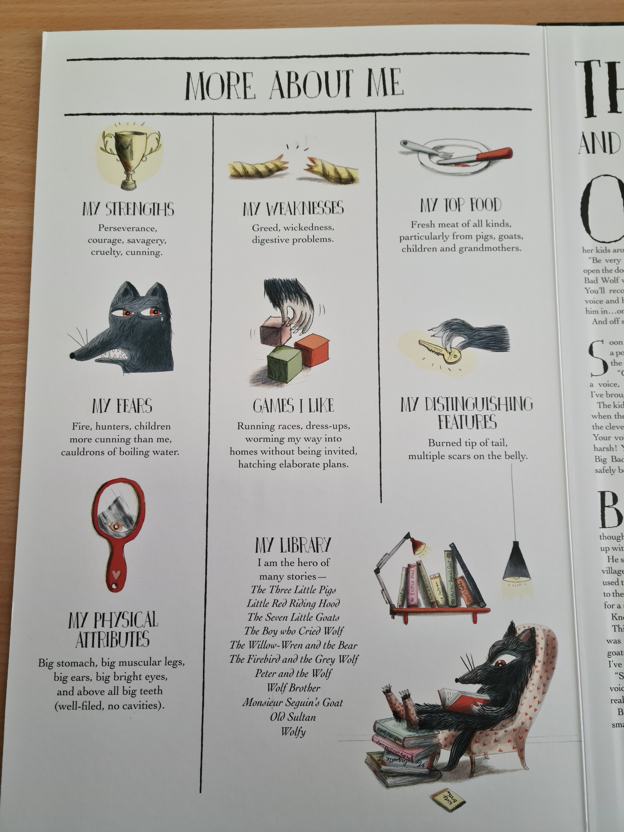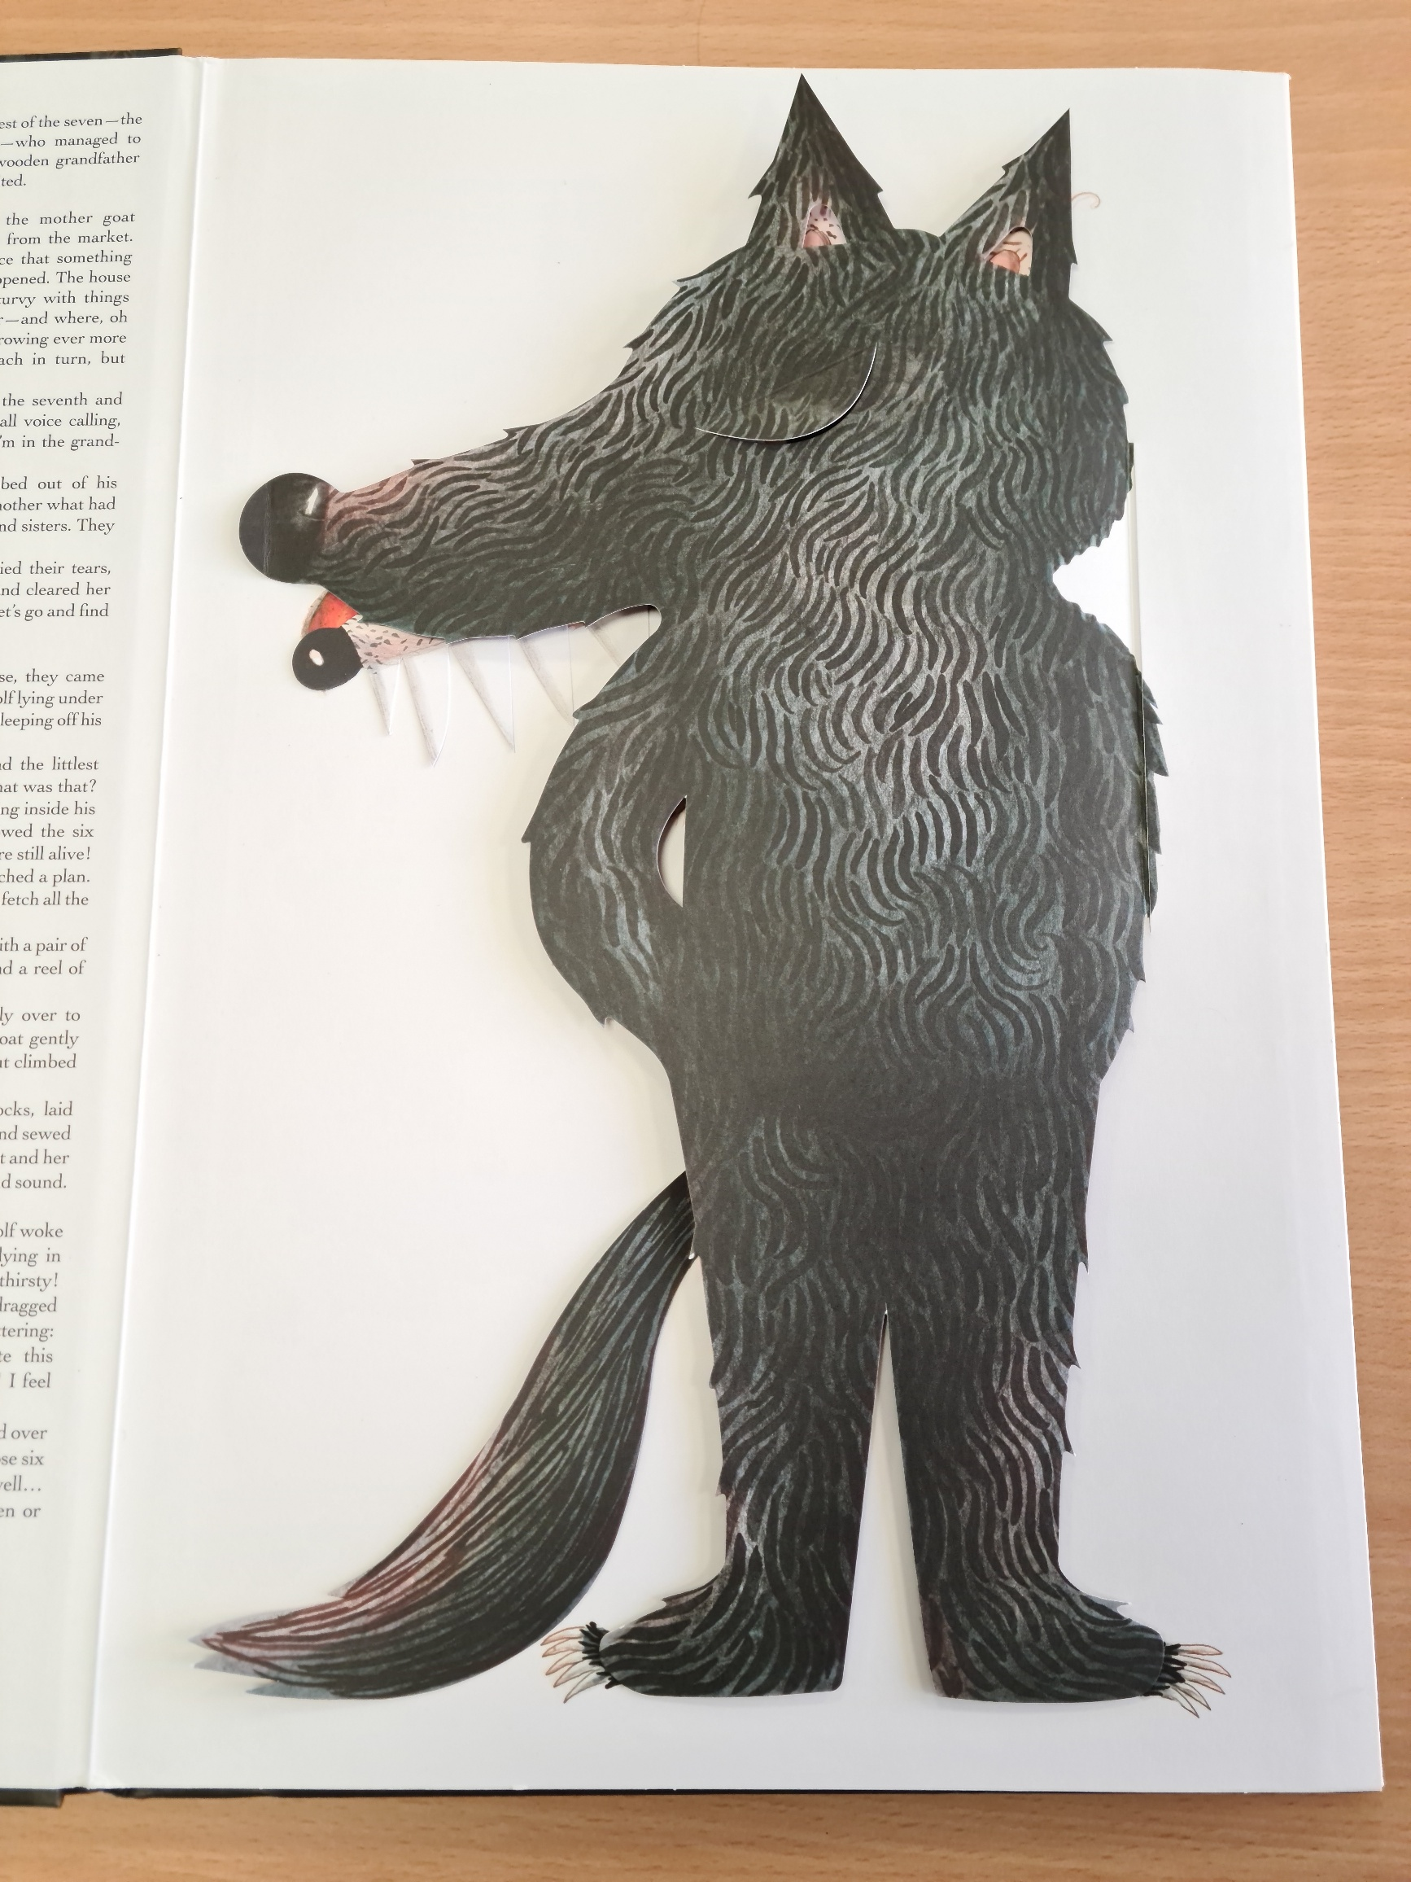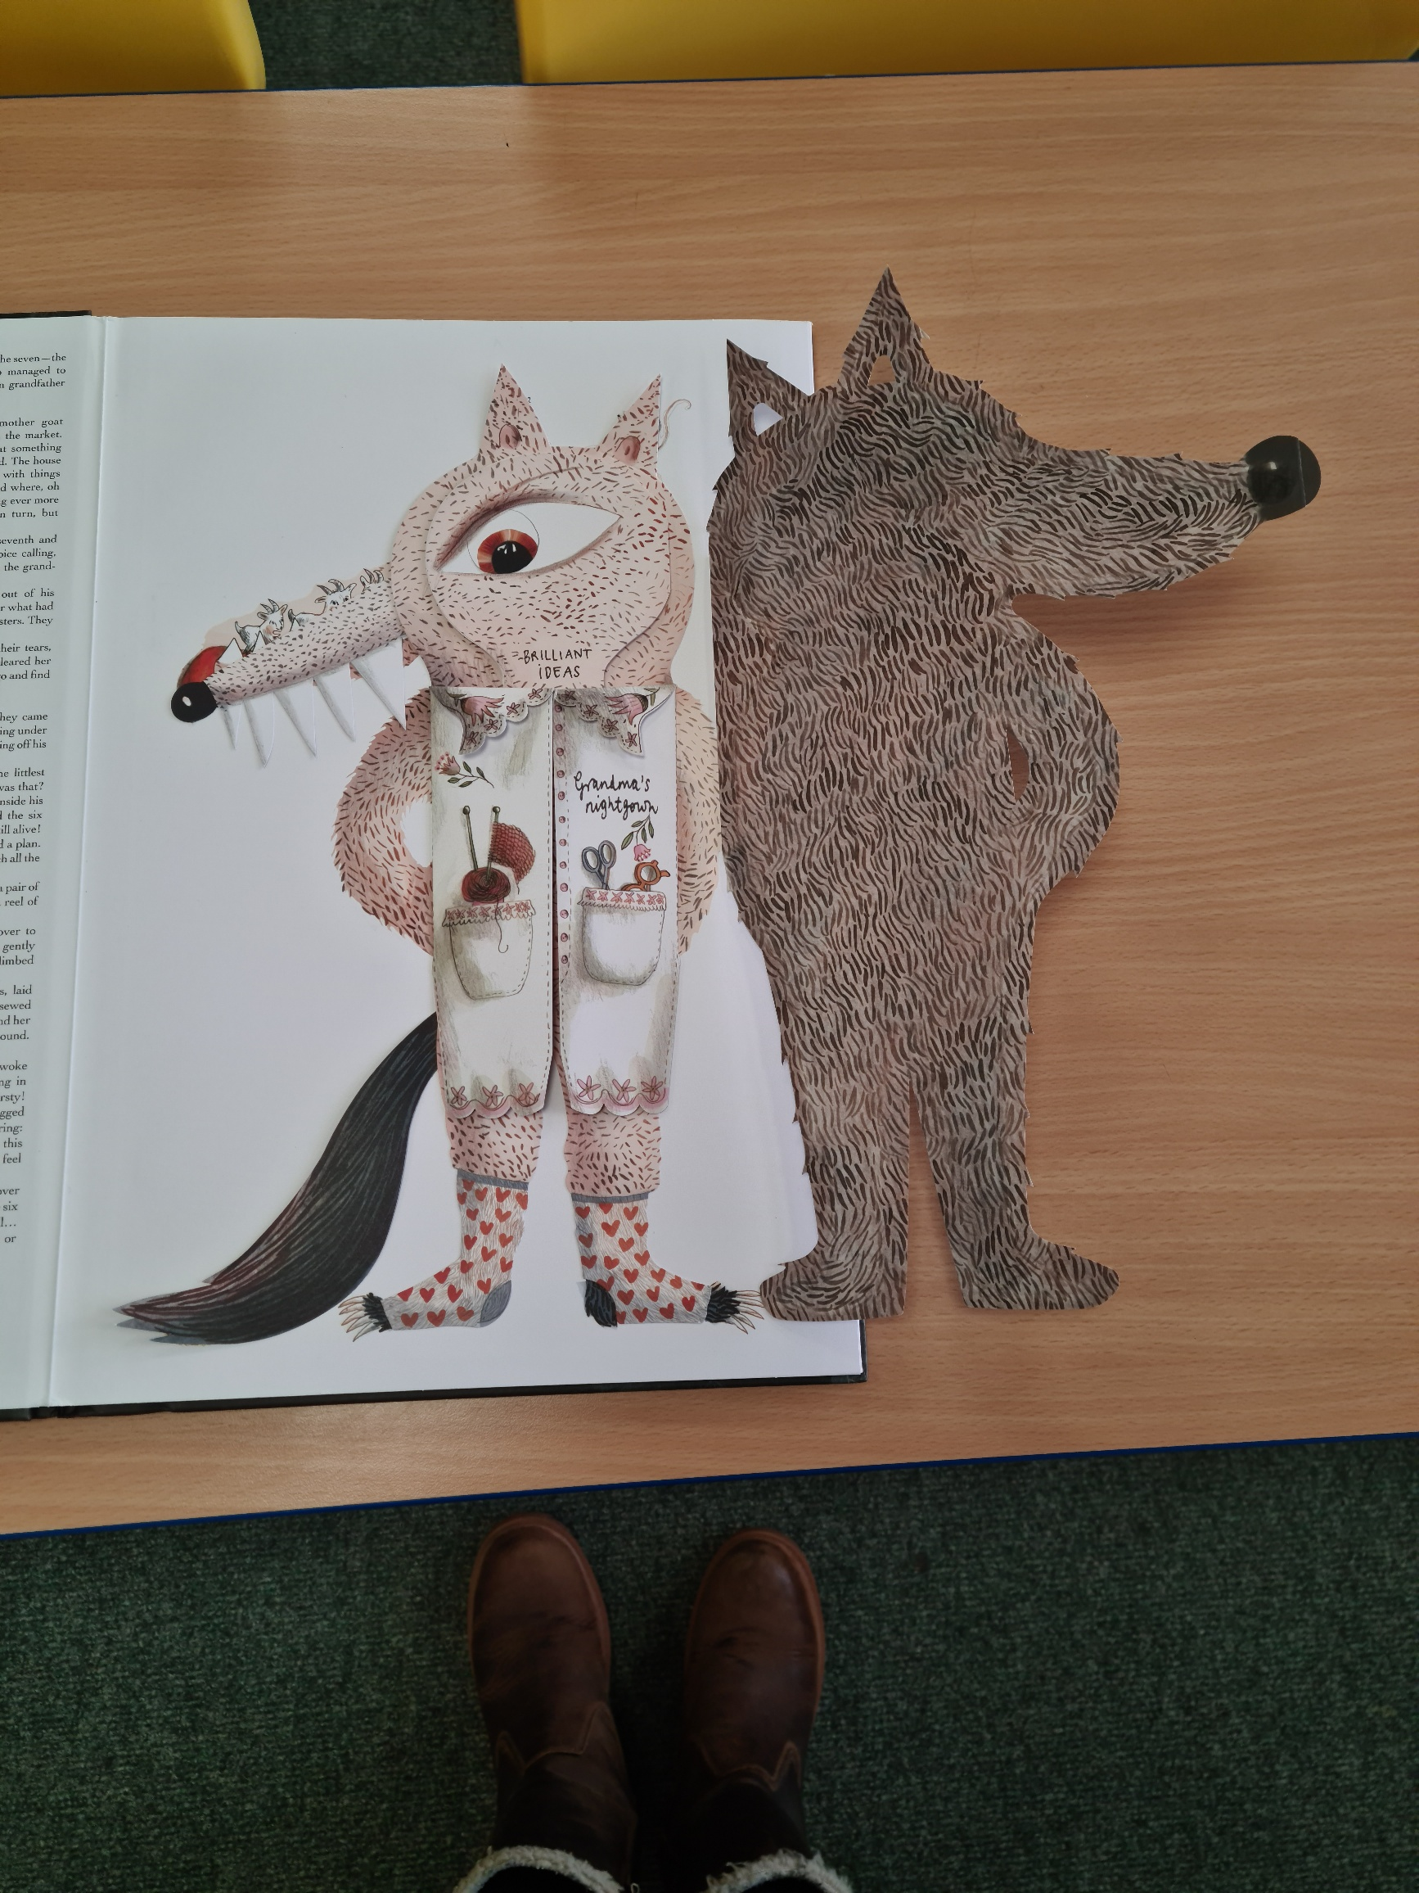  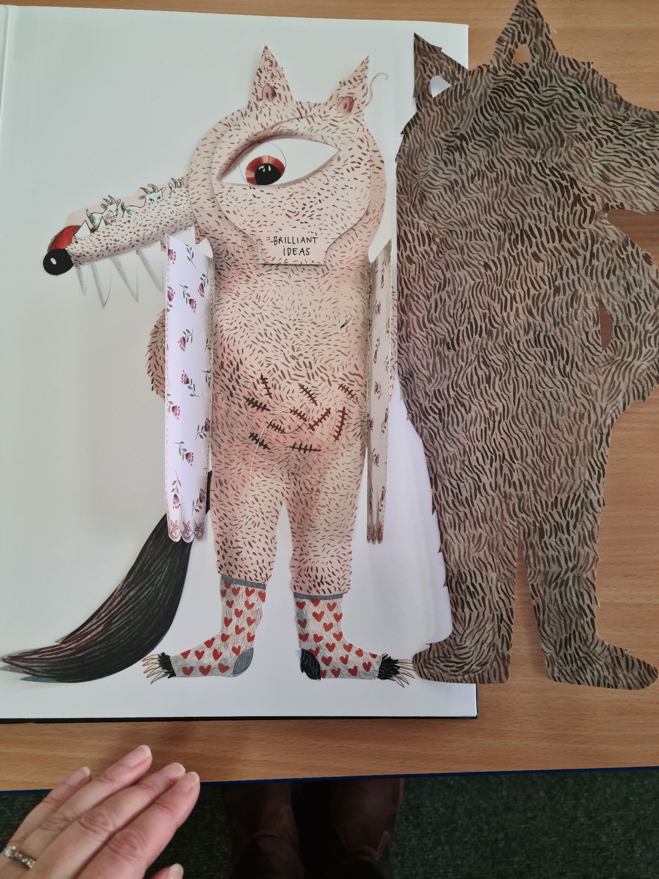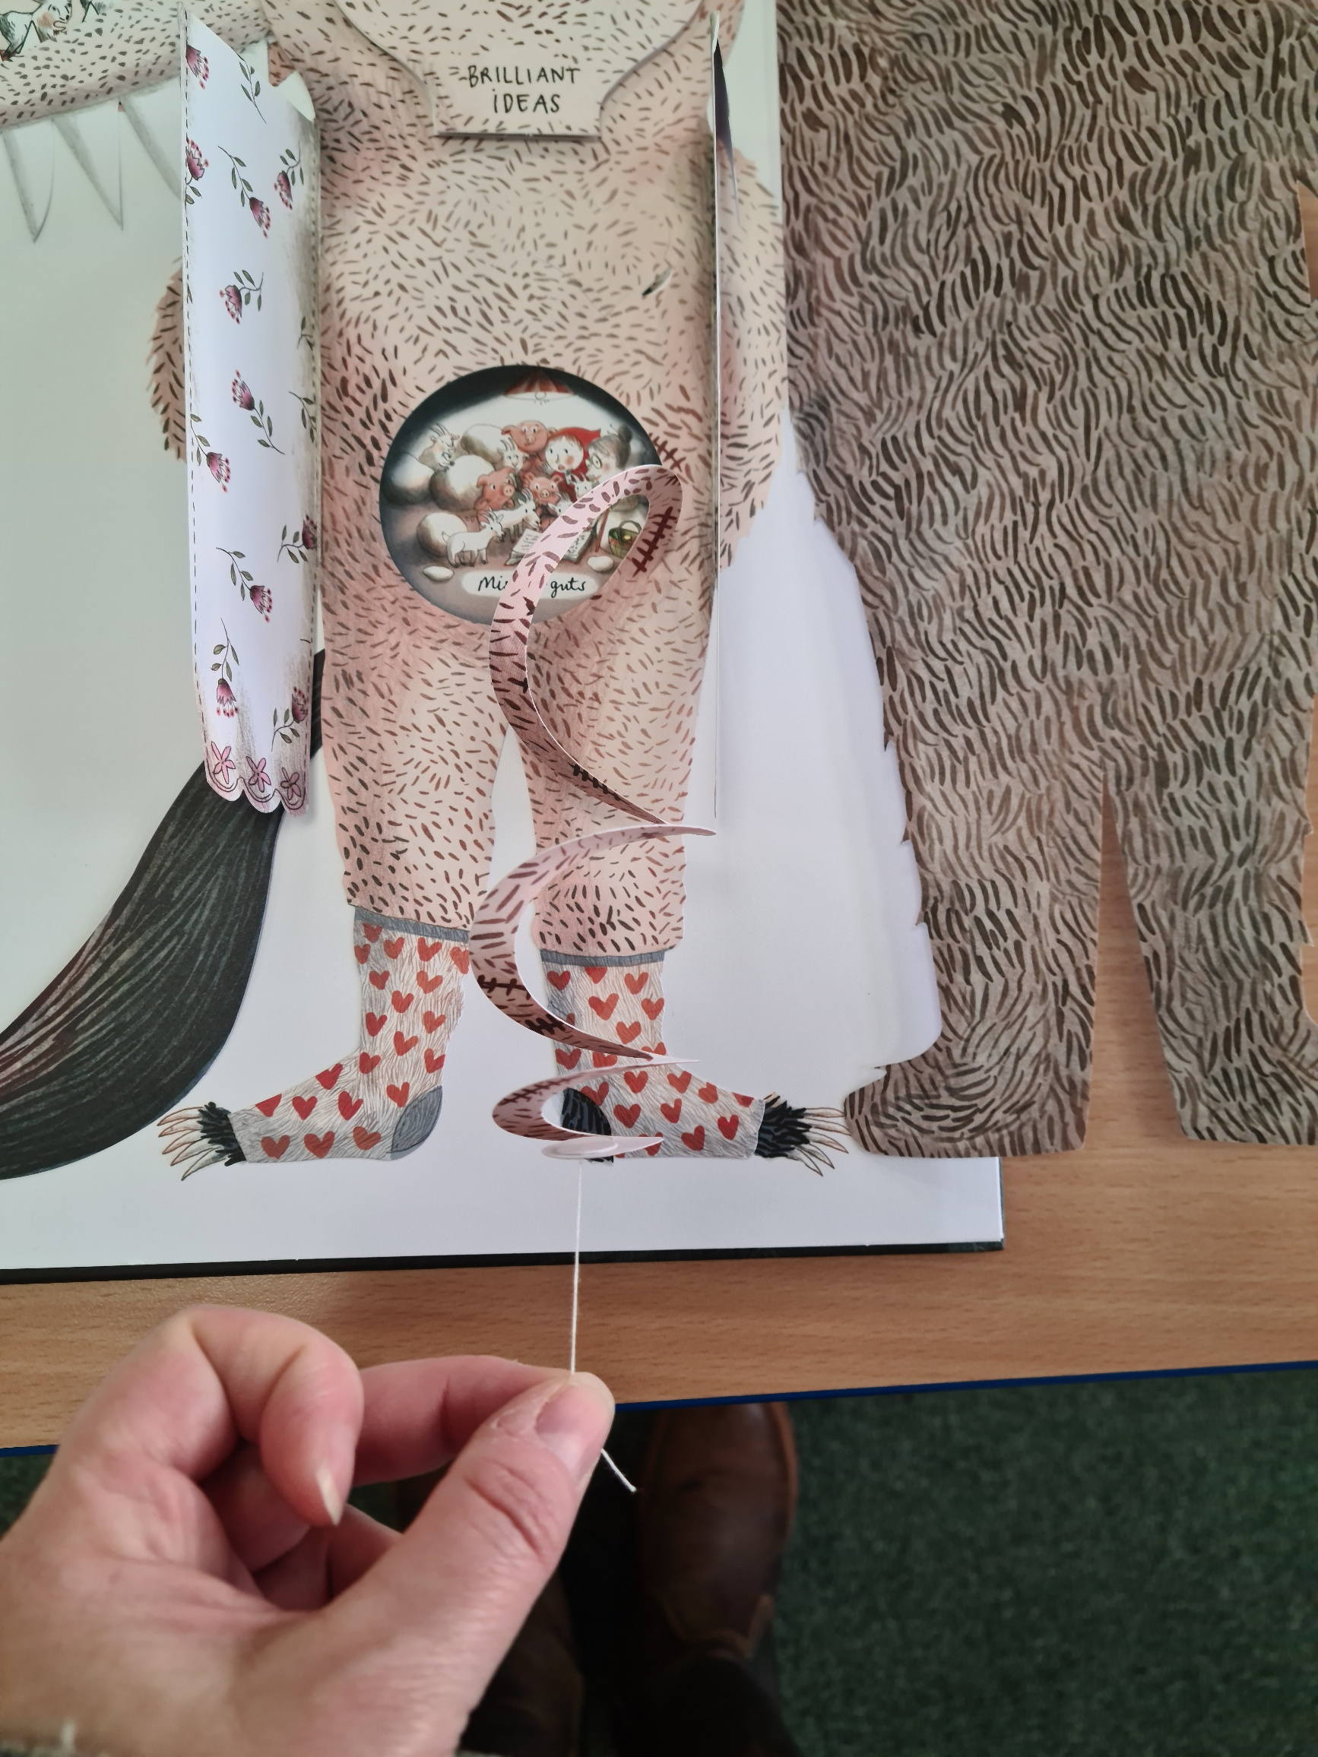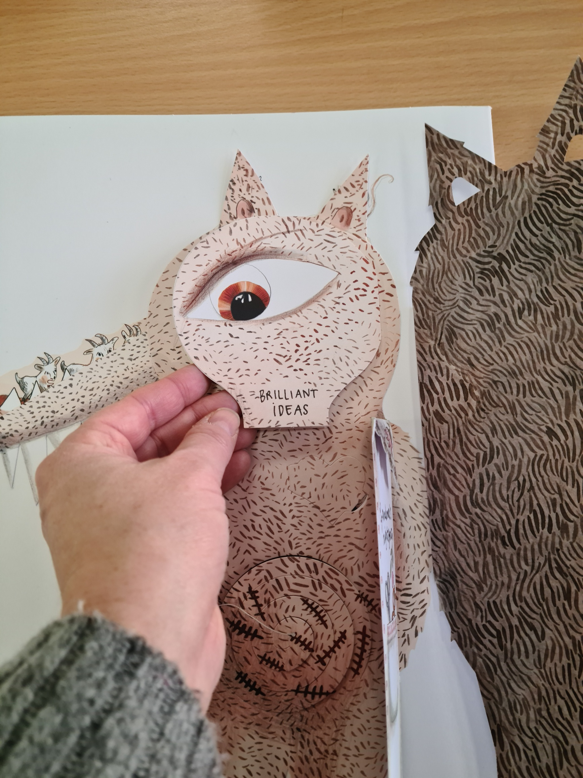  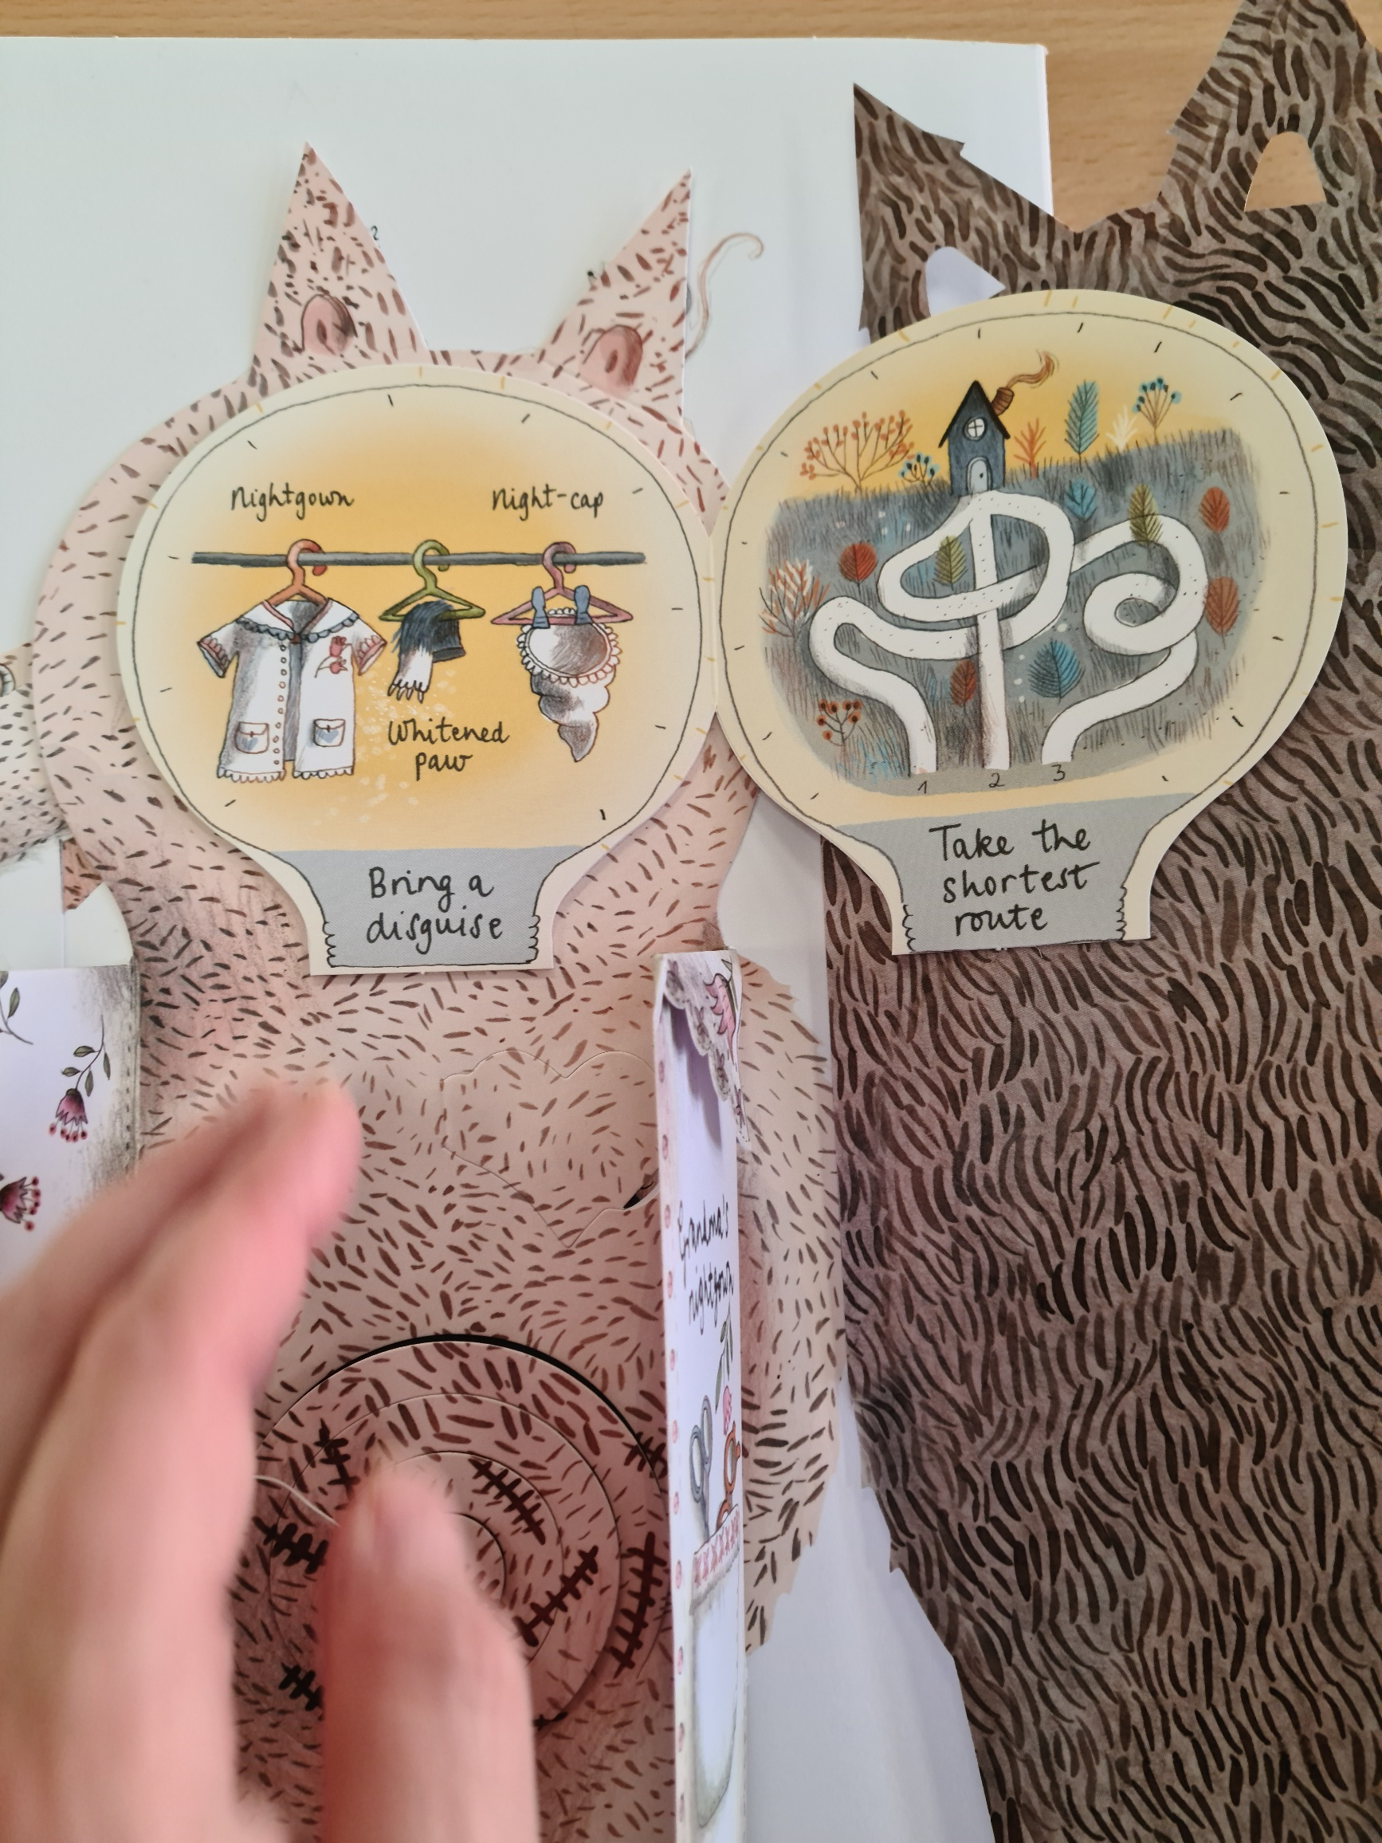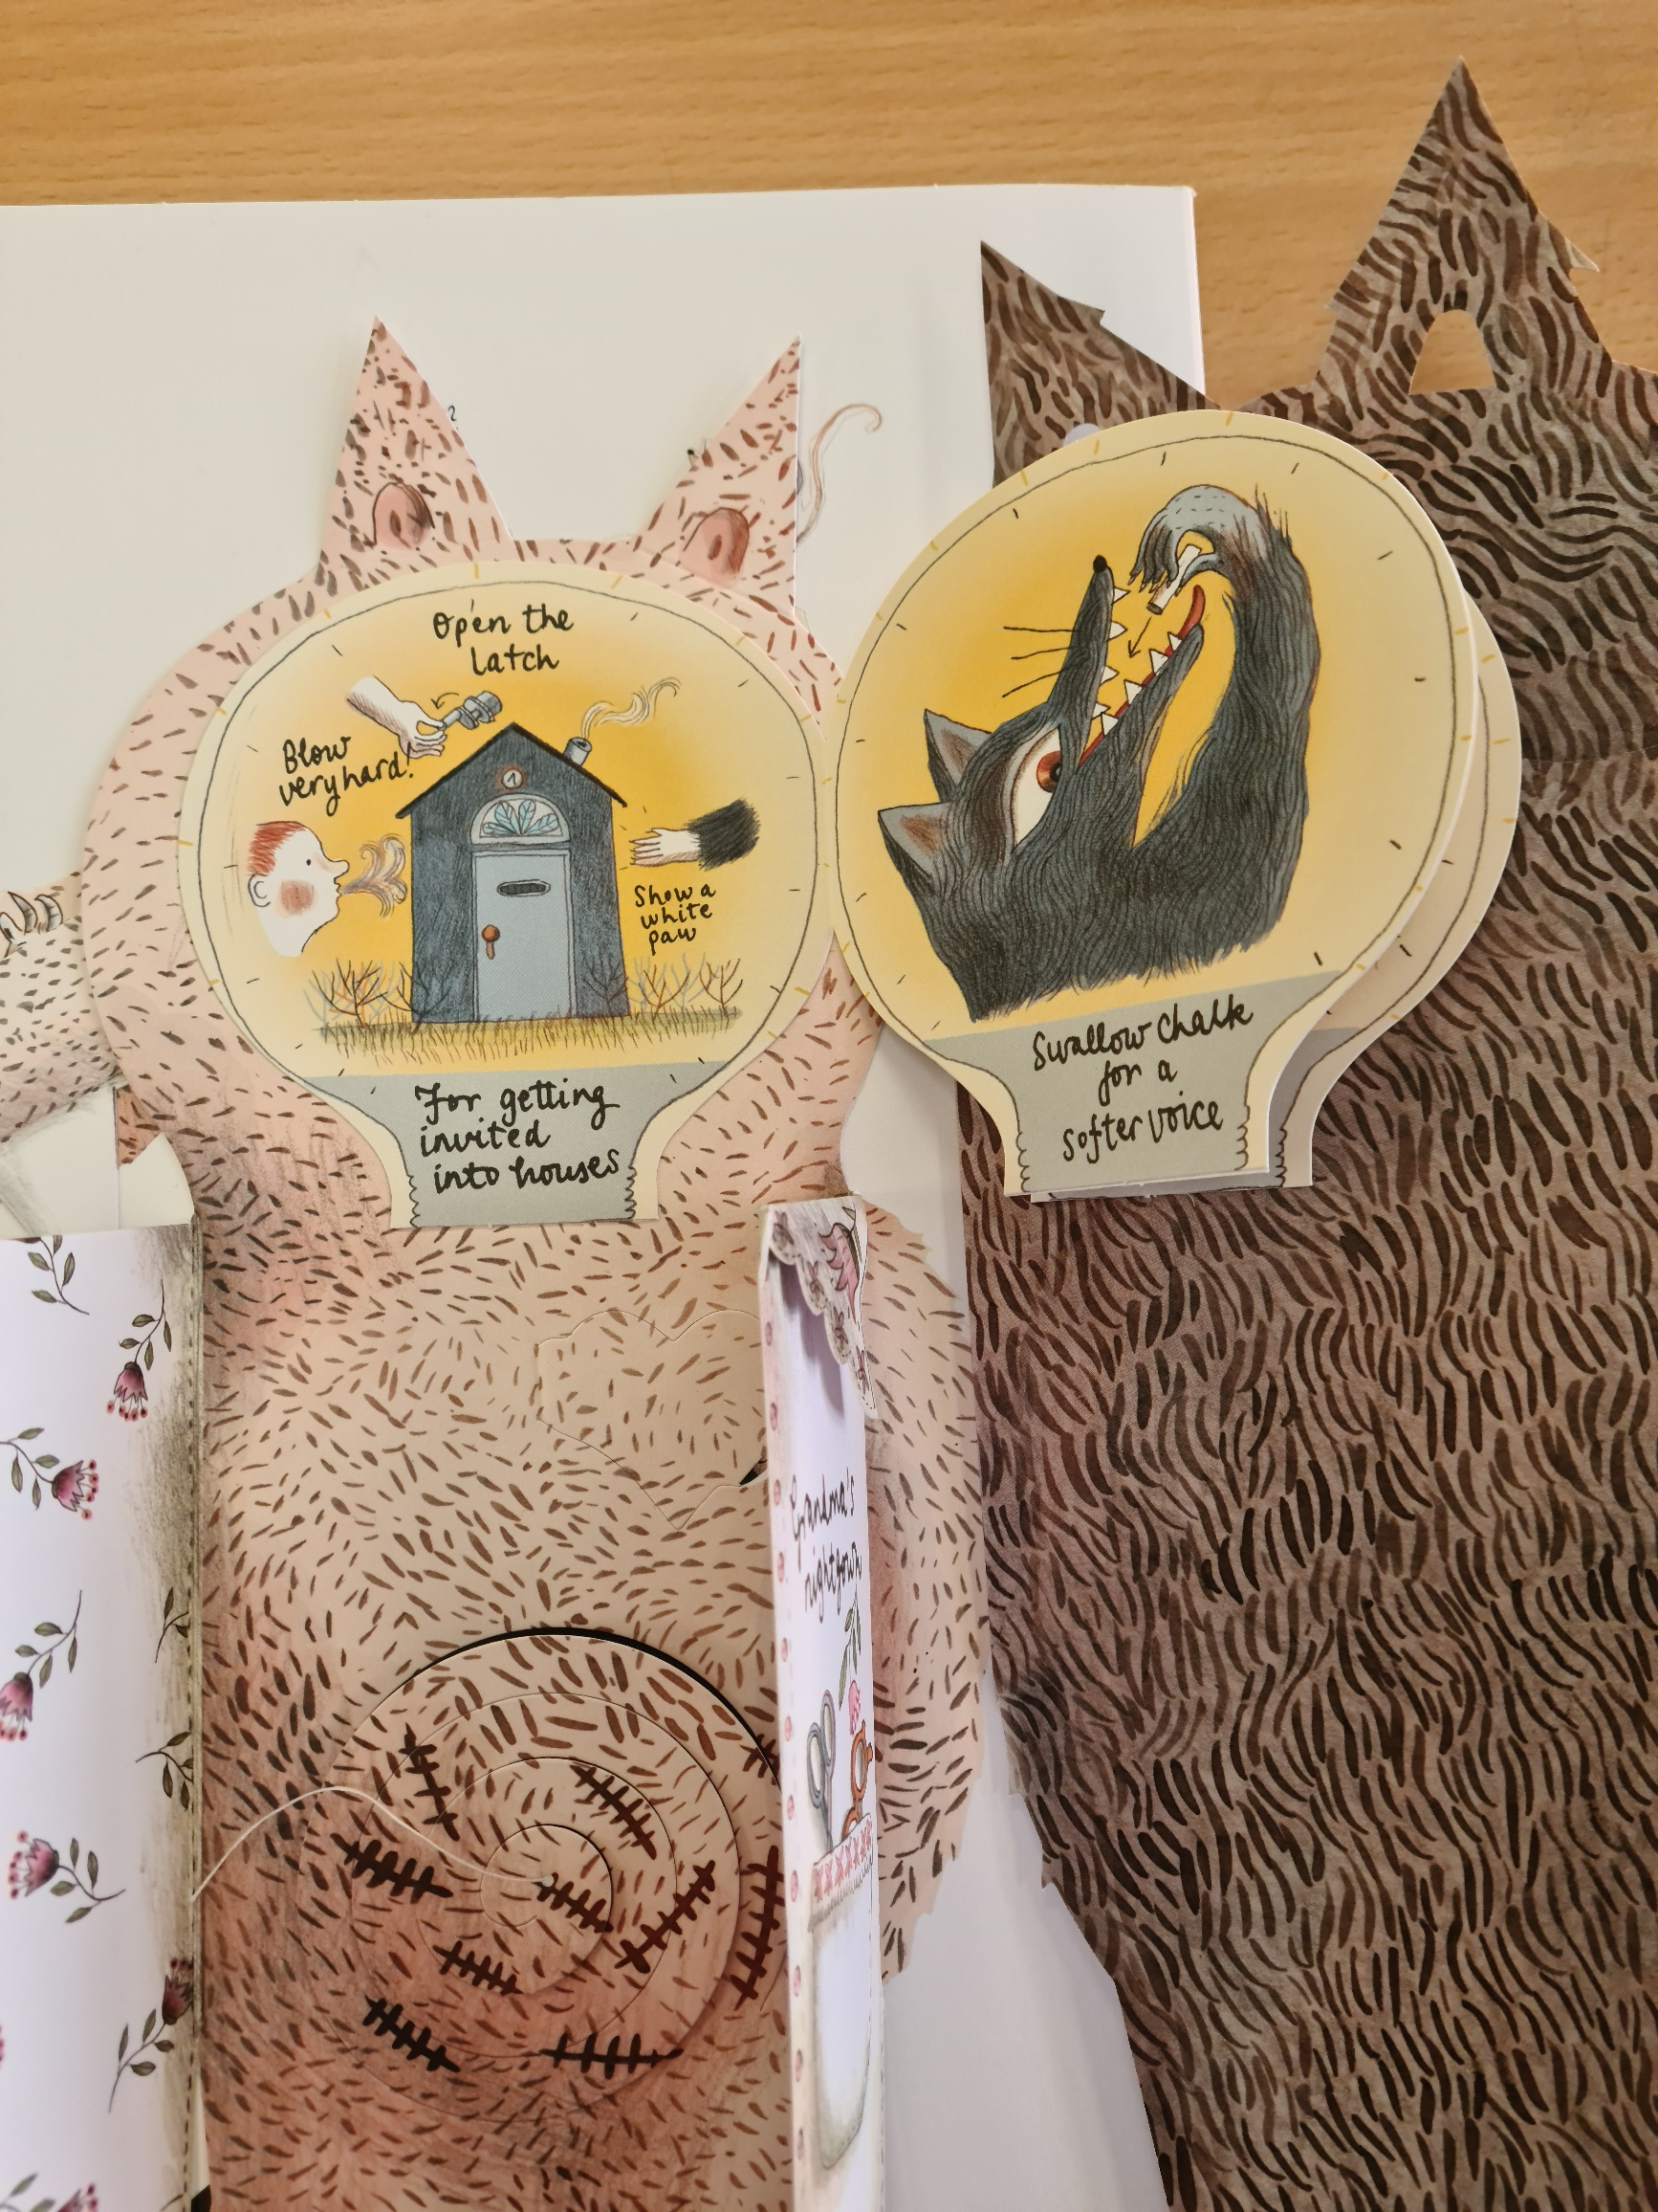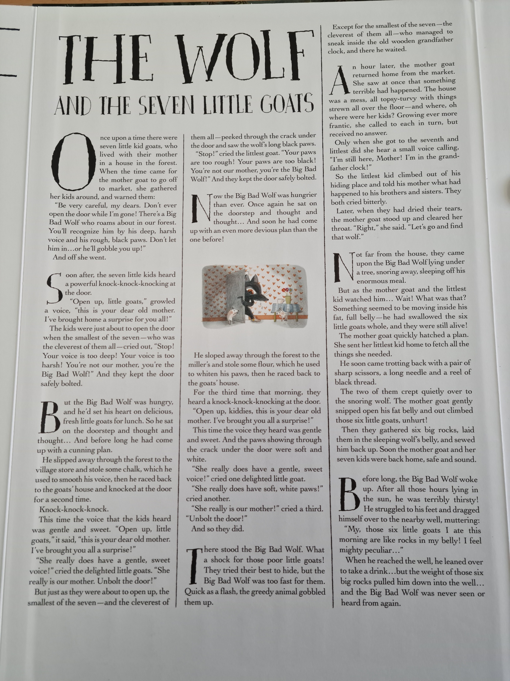  Maths:  Problem solving and reasoning  Go to Google classroom or find the information in your pack.  ICT:  Features of an effective video  https://classroom.thenational.academy/lessons/features-of-an-effective-video-74w3ee  RE:  What do we think of when we think of Christmas?  https://www.youtube.com/watch?v=LUmPzwLNiMk  https://www.youtube.com/watch?v=kuRn2S7iPNU  https://www.youtube.com/watch?v=yg4Mq5EAEzw  https://www.bbc.co.uk/teach/class-clips-video/religious-studies-KS2-christmas/z4xcjhv  Watch the adverts and fill in the grid on Google Classroom or in your pack.  How does this relate to the birth of Jesus and the idea of Jesus as the Messiah?

