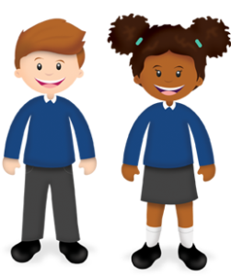

Year 2 Learning from Home Grid
Week Beginning 15.03.21
For their return to school after lockdown the children in school will be doing activities to support transition and adjustment. We will be using supportive return curriculum materials to support wellbeing.
Think about how we can develop your child’s learning behaviours. This week we are looking at taking good habits and ideas from those around us.  Tell Mrs Hooper how your child has shown this behaviour this week by email | 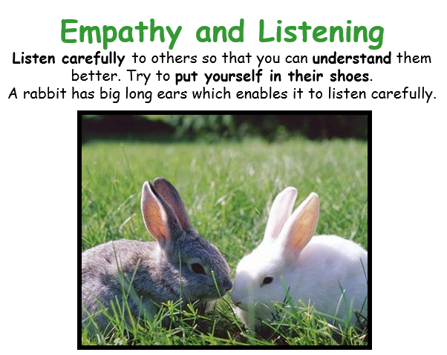
Monday
Reading (30 Mins)
You have been set a reading book in your library on Bug Club using your Active Learn Login. Don’t forget to answer the questions on the hotspot bug eyes. This tells us at school that you are doing your reading,
Phonics (30 Mins)
The sounds for this week are available on your Bug Club login. You will find three lessons and four games to practise the sounds eer, ear, and ere.

English
We are thinking about colours and how they can represent feelings.
Watch and listen to the reading of The Colour Monster on this link:
https://www.youtube.com/watch?v=Ih0iu80u04Y .

After the story draw a picture of a monster and colour it in using only two colours to show how it is feeling. Encourage your child to add facial features. Can they explain what their monster is feeling and why ?

Maths
Using the numbered activity cards supplied lay them out so children can see them. You call out a number and they do the movement that matches on the cards.
When you call out a number say three. They show you three legs flicks.
When you call out say two they show you two wing flaps.
Now make it tricky. If you say three they have to do the number of leg flicks that would total 10 (so 7 leg flicks or 8 wing flaps)
Extend it to the teen numbers so they have to make upto 20. Move over Joe Wicks !

Tuesday
Reading (30 Mins)
You have been set a reading book in your library on Bug Club using your Active Learn Login. Don’t forget to answer the questions on the hotspot bug eyes. This tells us at school that you are doing your reading,
Phonics (30 Mins)
The sounds for this week are available on your Bug Club login. You will find three lessons and four games to practise the sounds eer, ear, and ere.

English
Play the animation
https://www.youtube.com/watch?v=dOkyKyVFnSs
At each 3,2,1 stop the film and talk about how the girl might be thinking and what mood she is in.
Now use two soft toys you may have to act out a scene where one of the toys is sad and the other is trying to comfort them.

Maths
Look at the Kandinsky paintings in the resource file. Explain secret messages can be hidden in paintings like codes. So the large circles could be tens and small circles could be ones. What number is hidden in picture one? (12) and picture two ( 22)
Look at painting three. Can you see the red number and the green number? Decide which of the red circles to count as large (tens) and which to count as small (ones) The painting also contains one big and three little green circles that is 13. How much is 28 and 13 altogether ?
How could you represent the number 34 in a painting or drawing, how about another number ?
Can you design a painting that where the numbers in code add to 99 ?

Wednesday
Reading (30 Mins)
You have been set a reading book in your library on Bug Club using your Active Learn Login. Don’t forget to answer the questions on the hotspot bug eyes. This tells us at school that you are doing your reading,
Phonics (30 Mins)
The sounds for this week are available on your Bug Club login. You will find three lessons and four games to practise the sounds eer, ear, and ere.

English
Think about and talk about a tune which you makes you feel sad and discuss why. The think about a piece of music that makes you feel happy, then a piece that makes you feel calm.
Clear a space if you can, play each track in turn. Use the space to move /dance in anyway that you feel fits the music playing.
End with the calm music, children can lie on the floor pretending to be the colour monster from Monday laying in his hammock thinking calm thoughts.

Maths
Using the example template make a 2 or 3 spiral snakes ready for your child to complete.
Decide how you are going to number them you could write the numbers counting up in 2, 5 or 10.
Decorate tehm afterwards and then cut them out.
Can they read the snakes backwards as well as forwards ?
For a challenge you could make a snake that counts in tens from another number other than zero so 4 for example. Or even count up in threes…

Collective Worship (15 Mins)
Please log into you Google classrooms account to view the Collective Worship from Mrs Padbury.
Thursday
Reading (30 Mins)
You have been set a reading book in your library on Bug Club using your Active Learn Login. Don’t forget to answer the questions on the hotspot bug eyes. This tells us at school that you are doing your reading,
Phonics (30 Mins)
The sounds for this week are available on your Bug Club login. You will find three lessons and four games to practise the sounds eer, ear, and ere.

English
Read and enjoy the story In Every Corner, talk about each page as you read it.
https://hamiltontrust-live-b211b12a2ca14cbb94d6-36f68d2.divio-media.net/documents/GR_In_Every_Corner_web.pdf
Discuss which feelings monster your child would like to make. Playdoh or plasticine is ideal but junk modelling would work too if that is what you have.
Hwne it is finished ask your child’s monster how it is feeling. Can the monster say ? and why ?

Maths
Find two ways of making a sound two different saucepans with a wooden spoon for example, or a pan and a box, (anything your ears can bear.) the pan can be tens and the box can be ones. You say a number say 24, your bashes the pan twice and then the box four times. Repeat for different two digit numbers.
Can you swap and bash out a number for your child to guess ?
Finally beat out two different two digit numbers. Children write them down and then add them together by combining the tens and then the ones.

Friday
Reading (30 Mins)
You have been set a reading book in your library on Bug Club using your Active Learn Login. Don’t forget to answer the questions on the hotspot bug eyes. This tells us at school that you are doing your reading,
Phonics (30 Mins)
The sounds for this week are available on your Bug Club login. You will find three lessons and four games to practise the sounds eer, ear, and ere.

English
Re watch the Colour Monster from Monday.
Write a letter to the Monster to tell him how you feel and suggest ways that he could cheer himself up when he is sad.

Maths
Teaching | - Draw a hopscotch track somewhere outside for numbers 1 to 12.  - Throw a dice and make that many jumps/hops along the track.  - Notice, for example, that six leaps lakes you to 8 and 9.  - Explain that you are going to choose either 8 or 9, or make them into a 2-digit number: 89, and write it on your whiteboard. Your aim is to make a total of 100, so it might be wise to make 89….  Stay on that number.  - Throw the dice again and hop/jump on from your previous number. Explain that if you roll a number that takes you beyond the track, you return to the beginning to continue counting, e.g. if you are on 8 and 9 and you roll a 5, you move to 10, then 11 and 12, then 1, then 2 and 3, then 4. You add the number you land on (4) to your 89.  - Keep taking turns until the first person reaches 100 or more - they win!

