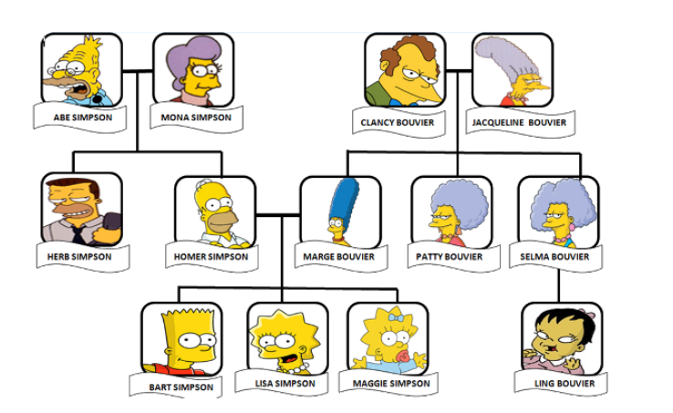
La famille – The Family
le grand-père (lu grond pear) | grand father
la grand-mère (grond mare) | grand mother
la mère (mare) | mother
le père (pear) | father
le fils (feece) | son
la fille (fee) | daughter
la soeur (sir) | sister
le frère ( frair) | brother
la tante | aunt
l’oncle | uncle

Try to read some of them. I have put a pronunciation next to the words to help you!

Here is a selection of statements about the family, in French.
The word for ‘is’ is ‘est’ and the word for ‘of’ is ‘de’.

Homer est le père de Bart. Homer is the father of Bart.
Maggie est la fille de Marge. Maggie is the daughter of Marge.
Herb est le frère de Homer. Herb is the brother of Homer.

Now you try some.
_____________________________________________________________________________________________________________________________________________________________________________________________________________________________________________________________________________________________________________________________________________________________________________________________________________________________________________________________________________________________________________________________________________________

