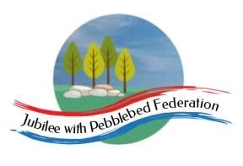
Learning
from Home

Year: Reception  Wk beg: 30/11/2020 | Lesson One | Lesson Two | Lesson Three | Lesson Four | Lesson Five
Monday | Name Practise  Support your child to order the letters of their name using the letter cards in their home learning packs, or magnetic letters if you have them. Then get them to have a go at writing their name. Try to encourage your child to hold the pen/pencil correctly. | Reading  Share your child’s reading book. This can be one from their book bag or from Bug Club. Login details in reading record.  Model reading cvc words together in home learning pack, e.g. s-a-t sat | Maths  Choose a ‘Found how many by counting’ activity. Please adapt using resources you have at home. | Phonics  Revisit sounds previously taught s a t p i n m d g o c k ck e – see flash cards in home learning pack.  Teach the sound u  https://www.bbc.co.uk/iplayer/episode/p0873129/alphablocks-magic-words-21-meet-alphablock-u  Magic Words: Meet Alphablocks U | Literacy  Draw a picture of a present you would like to get for Christmas.  Extend can you have a go at labelling the picture using your phonic knowledge?  Please cut out your picture using scissors.
Tuesday | Name Practise  As Monday | Reading  Share your child’s class library book from their book bag or share a story that you have at home.  Model reading cvc words together in home learning pack, e.g. s-a-t sat | Maths  Order numerals 1-10. Point to each card and count forwards and backwards. | Phonics  Revisit sounds previously taught s a t p i n m d g o c k ck e u – see flash cards in home learning pack.  Teach the sound r  https://www.bbc.co.uk/iplayer/episode/p08730tw/alphablocks-magic-words-18-meet-alphablock-r  Magic Words: Meet Alphablocks R | Understanding the World  Watch the Christian Christmas Story  https://www.youtube.com/watch?v=FrTFAZPQxpE
Wednesday | Name Practise  As Monday | Reading  Share your child’s reading book. This can be one from their book bag or from Bug Club. Login details in reading record. | Maths  Choose a ‘Found how many by counting’ activity. Please adapt using resources you have at home. | Fine Motor  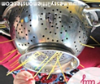  Poke spaghetti or pipe cleaner into the holes of a colander | PE  https://www.youtube.com/watch?v=u0_1QBQ8Syk
Thursday | Name Practise  As Monday | Reading  Share your child’s class library book from their book bag or share a story that you have at home.  Model reading cvc words together in home learning pack, e.g. s-a-t sat | Maths  Order numerals 1-10. Point to each card and count forwards and backwards. | Phonics  Revisit sounds previously taught s a t p i n m d g o c k ck e u r – see flash cards in home learning pack.  Teach the sound h  https://www.bbc.co.uk/iplayer/episode/p0872zvg/alphablocks-magic-words-8-meet-alphablock-h  Magic Words: Meeting Alphablocks H | Literacy  Have a go at writing a letter to Santa.  Write ‘ To Santa’  Stick the picture of what you would like for Christmas in the middle.  Then write ‘Love From…’ in your neatest handwriting.
Friday | Name Practise  As Monday | Reading  Share your child’s reading book. This can be one from their book bag or from Bug Club. Login details in reading record.  Model reading cvc words together in home learning pack, e.g. s-a-t sat | Maths  Choose a ‘Found how many by counting’ activity. Please adapt using resources you have at home. | Phonics  Revisit sounds previously taught s a t p i n m d g o c k ck e u r h – see flash cards in home learning pack.  Teach the sound b  https://www.bbc.co.uk/iplayer/episode/p0872ymg/alphablocks-magic-words-2-meet-alphablock-b  Magic Words: Meeting Alphablocks B | Fine Motor  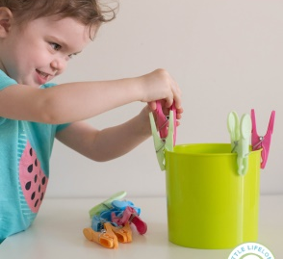  Squeeze pegs around the edge of a container.

