Hub Weekly Challenges 2
Week beginning 27th April 2020
Get Building Challenge  Can you build a catapult? Measure how far your objects fly. Be careful not to fire them near anyone or your pets! | Arty Crafty Challenge  Make a crystal geode egg – crystal geodes using Epsom salts, eggs, glue and food colouring  https://www.parents.com/fun/arts-crafts/kid/how-to-make-crystal-geode-eggs/
The Tasty Challenge  Try making chequerboard biscuits. There is a recipe on Bakingmad.com You will need a ruler for this exercise!  Remember to tell me what you thought of the taste and send me pictures! | Keep Fit Challenge  Can you spot or find the following on your daily walk? You can use a tally, if you find more than one!  Postbox  Blue cars  Bikes  Bird Feeders  Bus  Gnomes  Dogs  Lawn mower  Recycling bins  Bird on a wire  Ladders
Can you find out Challenge?  Where does chocolate come from? | Pass the Parcel Challenge  Continue with your stories, poems and newspaper articles. You have a new one that has been passed onto you this week. You need to write the next paragraph or verse ONLY and then email it back to me. Each week, I’ll pass the stories around….amongst the adults as well! Our writing will grow each week.
Grill a Teacher Challenge  This week’s teacher is Miss Hitchcock.  Email any questions you would like to ask her and I’ll give you the answers next week. Make sure you are polite! | Your turn!  Would you like to set any of the challenges next week? Email me any of your ideas. Maybe you would like to set a Tasty Challenge or the next Keep Fit Challenge. Be creative!
I will email this out to you on a Monday. Please send me an email once a week with any of your responses, pictures etc. By Sunday 2.00pm please if you want your entries to be included. Send me an email to keepintouch@littleham.devon.sch.uk

Mrs Cambridge:
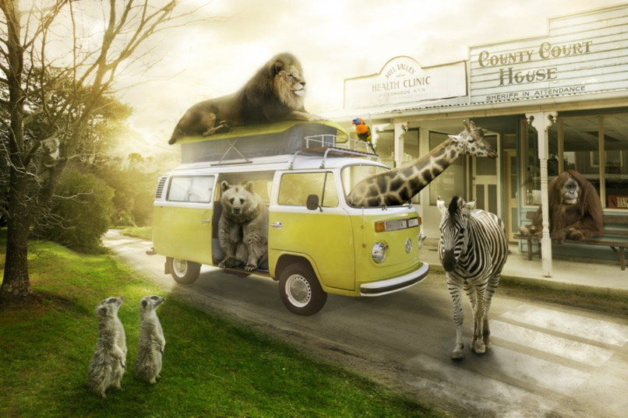
Most visitors are a little shocked (to put it mildly) when they arrive at Animal Town. Despite the fact that the name of the town gives a slight indication to passers-by that the inhabitants of the town are ‘not normal’, it’s as if people don’t believe things until they see them with their own eyes!
Once you get used to being in Animal Town – or so they say – seeing an orangutan behind a desk in a sheriff’s office and upholding the law to an impeccably high standard becomes relatively ‘normal’…
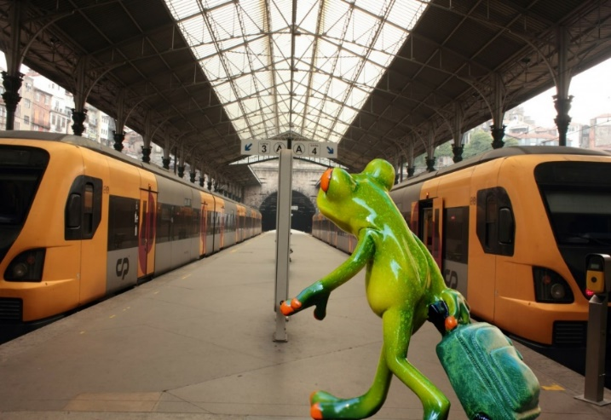
- : There is even a train station that is run by a Rattlesnake called Lucy and her family. They help the other snakes to and from London, Zootropolis and Penzance.
- :

There was an old man with a beard
Who said, “It’s just how I feared!
Two owls and a hen
Four larks and a wren
Have all built their nests in my beard

There was a silly old cat,
He wore a coat, some gloves and a hat,
He ate all day long,
To be big and strong,
But ended up very fat!

A young witch called Nellie,
Made potions that were smellie,
The spells were not right,
As she was not bright,
And she ended up with a sore belly!

Mrs Clark: (You have the headline below. Can you begin the newspaper article?)

I wish there was a law that said………

That adults aren't in charge of children 7 days a week.
For one day, children have free reign. They can choose what they want to do, and where they want to go, and the adult must adhere to the rules!

In six days there will be no more chocolate in the world….ever! That’s what it said on The Seven Show. Jelly had nearly reached the next level of Zombie Puppy Dash, but hearing this made her plunge the pink puppy into a huge tank of zombie dog food. “Woah! What was that about chocolate….”

Dear Diary,
Today, the doorbell rang, and I eagerly ran down the stairs. By the time I had opened the door, the delivery driver had vanished, but a giant box had been left on my doorstep.
​ The box was too heavy to lift and too big to get through the door. I opened it to find a smaller box inside, covered in chains and padlocks. A note was stuck on the top that said ‘this box of secrets has been hidden for hundreds of years. Look closely and follow the clues’
I sat next to the box for a while, reading the note, wondering how I was going to solve this mystery. A white feather with two black spots on fell from the sky and landed on my foot. I picked it up and looked at it closely. Was this my first clue?

Bleary-eyed, I went downstairs for breakfast, the house was empty, even the furniture had gone.
-I rubbed my eyes. Am I dreaming? But as my eyes adjusted to the morning light creeping in through the slits in the curtains, I realised this was no dream. What was happening? Walking around, in a shocked daze, I noticed dents in the carpet where the furniture had been. There had sat my favourite rocking chair with my fluffy purple cushion; over there had lived my piano with one key missing and beyond had stood my slightly faded sofa. Suddenly, a chill ran down my spine, and turning sharply, I thought I noticed a slight scurry of movement in the corner of the room.

