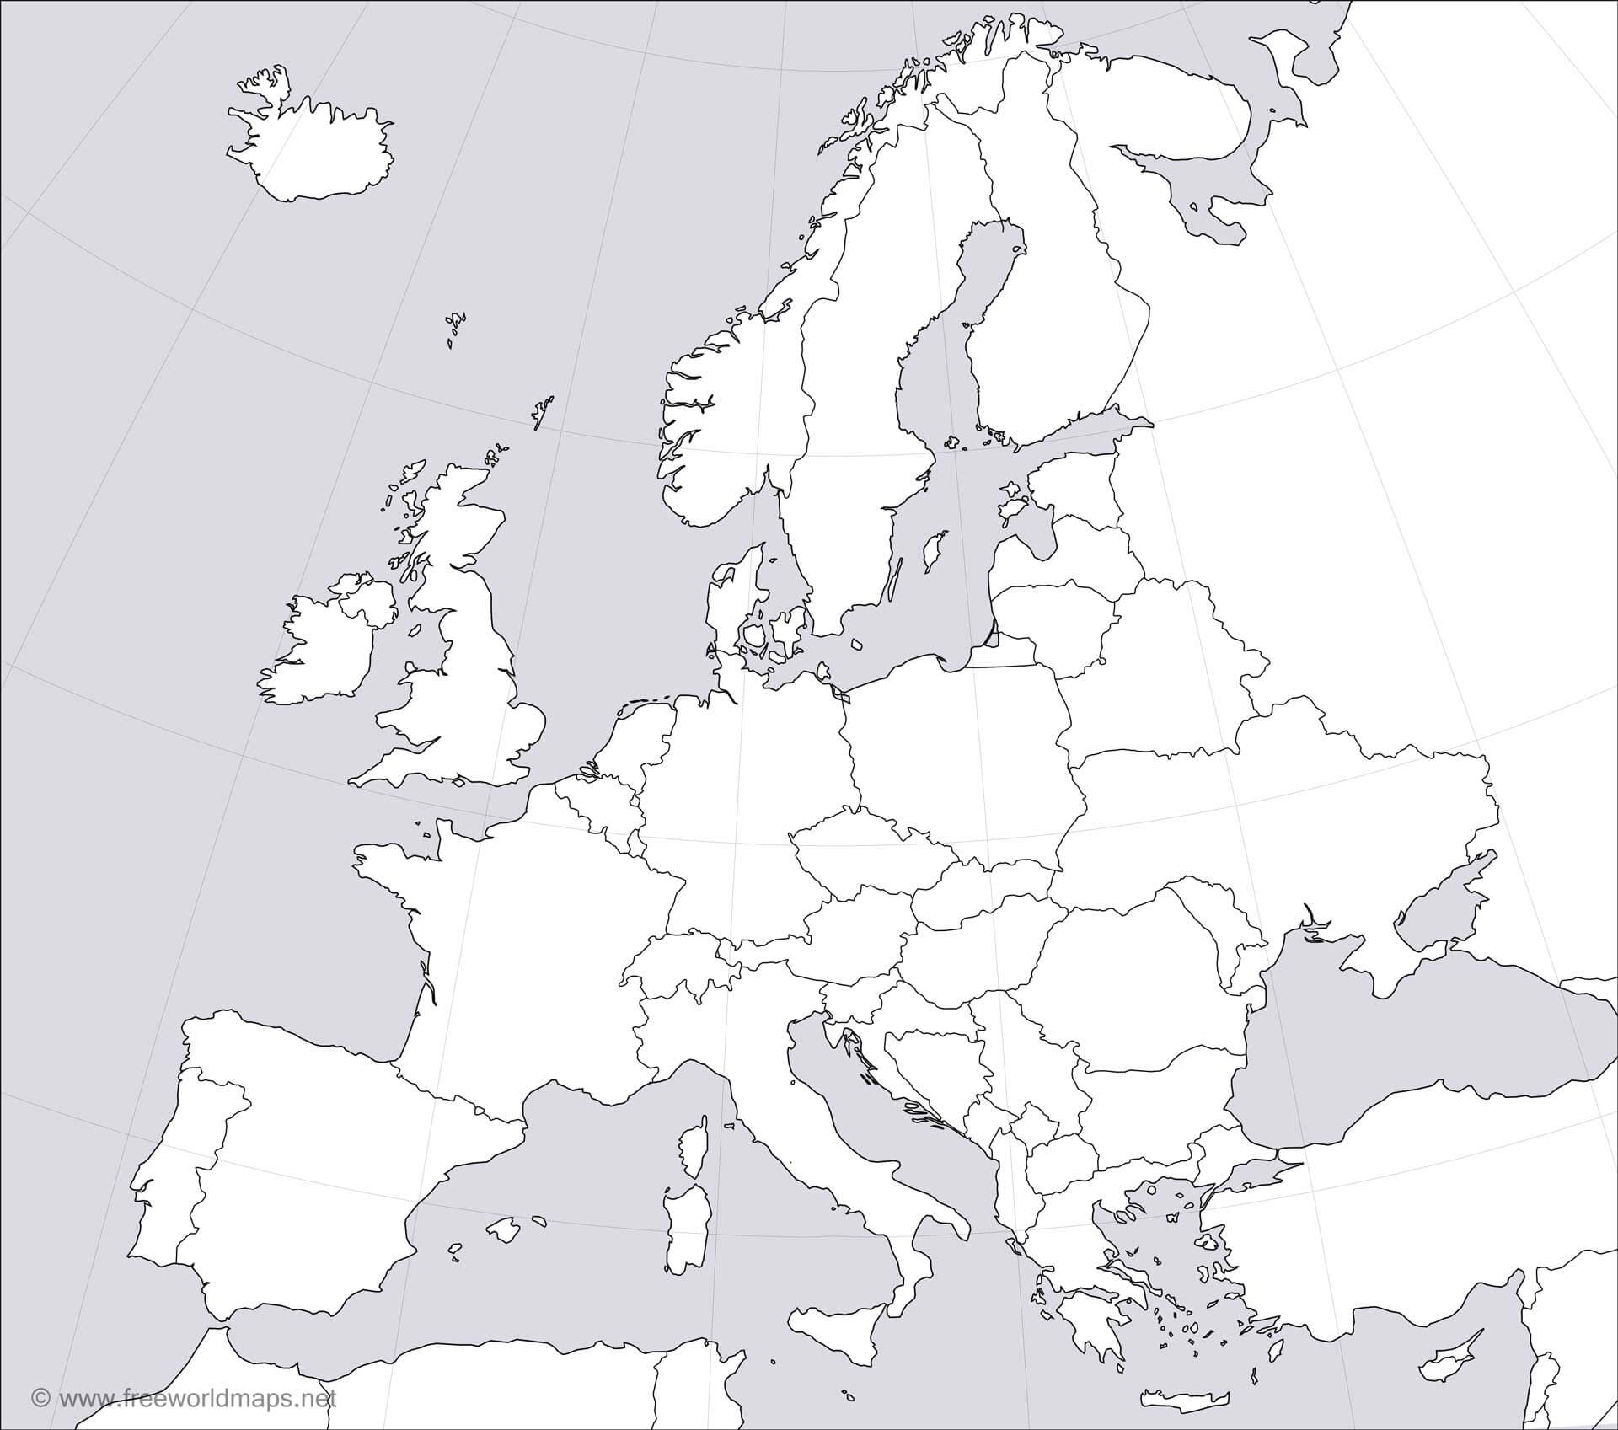

Find the following countries: Put the correct Roman numeral in the correct country.

1. United Kingdom
2. Ireland
3. Iceland
4. France
5. Spain
6. Germany
7. Norway
8. Sweden
9. Italy
10. Denmark
11. Austria
12. Poland

Can you identify any others?