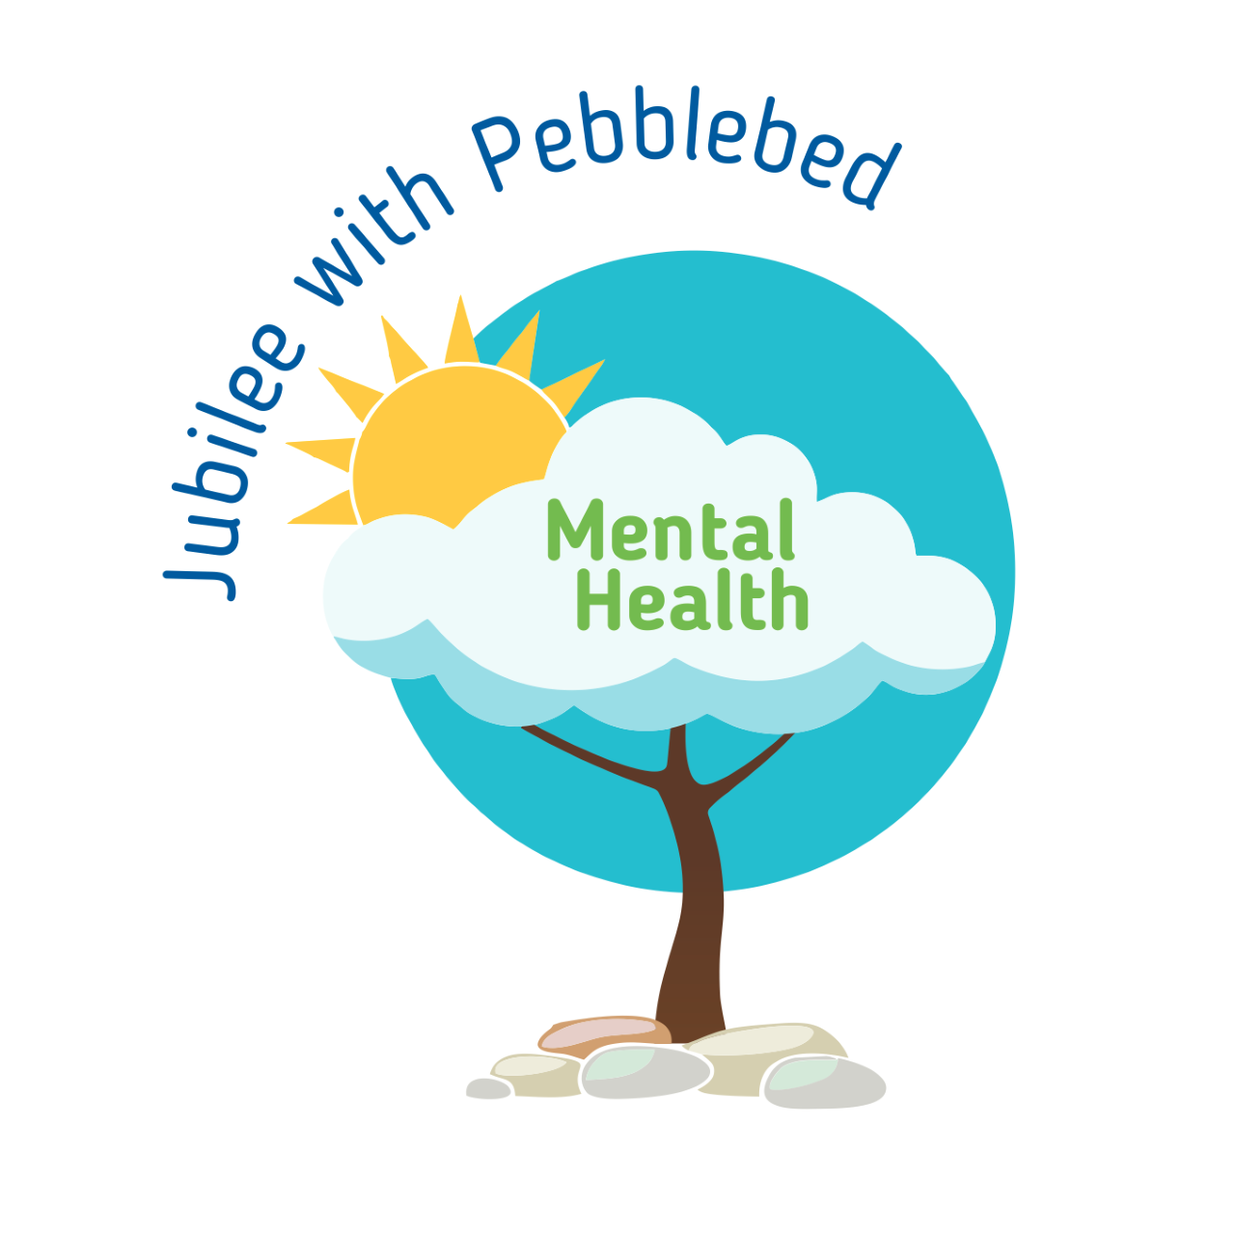
’10 a day’ for Positive Mental Health 4
While we are working from home it is important that you continue to support your mental health. One way of doing this is to continue to use the ’10 a day’.
Below are some activities to try at home this week. Each one is linked to one of our ’10 a day’.
10 a day | Activity
The following link gives information about how to deal with emotions directly linked with the Coronavirus from Exeter Diocese.
https://exeter.anglican.org/wp-content/uploads/2020/03/Covid-19-Primary-School-Parent-Pack.pdf

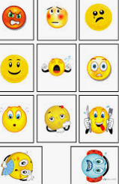
https://www.childline.org.uk/toolbox/
Use these games to think and talk about how you are feeling.
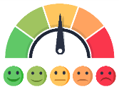
Make your own feeling barometer to show how you are feeling.
Before we can talk about our feelings, we need a vocabulary around feelings and recognising the responses made in our body when we feel this way. Decide on a list of emotions together as a family (happy, sad, frustrated, excited, angry etc.) Can you play charades where somebody acts out an emotion and you guess what it is?
A nurse was worried about the effect that Coronavirus was having on children and how we can explain it to them in a ‘child friendly’ way. She has written a free to download story book called ‘Dave the dog is worried about Coronavirus’.
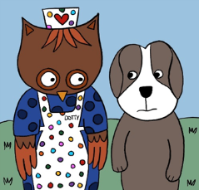
https://nursedottybooks.com/dave-the-dog-is-worried-about-coronavirus-2/
What are you really good at? Ask somebody to record a video of you doing it or take a photo. Share it with relatives or friends. Be proud!
Teach someone in your family to do something you are good at, e.g. drawing, playing an instrument, juggling, maths.

Enjoy colouring together with these relaxing patterns.
https://familyresource.eci.org.uk/download/Colouring-Book-for-Boys-Girls.pdf
Did you know that the recommended daily fluid intake for 5-8 yr olds is 5 glasses (1 litre) and 7 glasses (1.5 litres) for 9-12 year olds.
Measure this out into a large jug and out on the side or in the fridge. Can you empty your bottle/jug by the end of the day?

This week why don’t you try making home-made ice lollies?
Here are some ways to make them if you don’t have lolly moulds.
https://www.thekitchn.com/5-ways-to-make-popsicles-without-a-mold-220407
You can use sugar free squash or fruit juice
mixed with water, you could even
add some fruit!
Help prepare lunch or dinner for the family.
Maybe try some of the recipes from these websites.
https://www.bbc.co.uk/cbeebies/shows/my-world-kitchen
https://www.bbc.co.uk/cbbc/shows/matilda-and-the-ramsay-bunch
https://www.bbcgoodfood.com/recipes/collection/kids-cooking
Challenge yourself to eat a rainbow. Think about the food you are eating, can you eat all the colours of the rainbow in one day?

Exeter diocese has set up a Family Fun Cooking Club. Look at their recipes on the following link.
https://exeter.anglican.org/resources/faith-action/family-fun-cooking-club/

Can you make a fruit kebab?
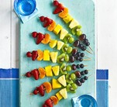
Ask a grown up to chop up lots of different fruit and put it on a kebab stick. Which fruit will you choose? How many colours are in your kebab? Can you make a pattern with the fruit?
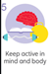 | Can you design an obstacle course in the garden?  You might use boxes, toys, a blanket, sticks, anything you can find to jump over/around/under. Can you see how many circuits you do? Can you challenge other members of your family.  Try some 60 second challenges  https://www.youthsporttrust.org/60-second-physical-activity-challenges  Try some Zumba  https://www.youtube.com/watch?v=doSmJ9AOA1E  On a walk what can you spot, creatures, plants, colours? Play eye-spy as you go.
If you would like some help relaxing try this mindfulness meditation website.
https://www.cosmickids.com/mindfulness-meditation-videos-kids/

Try this technique once a day (or more) Practising it when we are not anxious, helps us to turn to it naturally when we are.
Take 5.
Hold your hand and fingers outstretched in front of you. Trace a line with the finger of your other hand up and down the outline of your hand breathing in through your nose as you go up very slowly and out through your mouth as you come down. Keep it going and repeat if you need to.

Here is a guided video to try. https://www.youtube.com/watch?v=nmFUDkj1Aq0

Dragon Breathing
Breathe in through the nose as far as you can, Breathe out through the mouth sticking your tongue out, making a noise in the back of your throat like a dragon breathing. Hold the breath for as long as you can before breathing in through the nose quietly again. Repeat this 20 times.
Write a letter, email or draw a picture to a relative to send.

Talk to relatives or friends on the phone or video call.

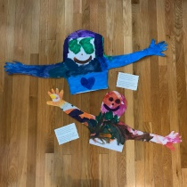
Ask a relative to teach you something, read you a story or help with your school work over a video call.
Send a relative or friend a HUG in the post. Lie down and ask a grownup to draw around your head/arms/shoulders on a large sheet of paper. Paint/draw/colour it and then cut it out. Send your hug in the post for a relative or friend.
If you are stuck on your home learning or with you feelings ask someone for help. If you can’t put it into words write it down or draw pictures.
- Remember, it's okay to ask for help. Don't be embarrassed, and don't worry about other people judging you.
- Decide what the problem is and what help you need.
- Think about who you can ask for help. Choose someone you trust and who will know how to help you.
- Think about what you'll say when you ask for help. Do it.
Read the story ‘The Huge Bag of Worries’ by Virginia Ironside. If you don’t have the story, you can watch somebody read you the story by following this link: https://www.youtube.com/watch?v=CDrnuPj7xfs
Keep diary of all the positive things you do each day.
Show a family member something you have done that you are proud of.
What are your star qualities? What makes you you? You can either draw around your hand and cut it out, writing your special qualities on each finger OR you could print or draw a star and write your star qualities on each point of the star.
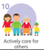 | Help in the house by doing the washing up, setting the table, tidying your room.  Keep a calendar of your acts of kindness  https://www.redcross.org.uk/-/media/documents/get-involved/teaching-resources/power-of-kindness-calendar-blank.pdf?la=en&hash=402E801F6375AAD2E662B84465004F931998A9A0  Go outside of your house into your street and clap for the NHS workers on a Thursday night at 8 o’clock each week.  When you do kind things, you feel good about yourself. You get to see that what you do means a lot.

