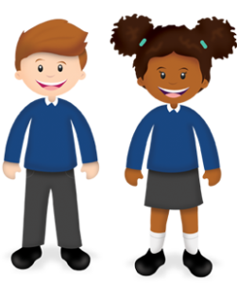
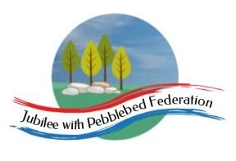
Learning
from Home

Year: 5  Wk beg: 7.12.2020 | Lesson One | Lesson Two | Lesson Three | Lesson Four
Monday | SPAG  https://classroom.thenational.academy/lessons/to-explore-simple-and-compound-sentences-6hk3ed  practise some of your own sentences  EXTRA-CREATE COMPOUND SENTENCES LINKED TO EITHER OUR SCIENCE, OR ANCIENT EGYPTIAN TOPIC | MATHS  https://classroom.thenational.academy/lessons/rounding-2-and-3-digit-numbers-to-the-nearest-10-6gu3er  Create problems to solve.  Practice your next times table. Remember the sort of games in class we do. | SCIENCE  www.bbc.co.uk/bitesize/clips/zsjd7ty  Watch the clip and try out some of the suggestions. What is going on? Be prepared to talk about what you have found out in class. | PE  Create your own workout programme, which you can present to the class, as a warm up session. E.g. Different pathways, star jumps, an imaginative 1 minute aerobic exercise. A stopping and starting routine. Be creative! There is always Joe Wicks to follow.  .
Tuesday | SPELLING  https://classroom.thenational.academy/lessons/to-investigate-c-making-soft-and-hard-sounds-74wk0c | ENGLISH  Listen to the poem Bethlehem.  https://www.youtube.com/watch?v=DYPl3oO67wk  Imagine you were there, what would you see, hear, smell, feel? Write a letter home to tell them about the events. | MATHS  https://www.bbc.co.uk/bitesize/topics/zy2mn39/articles/zr3ytrd  Watch the clip and write 5 of your own, remember to solve them! | FRENCH  Revise the colours you have learnt!
Wednesday | SPELLING  https://classroom.thenational.academy/lessons/to-practise-and-apply-knowledge-of-c-making-soft-and-hard-sounds-including-test-75h64e | ENGLISH  Adverbs and adverbials PowerPoint | MATHS  https://www.bbc.co.uk/bitesize/articles/zqhkg7h | HISTORY  https://www.bbc.co.uk/bitesize/topics/zg87xnb/articles/zr7qy9q  Think about what remains of Ancient Egypt, what do the remains tell us?
Thursday | READING  Reread a chapter of you book, pick out ten words which you think are powerful words that you could use in your own writing. Write them down in your own sentences. | ENGLISH  https://classroom.thenational.academy/lessons/to-write-prepositional-phrases-6th38e | MATHS  https://classroom.thenational.academy/lessons/subtracting-using-the-column-method-6xj32d | DT  Build your own pyramid like the Ancient Egyptians. You could build it out of Lego, boxes etc
Friday | READING  Look at the beginning of a story. How does the story hook you in at the beginning? Make a list of words and phrases that you feel are effective in making you want to read on. | ENGLISH  https://www.youtube.com/watch?v=DYPl3oO67wk  Then watch:  https://www.bbc.co.uk/bitesize/topics/zvwwxnb/articles/zshfdxs  Where would you use a semi-colon in the poem? | MATHS  https://classroom.thenational.academy/lessons/problem-solving-using-the-column-method-c8up6c | RE  https://classroom.thenational.academy/lessons/where-do-muslims-worship-6dgp6d

