Hub Weekly Challenges 16
Week beginning 25th January 2021
Robotic Japan! Week 3  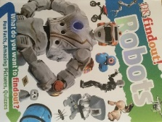  This week, I would like you to find out about a certain type of robot. There is a choice of robotic dinosaurs, robotic animals, or the robotic car. I bet you can guess who I was thinking of when I chose these!  Use my worksheet to help you. You’ll notice, I’ve only included half the picture/diagram – you’ll have to finish it. Make sure you add labels. I’m looking forward to seeing your Star Fact and your Did you Know…? section. | Penpal Challenge  Enjoy reading your letters from your pen pals. Can you write back? I’m sure you have lots to tell them about Christmas, New Year and working from home.
It’s Quiz Time
It’s time to do the quizzes that you set for each other last week! Have fun! Remember to read the pages from the book first.

The Tasty Challenge  Have a go at making Japanese DIY tuna sushi hand rolls. These look really exciting to make.  https://www.kidspot.com.au/kitchen/recipes/tuna-sushi-roll-recipe/j9ja4iet | What are the Pros & Cons of using Robots?  Watch the following youtube clips of using robots in Japan:  Japan's Robots: Robots used in care for the elderly - YouTube  Robots help paralyzed people walk - YouTube  Where hotel is staffed by robots - BBC Click - YouTube  Can you think of all the positive and negative reasons for using them? Can you write them down for me? You can use pictures to support your ideas.
Arty Crafty  Can you do some Japanese writing? Symbols or pictures represent meaning instead of letters. Kanji are used for writing nouns, adjectives, adverbs and verbs. But unlike the Chinese language, Japanese cannot be written entirely in kanji. Hiragana and katakana, each consisting of 46 syllables, are used too.  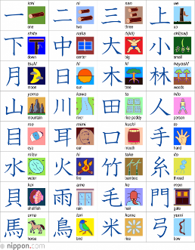  The writing is written vertically in columns going from top to bottom, from right to left.  You can see the sheet on Google Classrooms. | Maths Madness  - Complete Puzzle 74. Anyone for tennis? Can you work out which children play the game?  - Learn how to play the card  game 31. You can watch this video to help you.  How To Play 31 (Card Game) - YouTube  - ‘Play Stuck in the Mud’ with your dice. I wonder who will get the highest score?
Would you rather…?  Would you rather live with 7 cows in your living room or a panda in your bedroom?  Can you explain the reasons for your choice? | Stay healthy!  Make sure you do some Funfit at home. My challenge to you is to find some things to use as markers. Can you bounce a ball around the markers keeping control of the ball? You could try this with a balloon inside seeing how long you can keep the balloon in the air as you move around.  Or you could log onto PE with Joe on a Mon, Wed and Fri morning at 9.00 on youtube or you can play them back at any time.  Remember to take a break. If you would like some help relaxing try this mindfulness meditation.  https://www.youtube.com/watch?v=nmFUDkj1Aq0  Don’t forget it’s important when learning from home to sometimes find a quiet spot to dream and imagine. Be like a unicorn and create  stories, dream up new ideas  and use your imagination.
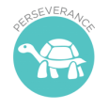
Collective Worship
Our value this half term is Perseverance. “Let us run with perseverance the race that lies before us. Let us keep our eyes fixed on Jesus, on whom our faith depends from beginning to end.” Hebrews 12 v1-2
Log onto the youtube page of exmouthcoastalchurches to find our weekly collective worship or look on Google Classrooms.
There’s also a sheet full of ideas on Google Classrooms for you to do together with your family.
It’s Game Time  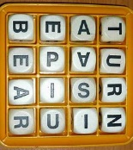  In your home learning box this week, I’ve sent you home with some games to play.  Have fun!  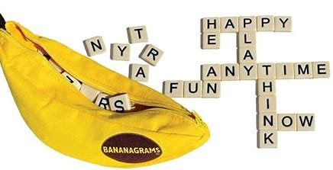 | Your turn!  Would you like to set any of the challenges next week? Send me any of your ideas. Maybe you would like to set a Tasty Challenge or the next Would You Rather. Be creative!
Parents, please be aware that when accessing the youtube clips I post, that adverts could pop up. It is always advisable to have your home security filters on. Please let me know if there are any issues.
This will be on the school website and on Google Classrooms by 8.30am every Monday. Please send me your responses and pictures by Friday 4.00pm please if you want your entries to be included in our Hub Exhibition. Send me an email to hubteacher@littleham.devon.sch.uk or reply in Google Classrooms.

