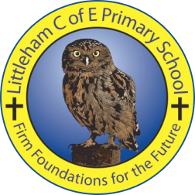
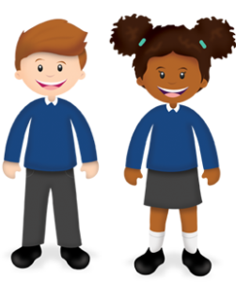
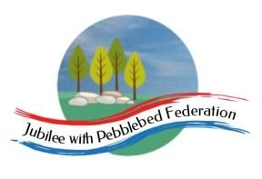
Year 5
Learning from Home

Year:  Week beg:  15/3/2021 | Lesson One | Lesson Two | Lesson Three | Lesson Four
Monday | Science  https://www.youtube.com/watch?v=LroX6ThIDpw  Draw a compass that shows the four main points of the compass and position it to point at where you think north, south, east and west are. Find objects at home and identify which direction they are facing. If you can take a photo or draw pictures with the direction. | PE  Get your heartrate up! Try some PE with Joe Wicks  https://www.youtube.com/watch?v=OozWcmne_eM | Maths and Movement  Work through Day two – Movement Multiplications on the PowerPoint. Remember that multiplication and division are the inverse of each other. Look at the activity sheet and think of ways to use movement when multiplying and dividing. | Back to School Booklet  Complete the What’s been going on sheets about what your life has been like during lockdown.
Tuesday | English and Art  Look at the picture of the open-roof house. What are they looking at? How do you think they feel?  Think about a place or a time when you have felt most safe. Where do you feel the safest? The happiest? What do you do there?  Draw a picture of your happy place and label it with what makes it happy. | Maths and Design Technology  Work through Day three – 3-D sculptures on the PowerPoint. Look at the pictures of sculptures by Anthony Gormley. How do you feel today? Make a shape that shows that feeling using your body. How could you represent this as a sculpture? If you can use strips of cards to create your own sculpture – use the examples to help you. If you have no card, draw a picture of what your sculpture would look like. | PE  Try some Yoga!  Cosmic Kids – Yoga to make you smile!  https://www.youtube.com/watch?v=axpPQfiGsuA | PSHE  Eat Well Live Well Lesson 1 https://classroom.thenational.academy/lessons/life-is-all-about-balance-crwk6r
Wednesday | English and Design Technology  This week we will be looking at how people act on their ideas. Look at the Save the Children logo. Save the Children is a charity that began in the UK to improve the life’s of children around the World.  Watch the poem:  https://www.youtube.com/watch?app=desktop&v=4cOBUxT7PxQ&ab  Whose experience in Lockdown was most like yours? Whose was most different?  Follow the Tabernacle sheet to create your own Tabernacle (a place of worship), on the outside draw and colour your home and on the inside draw, write and colour things that you have missed during lockdown. | Maths and The History of Numbers  Work through Day four – Hieroglyph place value on the PowerPoint. Choose one of the four or 5 digit numbers represented by hieroglyphs and decode the symbols. Repeat for other numbers.  Challenge: You could create your own symbols for each one. | Outdoor Learning  Have a look at the activity Map your patch.  Create a detailed map of your journey from home to school. | Art  Draw a lighthouse. Use this video to help you!  https://www.youtube.com/watch?v=06iZ65pFijU
Thursday | English and Drama  Read the Bell Pepper by Rakshan Rizwan.  Act it out! If you can ask your grown up to take photos of you acting the poem out and then send them to the year 5 email address. | Maths Maths and Patterns  Work through the Day Five – Celtic Knots on the PowerPoint.  - Assemble one of the Celtic Design  - Create your own Celtic design | Project work  Look at the inside of the lighthouse, think about the different rooms and the items inside them. Create a detailed sketch of the inside of a light house, annotate around the outside what you have included and why.
Friday | English and Art  Look at the portraits and think about the portrait questions. If there are any words that you don’t know you can find them in the glossary sheet. Then think of a person that is special to you, create a portrait of that person thinking about posture, gesture and the background. | Maths  Coded Hundred Square Investigation  The hundred square is written in code, it begins at 1 and ends at 100. Can you complete the square?  https://nrich.maths.org/6554 | Reading  Choose your favourite book, what did you like about it? Write a blurb about the book that would make it even more appealing to a reader. | ICT  https://classroom.thenational.academy/units/web-page-creation-0205  If you have not looked at this unit yet start on Lesson 1, if you have been working though these during lockdown today’s lesson is How does it look?
Reading
This week I would like you to read for 20 minutes every day. You can read a book at home or you can access a book through
https://www.getepic.com/
If you have not already logged in the code is: Jla6766
Click on your character and explore the books in your AR band, have fun!

Please be aware that your home filter may allow unsuitable links to pop up when watching any YouTube videos.

Please remember to send in your work to the year 5 email address: Y5Teacher@littleham.devon.sch.uk

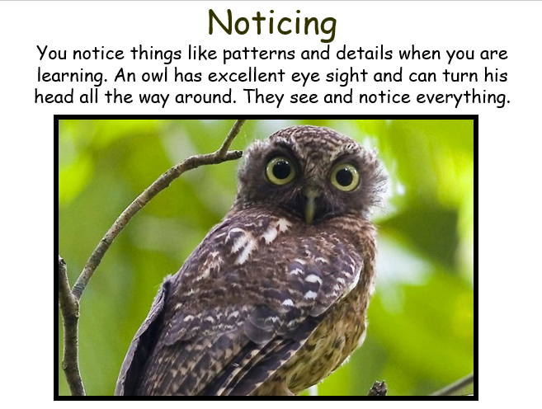
This week’s learning animal is the owl. The owl is good at noticing patterns and details which helps it to learn. Look for times when you are learning like an owl!

