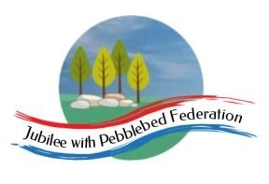
Year 5
Learning from Home

Year:  Week beg:  26/4/2021 | Lesson One | Lesson Two | Lesson Three | Lesson Four
Monday | PE  https://www.youtube.com/watch?v=bcNhWa18nuE&t=2s  Try some Yoga! It was Earth Day last week and this Cosmic Yoga is all in honour of the Earth! | English  https://www.youtube.com/watch?v=TbQSdapmALw | Maths  Spend some time working on your times tables you can do this using TT Rockstars or Hit the Button.  https://www.topmarks.co.uk/maths-games/hit-the-button | Science  What does biodegradable mean and which types of materials are biodegradable?  A material which is biodegradable can decompose (rot away) making it less harmful to the environment. Which of these objects do you think are biodegradable when they are buried in soil.?  Newspaper, apple cores, banana skins, bread, crisp packets, socks and toy car  How could you investigate this? Write about how you would investigate which of the items are biodegradable and make predictions about what you think could happen to each one.
Tuesday | Spelling  Suffixes  https://classroom.thenational.academy/lessons/to-investigate-suffixes-plurals-64r36d | English  Verb Forms  https://classroom.thenational.academy/lessons/to-explore-being-verbs-6mr68r?from_query=verb+forms+AND+is_sensitive%3Afalse | Maths  Short Multiplication  https://classroom.thenational.academy/lessons/short-multiplication-c8v64c | PE  Get your heartrate up! Try some PE with Joe Wicks  https://www.youtube.com/watch?v=WhnRJbSNyfM
Wednesday | Spelling  Suffixes  https://classroom.thenational.academy/lessons/to-practise-and-apply-knowledge-of-suffixes-plurals-including-test-cgwket | English  Expanded Noun Phrases  https://classroom.thenational.academy/lessons/to-explore-expanded-noun-phrases-64r3ec | Maths  Short Multiplication  Using the short multiplication method complete the Multiplication Challenge sheet, choose from sheet 1 or 2. | Art  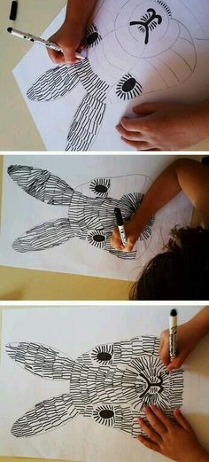  Look at any plants, fruits, vegetables or flowers that you have at home. Sketch them carefully and then colour them using coloured pencils.
Thursday | Spelling  Suffixes  https://classroom.thenational.academy/lessons/to-investigate-suffixes-ate-en-ify-ise-6xj62t | English  Punctuating sentences using commas  https://classroom.thenational.academy/lessons/to-revise-complex-sentences-cct34c?from_query=commas+AND+is_sensitive%3Afalse | Maths  Short Multiplication  Using the short multiplication method complete the Multiplication sheet | Allotment  Where does your food come from? Look at different food suppliers e.g. supermarket, market, greengrocer. Where do they source their fruit and vegetables from? Look at the labels of some food that you have at home, where do they come from? Find put where your fresh vegetables and fruit come from.
Friday | English  Punctuating speech  https://classroom.thenational.academy/lessons/to-practise-speech-punctuation-rules-cdj34e?from_query=speech++AND+is_sensitive%3Afalse | Maths  Multiplication reasoning  Please complete the Multiplication Reasoning sheet | ICT  Variables in Games – Lesson 2  Variables in Programming  https://classroom.thenational.academy/lessons/variables-in-programming-cmtpad | Spelling  https://classroom.thenational.academy/lessons/to-practise-and-apply-knowledge-of-suffixes-ate-en-ify-ise-suffixes-including-a-test-60r30e
Reading
This week I would like you to read for 20 minutes every day. You can read your reading book, a book at home or you can access a book through
https://www.getepic.com/
If you have not already logged in the code is: Jla6766
Click on your character and explore the books in your AR band, have fun!

Please be aware that your home filter may allow unsuitable links to pop up when watching any YouTube videos.

Please remember to send in your work to the year 5 email address: Y5Teacher@littleham.devon.sch.uk

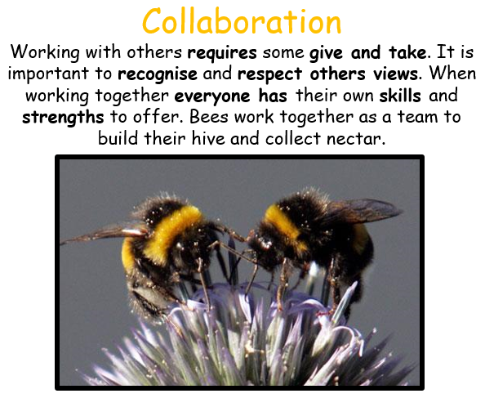
This week’s learning animal is the bee. The bee works with others. They recognise and respect others views! Look for times when you are learning like a bee!

