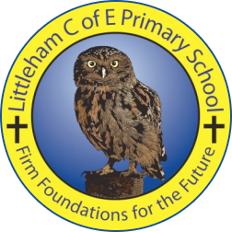
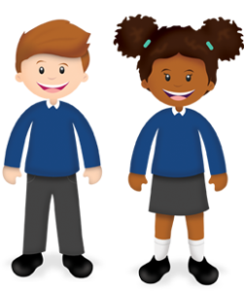
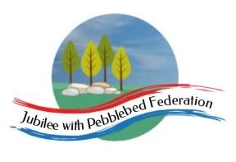
Learning
from Home

Year: 5  Wk beg: 16.11.2020 | Lesson One | Lesson Two | Lesson Three | Lesson Four
Monday | SPAG  https://classroom.thenational.academy/lessons/to-explore-simple-and-compound-sentences-6hk3ed  practise some of your own sentences  EXTRA-CREATE COMPOUND SENTENCES LINKED TO EITHER OUR SCIENCE, OR ANCIENT EGYPTIAN TOPIC. | MATHS  https://classroom.thenational.academy/lessons/rounding-2-and-3-digit-numbers-to-the-nearest-10-6gu3er  Create problems to solve.  Practice your next times table. Remember the sort of games in class we do. | SPAG  www.bbc.co.uk/bitesize/clips/zsjd7ty  Watch the clip and try out some of the suggestions. What is going on? Be prepared to talk about what you have found out in class. | PE  Create your own workout programme, which you can present to the class, as a warm up session. E.g. Different pathways, star jumps, an imaginative 1 minute aerobic exercise. A stopping and starting routine. Be creative! There is always Joe Wicks to follow.
Tuesday | SPELLING  https://classroom.thenational.academy/lessons/to-investigate-suffixes-plurals-64r36d | ENGLISH  https://classroom.thenational.academy/lessons/to-edit-a-non-chronological-report-6cv3jt | MATHS  https://www.bbc.co.uk/bitesize/articles/zkfyhcw  Activity 1 | HISTORY  https://www.theguardian.com/childrens-books-site/gallery/2016/may/01/pharoahs-tomb-ancient-egypt  Read the article and create a poster/PowerPoint to show what a pharaoh would have in their tomb and explain why.
Wednesday | SPELLING  https://classroom.thenational.academy/lessons/to-practise-and-apply-knowledge-of-suffixes-plurals-including-test-cgwket | ENGLISH  UFO hoax sheet | MATHS  https://www.bbc.co.uk/bitesize/articles/zkfyhcw  Activity 2 | PSHE  https://classroom.thenational.academy/lessons/i-roll-with-my-role-65h3gr
Thursday | READING  Write a review for your favourite book. What did you like about it? Why? Who was your favourite character? Would you recommend this book? Why? | ENGLISH  Write up your UFO encounter as a first person account | MATHS  https://www.bbc.co.uk/bitesize/articles/znggp4j  Activities 1 and 2 | GEOGRAPHY  https://classroom.thenational.academy/lessons/why-are-rivers-important-to-people-6cv3cd?
Friday | READING  Draw a picture of your favourite character from a book. Around the picture write words and phrases that describe them, include looks and personality! | ENGLISH  https://www.bbc.co.uk/bitesize/articles/zhxdg7h | MATHS  https://classroom.thenational.academy/lessons/add-and-subtract-fractions-with-a-common-denominator-68vpae | RE  https://classroom.thenational.academy/lessons/what-are-the-five-pillars-of-islam-70t6cd

