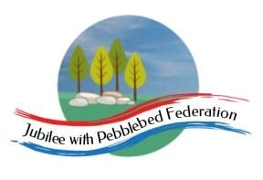
Year 5
Learning from Home

Year:  Week beg:  10/5/21 | Lesson One | Lesson Two | Lesson Three | Lesson Four
Monday | Spelling  https://classroom.thenational.academy/lessons/to-investigate-homophones-69jk0r | PE  Cosmic Yoga  Yoga for your mental health  https://www.youtube.com/channel/UC5uIZ2KOZZeQDQo_Gsi_qbQ | Science  The life cycles of plants  Look at any plants that you have at home.  Draw examples of some of these and then annotate with the different parts of the plant. Make sure you include these: seed, roots, stem, flower, leaves and remember to explain what they do. | RE  What would Jesus do?  Do you know the commandments that God gave to us? One of the most important is: Love God and your neighbour.  Think about these questions:  Who is our neighbour? What is better: Kindness or mocking, generosity or greed? What would you do if you ran out of food at a party and it looked like not everyone would be fed?  Watch the Feeding of the 5 thousand.  https://www.youtube.com/watch?v=S6rj9cAJrWE  What are your thoughts? Remember to record your answers.
Tuesday | Spelling  https://classroom.thenational.academy/lessons/to-practise-and-apply-knowledge-of-homophones-including-test-6xk36d | English  Paragraphs  https://www.bbc.co.uk/bitesize/articles/zc6ftrd  Activity 1 | Maths  Division  https://classroom.thenational.academy/lessons/using-multiples-to-divide-6cw3gd | Allotment  Where does your food come from? Look at these everyday foods: bananas, oranges, sweetcorn, grapes and rice. Where do they come from? How many miles do they have to travel to get to us? Look at a meal that you have eaten today. Where did the ingredients come from (which country!), work out how far the food in that meal had to travel to reach your plate!  Why did it have to travel so far? Why can’t we grow those items in our country?
Wednesday | Spelling  https://classroom.thenational.academy/lessons/to-investigate-more-prefixes-6nj3cr | English  Paragraphs  https://www.bbc.co.uk/bitesize/articles/zc6ftrd  Activities 2 and 3 | Maths  Division  https://classroom.thenational.academy/lessons/short-division-6gt64d | PE  Get your heartrate up! Try some PE with Joe Wicks  https://www.youtube.com/watch?v=WhnRJbSNyfM
Thursday | Spelling  https://classroom.thenational.academy/lessons/to-practise-adverbial-complex-sentences-6mt32r | English  Plan your own story in the style of Weslandia using the planning grid on the website | Maths  Division  https://classroom.thenational.academy/lessons/division-with-remainders-ccwk6r | Allotment  Draw a close-up picture of a flower, fruit or vegetable pay close attention to the patterns, textures and colours.
Friday | Spelling  https://classroom.thenational.academy/lessons/to-investigate-more-prefixes-bi-trans-circum-and-tele-69gk4c | English  Write your own Weslandia style story using your planning grid | Maths  Problem Solving and Reasoning  Please complete the division problem solving and reasoning grid on the website | ICT  Variables in Games – Lesson 4  Designing a game  https://classroom.thenational.academy/lessons/designing-a-game-64tpae
Reading
This week I would like you to read for 20 minutes every day. You can read your reading book, a book at home or you can access a book through
https://www.getepic.com/
If you have not already logged in the code is: Jla6766
Click on your character and explore the books in your AR band, have fun!

Please be aware that your home filter may allow unsuitable links to pop up when watching any YouTube videos.

Please remember to send in your work to the year 5 email address: Y5Teacher@littleham.devon.sch.uk

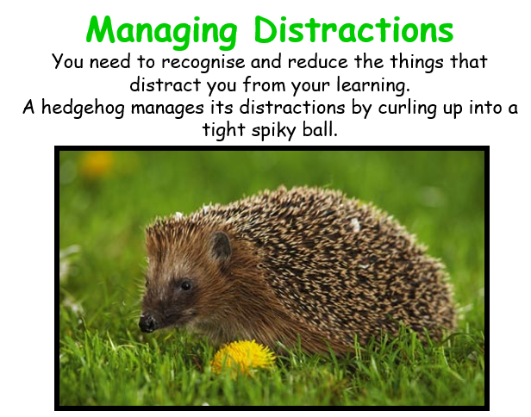
This week’s learning animal is the hedgehog. The hedgehog is great at recognising and managing when it is distracted! Look for times when you are learning like a hedgehog!

