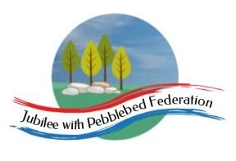
Learning
from Home

Year: 5  Wk beg: 18.1.21 | Lesson One | Lesson Two | Collective Worship | Lesson Three | Lesson Four | Lesson Five
Monday | PE  Either join Joe Wicks for this morning’s workout, or just use this link to get the one from last Friday!  https://youtu.be/l0k6XqfFEUo  Remember that there is nothing quite like getting out and doing some aerobic routines, or practice ball games with others at home.  READING.  Read for 20 minutes or so, trying to work on your expression. | MATHS  Learn multiplication facts.  MULTIPLICATION MASH UP! A FUN WAY TO LEARN YOUR MULTIPLICATION FACTS IN A FUN WAY!  Watch the video and join in!  https://www.youtube.com/watch?v=EgjCLhoI9Mk&authuser=0  If you are confident with your times tables, then time yourself to see how quickly you can complete the activities. | Collective Worship with Mrs Padbury – SEE GOOGLE CLASSROOM | LIVING THINGS AND THEIR HABITATS  The children in class have started taking notes about the creatures they have chosen to study, focusing on ‘Life Cycles.’ (They will look at plants at a later date!)  They include- Silverback Gorilla, The Emerald Tree Boa, Bees, Cheetahs, Dolphins and Jellyfish. Ideal for Exmouth! This week, we will continue to research and make labelled diagrams, ready to either start a ‘Back to Back’ booklet, or a power point.  Let us know how you are getting on and what your choice is. | SCIENCE  Understand how gears work.  https://youtu.be/5kib5aGuq70  Watch the video on how gears work.  Look for examples of gears at home and how they help us.  Then complete the worksheet. The power point might help too. | FRENCH  Learn weather phrases.  Listen to and practice out loud the weather phrases from the clip.  https://youtu.be/G8iBwQUvY-E  Try this song!  https://youtu.be/eBvJVOuBPXI
Tuesday | READING  I was a Rat – Phillip Pullman  Engage with the text  https://classroom.thenational.academy/lessons/to-engage-with-the-text-6mw38c | ENGLISH  Generate synonyms – GO TO GOOGLE CLASSROOM |  | MATHS  Find prime numbers less than 50 - GO TO GOOGLE CLASSROOM | HISTORY  Timeline of Henry’s marriages – write 5 questions about his marriages e.g. Why did he marry 6 times? – GO TO GOOGLE CLASSROOM | GEOGRAPHY  Compare and contrast maps of Tudor London and modern London – GO TO GOOGLE CLASSROOM
Wednesday | READING  I was a Rat – Phillip Pullman  Answer questions on a text part 1  https://classroom.thenational.academy/lessons/to-answer-questions-on-the-text-part-1-cru68t | ENGLISH  Recognise how brackets and dashes are used – GO TO GOOGLE CLASSROOM | Exmouth Coastal Churches - https://www.youtube.com/watch?v=ibcdh2V0VtQ&list=PLqWt6-qhTKHF_Yb18Npn-Ni0kRTQ-9-yp  Look at the playlist on the side for the Collective Worship this week. | MATHS  Revise using grid multiplication to multiply 3-digit numbers by single-digit numbers. – GO TO GOOGLE CLASSROOM | PSHE  Keep yourself hydrated – GO TO GOOGLE CLASSROOM | ART  Create your own portrait as a Tudor miniature – GO TO GOOGLE CLASSROOM
Thursday | READING  I was a Rat – Phillip Pullman  Analyse characters  https://classroom.thenational.academy/lessons/to-analyse-characters-c8w3jt | ENGLISH  Identify a range of cohesive devices – GO TO GOOGLE CLASSROOM | ICE EXETER - https://www.youtube.com/watch?v=gRLxKiuNVxk&list=PLMVzYqJcG7RcD_QgMd3h8XPvG6vhDnGqB&index=7 | MATHS  Use short multiplication to multiply 3-digit numbers by single-digit numbers. – GO TO GOOGLE CLASSROOM | OUTDOOR LEARNING  Think about the video you watched last week, how many birds, animals or insects can you spot from your home? Write down 5 things that you can see and why you think they live there.
Friday | READING  I was a Rat – Phillip Pullman  Answer questions on a text part 2  https://classroom.thenational.academy/lessons/to-answer-questions-on-the-text-part-2-crv66c | ENGLISH  Write an introduction for a villain –GO TO GOOGLE CLASSROOM |  | MATHS  Choose and use the most appropriate method to multiply. – GO TO GOOGLE CLASSROOM | ICT  Using a device  https://classroom.thenational.academy/lessons/using-a-device-6tjkgr | RE  Write a newspaper report about the arrival of the Messiah. – GO TO GOOGLE CLASSROOM
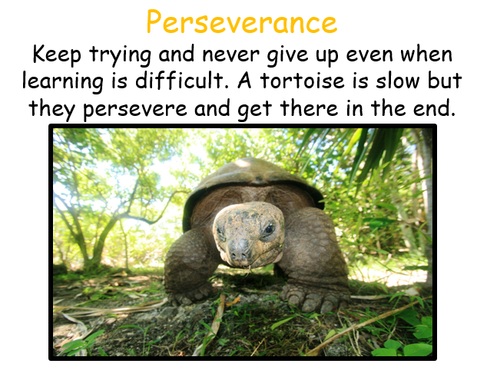
This week our learning animal is the tortoise, please can your adult look for times when you are showing this learning behaviour. If possible, your adult could email any examples of your perseverance to me and I will add them to our class display.

