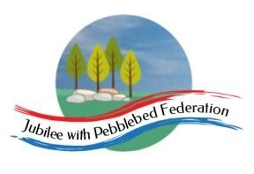
Year: Nursery  Wk beg: 1.2.21 | Lesson One  Literacy | Lesson Two  Learning to write | Lesson Three  Mathematics | Lesson Four  Cross curricular & PSED | Lesson Five  Physical development
Monday | Watch the video of Mrs Phillips reading Jack and The Beanstalk.  Once you have listened again see if your child can tell you the story in their own words. Maybe you could video this to share with Mrs Phillips?! | Today’s mark making challenge:  Copying your name. Have a go at making your name in lots of ways.  Can a grown up write the letters and cut them up for you to put in the right order? Can you have a go at copying some of the letter shapes. Remember only use a capital letter at the start. There is a letter formation guide on the website. | Shape and measures challenge:  On some big paper draw around your child. Now the challenge is to find five things smaller and five things bigger than  you. We’d love to  see some photos  of what  you discover. | Today we are going to carry on with some mental health work. Please watch the second presentation in the Mental Health section on the school website. | Fine Motor:  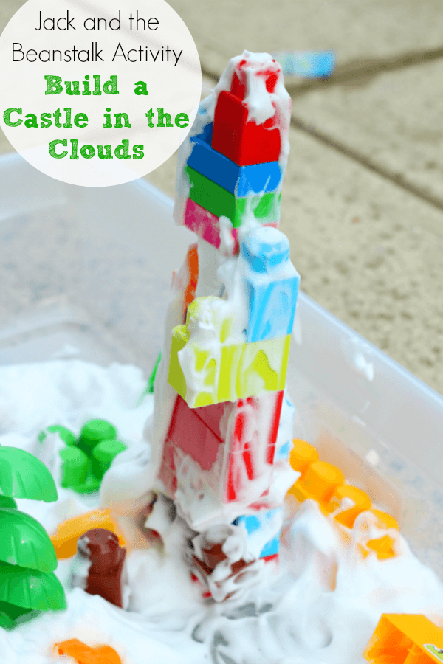Build a tower to the clouds! You can use any building blocks you like. At Nursery we will incorporate some sensory play  by adding  shaving foam  or foam soap  clouds to our  tower.
Tuesday | Watch or read Jack and the Beanstalk again (remember we are aiming for the children to know it off by heart.) There is a document on the website called “Can you label the picture”.  To start have a chat with your child about the picture and all that you can see. Then point out the blank labels and ask your child if they can help you label the picture. Write in the boxes the answers they give you. Please take a photo and send this in via the nursery email address. | Today’s mark making challenge:  Today we will do a name recognition activity. Write your child’s name with them using ideally a candle but you could use a light coloured wax crayon. Then colour over with water colours. If you don’t have watercolours at home you can make some by soaking an old felt tips in a small amount of warm water. | Shape and measures challenge:  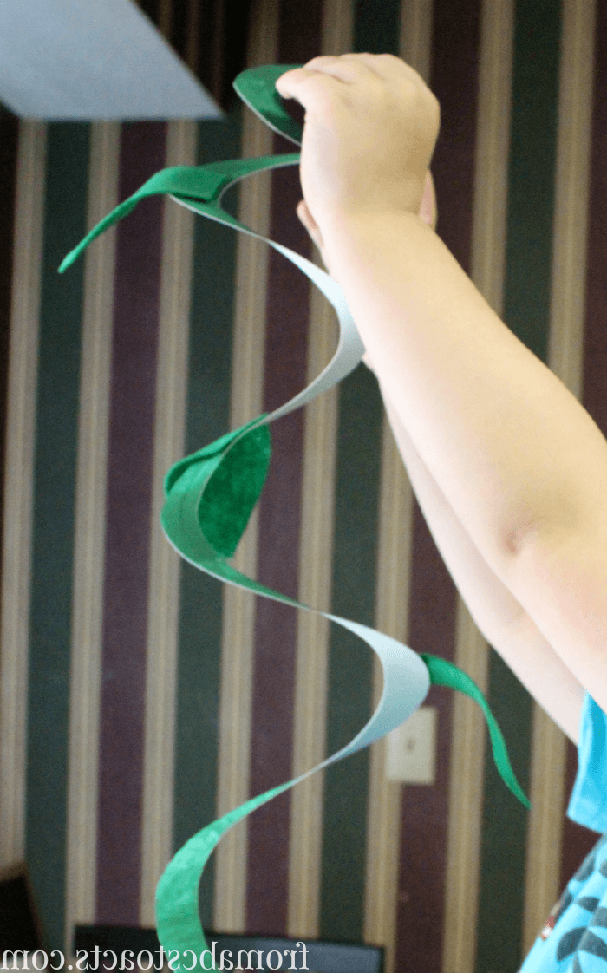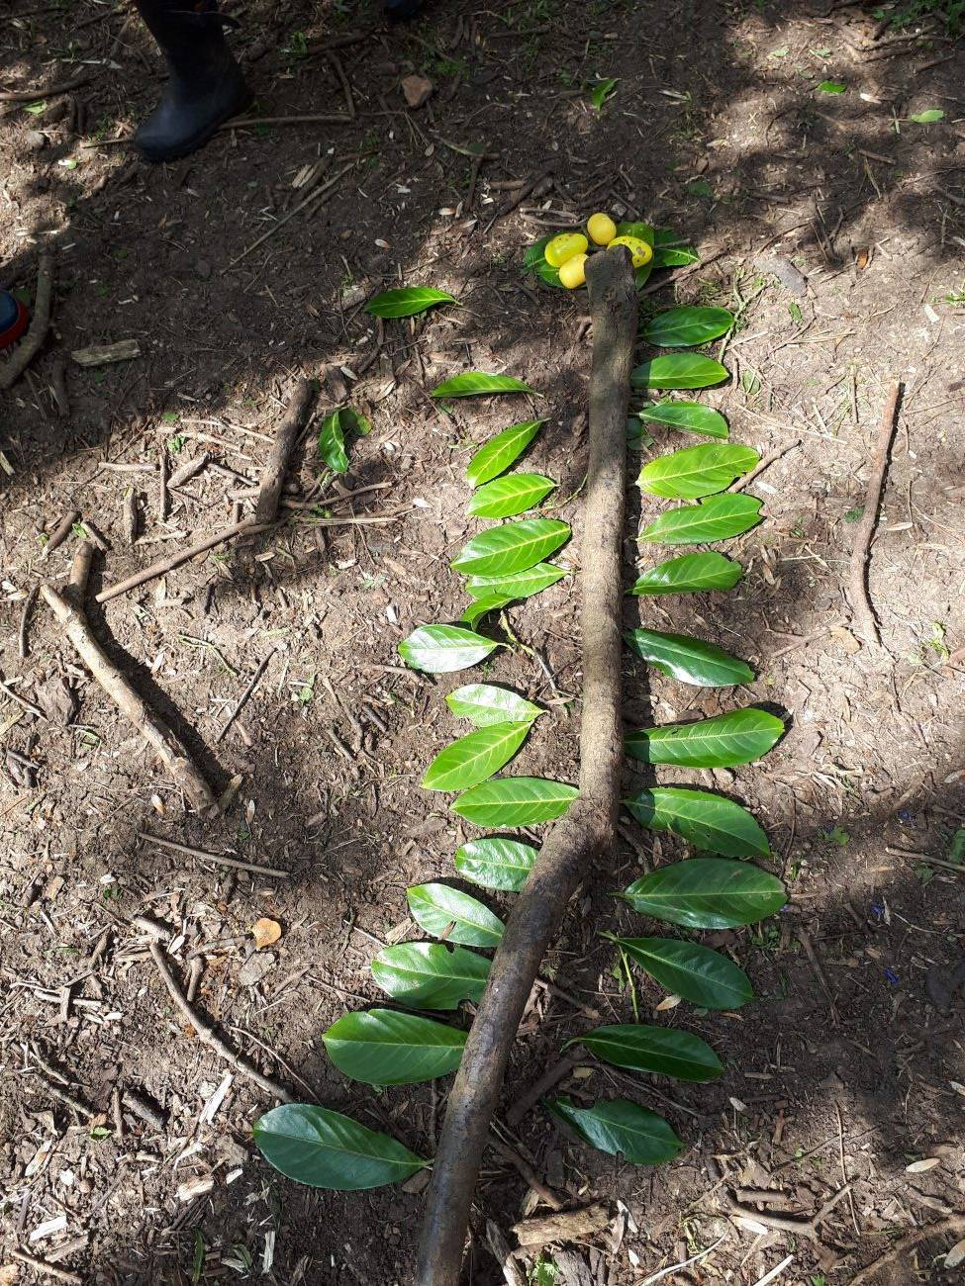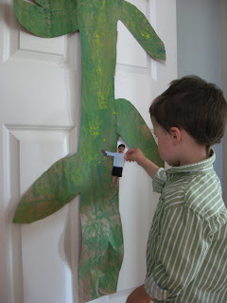Can you make… A beanstalk as tall as you! You could use string and thread paper leaves, you could cut a big paper spiral, you could make a paper chain, whatever you can manage… What did you chose to do? | Can you make some Jack and the Beanstalk role play masks for literacy tomorrow.  Print them on card or print on paper and then stick to card. You can either add a string/elastic to put round your head or a lollipop stick to hold your mask by, Don’t’ forget to cut the eye holes out carefully. | Gross motor:  PE Challenge from your friends in school:  https://www.youtube.com/watch?v=VHbQD7aZQxA&feature=youtu.be
Wednesday | 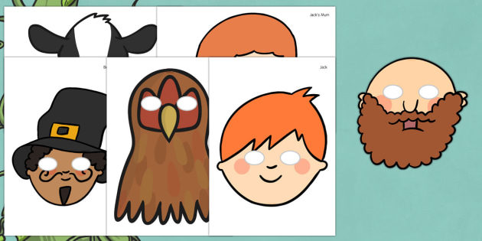Use the Jack and the Beanstalk role play masks to have a go at acting out the story together. | Today’s mark making challenge:  Can you do some more of those fabulous Jack and the Beanstalk colouring pictures today please. Remember colouring realistically and within the lines are big skills for us to learn. | Shape and measures challenge:  Can you do the magic bean measuring activity today. This is to introduce children to using numerals in measuring. The big focus is to try and write the numeral. It can be the nearest numeral don’t introduce the children to halves and quarters yet! | Creative and Fine Motor:  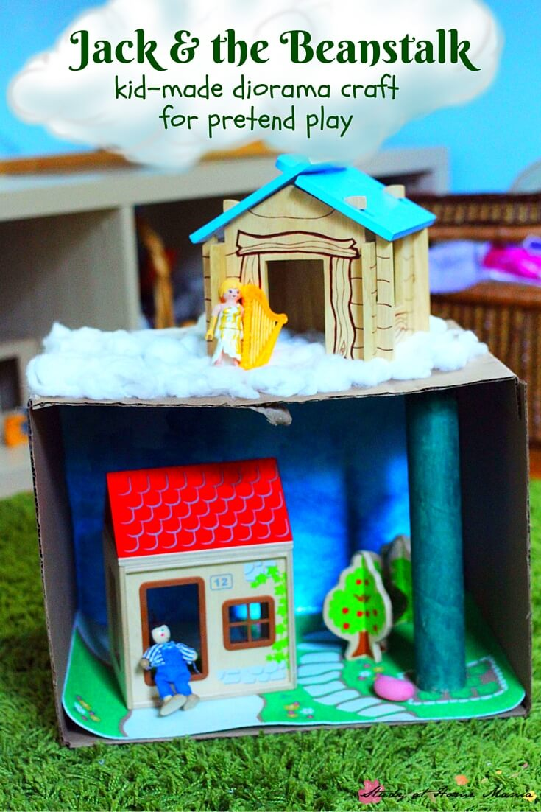Create a scene from Jack and the Beanstalk. There is a guide with some ideas and pictures on the website called Create a story scene.
Thursday | Today’s mark making challenge:  Can you complete page one and two of the “ write and colour Jack and the Beanstalk story” book. Ideally support your child to do this with little help, then under their marks ask them what this part of the story says and write it down underneath. This will cover your mark making challenge today too! (We will do more next week so keep this work.  I’d be super grateful if you could send this work  In to school when it’s all finished next week.  It will be my half term treat! |  | Shape and measures challenge:  Today I would like you to do a rainbow hunt! Send your child to find one thing of each colour (one at a time) once you have a whole rainbow can you talk about their sizes and put them in order big to small. Or short to tall. | This week I wondered if you could do a Walk in the wild challenge. Wild Exmouth have produced some lovely videos showing maps of routes to walk. There is a good 2 mile walk in the Littleham area (click to view)and some others too… Have a look here | Gross motor:  Can you join in with the Jack and the Beanstalk Yoga activity?  https://www.youtube.com/watch?v=SKC_Lgvukv0  Remember YouTube must be checked and monitored by a grown-up before child use.
Friday | Today can you watch or read the story again. Then do the sequencing activity. Cut out the boxes and read them one at a time to your child. Talk about whether it comes at the beginning middle or end. Encourage your child to put the boxes in order and keep re-reading it t them so they can check it makes sense. | Today’s mark making challenge:  I know from feedback from some parents that doing home learning with Nursery children is a massive challenge especially if you have older ones so this is a nice easy activity that can be reused every time you can fit mark making into you day.  Mix liquid soap, food colouring and corn four or talc to make bath paint. If you mix soap and flour in an ice cube tray you can add a different colour to each little section to create a palette. Then let your child paint in the bath or shower! | Shape and measures challenge:  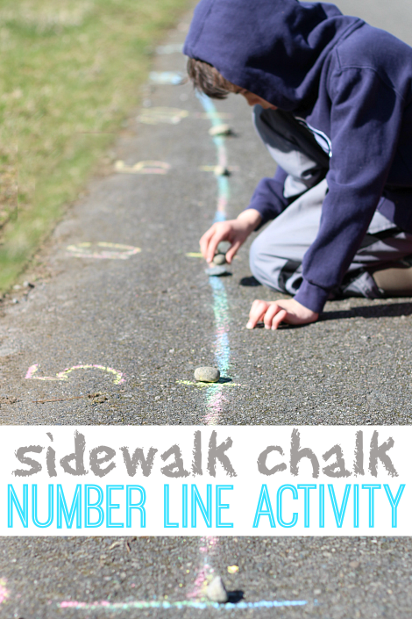Can you do some chalk drawing outside on the foot path draw some short lines and some long lines. Take the opportunity to use lots of shape and measures language with your child. Compare your line and theirs. You could measure you lines with their footsteps  and count  who has  the longest  line. | 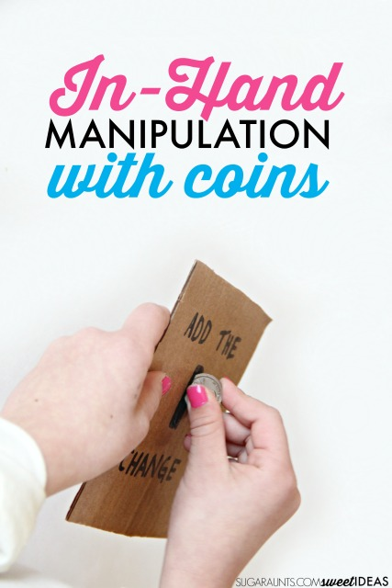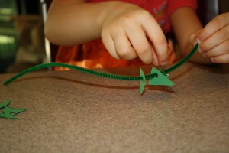Money and Fine Motor: Today if you can I’d like you to play with pennies. It’s surprising how may skills we learn to do with our hands with pennies. Try picking up a penny and “squirreling it away” into your hand… Can your child do this? Turn a coin over between your thumb and two forefingers to see both sides. Can your child do this? Can your child build a tower of coins? Holding a piece of card in one hand can your child post a handful of pennies through a slot? You can read more here if you like.

