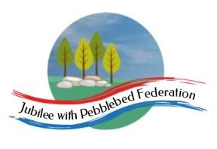
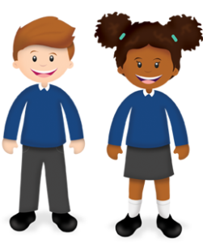
Year 3 Learning from Home Grid

Week Beginning 8.02.21
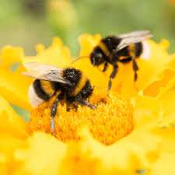 | This week, our learning behaviour is collaboration.  Working with others requires some give and take. It is important to recognise and respect the views of others. When working together, everyone has their own skills and strengths to offer. Bees work together as a team to build their hive and collect nectar.  If possible, please email me with examples of your child showing collaboration.
www.getepic.com.students
Use this website to read free digital books suitable for your child.
I will add some of the books to google classroom.
If you want to explore further, click on AR and choose the numbers at the back of your child’s reading record book.
Monday 8th February 2021 | Reading (30 minutes)  - Complete this week’s reading comprehension assignment by reading the text through and answering the questions on the quiz.  - You can read a book on bug club, your current book from the library or you can read a book of your own.  - I have assigned a digital book on google classroom for you to read. You can go to www.getepic.com/students and enter the class code: goh5518 to choose your own books to read as well.  English (1 hour)  LO: I can look closely at vocabulary used in the text.  Look at the page 'Hatching Out'. There might be some new words in there that you aren't sure about. I have found some of those words for you on the worksheet. Can you use these websites to find the meaning of these words and write your favourite definition next to the word? If there are any other words you do not understand from the page, you can look up the meanings for those too.  https://dictionary.cambridge.org/  https://www.dictionary.com/browse/online-dictionary  https://www.collinsdictionary.com/  Please take a photo and email it back to me at Y3Teacher@littleham.devon.sch.uk  I would also like you to send me the paper sheet when you pick up your next pack next week.  Maths (1 hour)  LO: I can add multiples of 1, 10 and 100 to 3-digit numbers.  256+10=266  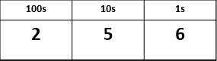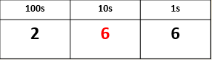  Please complete the allocated work sheet I have sent to you in your home pack or on google classroom. Remember the working out method is just as important as the answer. Please take a photo and email it back to me at Y3Teacher@littleham.devon.sch.uk  I would also like you to send me the paper sheet when you pick up your next pack next week.  Science (1 hour)  https://classroom.thenational.academy/lessons/how-are-organisms-adapted-to-live-in-the-deep-sea-74t64c  How are organisms adapted to live in the deep sea?  In this lesson, we will learn about the deep sea environment and the adaptations that organisms have evolved to survive there. We will also learn about deep sea conservation and create a poster to convince our schools to support this cause.  PE with Joe (30 minutes)  https://www.youtube.com/watch?v=yOvqLXv88L4
Tuesday ^{9th} February 2021 | Reading (30 minutes)  - If you haven’t already, please complete this week’s reading comprehension assignment by reading the text through and answering the questions on the quiz.  - You can read a book on bug club, your current book from the library or you can read a book of your own.  English (1 hour)  LO: I can learn how headings and sub-headings aid presentation.  Read the information on each page/slide.  At the moment, there are no sub-headings to go along with the information..  After you have read the information, can you think of a sub-heading (title) to go with each paragraph?  Write the title at the top of each page on the power point. I have done the first one for you in green.  A sub-heading should be short, simple and tell you what the paragraph is going to be about it. Sometimes, it could jsut be one word to summarise.  Please take a photo and email it back to me at Y3Teacher@littleham.devon.sch.uk  I would also like you to send me the paper sheet when you pick up your next pack next week.  Maths (1 hour)  LO: I can subtract multiples of 1, 10 and 100 to 3-digit numbers.  856-10=846  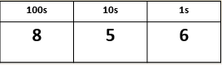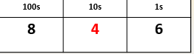  Please complete the allocated work sheet I have sent to you in your home pack or on google classroom. Remember the working out method is just as important as the answer. Please take a photo and email it back to me at Y3Teacher@littleham.devon.sch.uk  I would also like you to send me the paper sheet when you pick up your next pack next week.  RE (1 hour)  https://www.bbc.co.uk/teach/class-clips-video/religious-education-ks2-my-life-my-religion-ramadan-and-eid-ul-fitr/zdv7pg8  Watch the video about Ramadan and the festival of Eid-ul-Fitr:  Research Ramadan and Eid-ul-Fitr some more so that you can answer the following question: Why do people visit the mosque, get new clothes, share food, spend time with friends and family and give money to charity?  Collective Worship (30 minutes)  Please log into you Google classrooms account to view the Collective Worship from Mrs Padbury.
Wednesday 10th February 2021 | Reading (30 minutes)  - If you haven’t already, please complete this week’s reading comprehension assignment by reading the text through and answering the questions on the quiz.  - You can read a book on bug club, your current book from the library or you can read a book of your own.  English (1 hour)  LO: I can think of additional heading and sub-heading ideas for the text.  Click on the power point and add your ideas to the power point slides. Read the instructions carefully!  The contents page tells you the different headings for each page in the text. These are the main-headings that tell you what the WHOLE PAGE will be about.  I wonder if you can think of any other headings ideas that would be fun to read about.  You can use your imagination.  Think about a part of dragons that would interest you and give it a title.  I.e. I would want to find out more about dragon friendships.  So my heading will be….. Dragon Friendships. Then think of sub-headings that you could have with your main heading.  Bring your imagination!!!  Please take a photo and email it back to me at Y3Teacher@littleham.devon.sch.uk  I would also like you to send me the paper sheet when you pick up your next pack next week.  Maths (1 hour)  LO: I can add/subtract multiples of 1, 10 and 100 to/from 2-digit numbers.  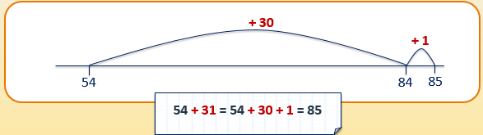  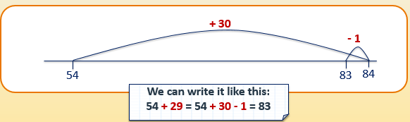  Please complete the allocated work sheet I have sent to you in your home pack or on google classroom. Remember the working out method is just as important as the answer. Please take a photo and email it back to me at Y3Teacher@littleham.devon.sch.uk  I would also like you to send me the paper sheet when you pick up your next pack next week.  History (1 hour)  https://classroom.thenational.academy/lessons/who-were-the-ancient-greek-philosophers-cthkac  Who were the Ancient Greek philosophers?  In this lesson, we will learn about Socrates, Plato, and Aristotle, three Ancient Greek philosophers whose thinking remains influential to this day.  PE with Joe (30 minutes)
Thursday 11th February 2021 | Reading (30 minutes)  - If you haven’t already, please complete this week’s reading comprehension assignment by reading the text through and answering the questions on the quiz.  - You can read a book on bug club, your current book from the library or you can read a book of your own.  English (1 hour)  LO: I can learn about compound sentences.  https://classroom.thenational.academy/lessons/to-explore-compound-sentences-6wt3jt  To explore compound sentences  In this lesson, we will recap what a simple sentence is and define what a compound sentence is. We will learn what the three coordinating conjunctions are and when to use each one appropriately. We will also practise writing compound sentences using all three coordinating conjunctions. For this lesson, you will need an exercise book or some paper and a pencil.  Please take a photo and email it back to me at Y3Teacher@littleham.devon.sch.uk  I would also like you to send me the paper sheet when you pick up your next pack next week.  Maths (1 hour)  LO: I can add near multiples of 10 to 3-digit numbers.  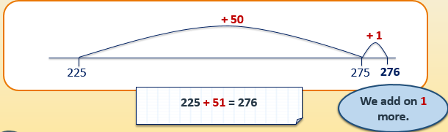  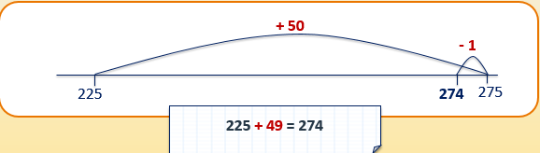  Please complete the allocated work sheet I have sent to you in your home pack or on google classroom. Remember the working out method is just as important as the answer. Please take a photo and email it back to me at Y3Teacher@littleham.devon.sch.uk  I would also like you to send me the paper sheet when you pick up your next pack next week.  Geography (1 hour)  https://classroom.thenational.academy/lessons/what-is-the-geography-of-wales-61jpar  What is the geography of Wales?  In this lesson, we will recap our knowledge of the seven continents, and locate the UK on a world map. We will then zoom into Wales and look at the different human and physical geographical features. We can then compare these to the area where we live, as well as comparing them to Scotland.  Mental Health ( 30 minutes)  See google classroom for this week’s mental health activity.
Friday 12th February 2021 | Reading (30 minutes)  - If you haven’t already, please complete this week’s reading comprehension assignment by reading the text through and answering the questions on the quiz.  - You can read a book on bug club, your current book from the library or you can read a book of your own.  English (1 hour)  LO: I can use the coordinating conjunctions ‘and’, ‘but’, ‘so in a compound sentence.  so, and, but, yet, or,  Today you are going to play a conjunction game. The aim of the game is to write some fun and silly compound sentences about dragons.  Start with a simple sentence about a dragon.  The dragon breathed fire.  Then choose a coordinating conjunction from the list and keep going.  The dragon ate 500 sausages and he burped for 10 minutes.  Please take a photo and email it back to me at Y3Teacher@littleham.devon.sch.uk  I would also like you to send me the paper sheet when you pick up your next pack next week.  Maths (1 hour)  LO: I can subtract near multiples of 10 from 3-digit numbers.  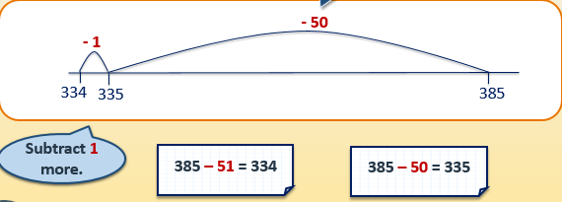  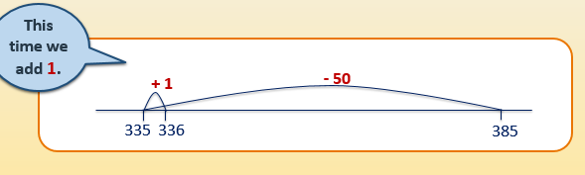  Please complete the allocated work sheet I have sent to you in your home pack or on google classroom. Remember the working out method is just as important as the answer. Please take a photo and email it back to me at Y3Teacher@littleham.devon.sch.uk  I would also like you to send me the paper sheet when you pick up your next pack next week.  PSHE (1 hour)  https://classroom.thenational.academy/lessons/i-roll-with-my-role-65h3gr  I roll with my role  In this lesson, you will explore the roles and responsibilities that you, as a citizen, have in your community. You will then create a video that outlines your role, alongside the main responsibilities you have.  Music (30 minutes)  https://www.bbc.co.uk/bitesize/topics/zcbkcj6/articles/z2mqw6f  What are pulse and rhythm?  Pulse is a steady beat like a ticking clock or your heartbeat. It can be measured in time by counting the number of beats per minute (BPM).  Rhythm is the pattern of long and short sounds as you move through the song.

