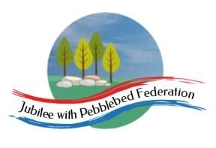
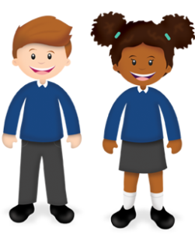
Learning
from Home

Year: Reception  Wk beg: 23/11/20 | Lesson One | Lesson Two | Lesson Three | Lesson Four | Lesson Five
Monday | Name Practise  Support your child to order the letters of their name using the letter cards in their home learning packs, or magnetic letters if you have them. Then get them to have a go at writing their name. Try to encourage your child to hold the pen/pencil correctly. | Reading  Share your child’s reading book. This can be one from their book bag or from Bug Club. Login details in reading record.  Model reading cvc words together in home learning pack, e.g. s-a-t sat | Maths  Choose an ‘Exploring repetitive patterns’ activity. Please adapt using resources you have at home. | Phonics  Revisit sounds previously taught s a t p i n m d g & o – see flash cards in home learning pack.  Teach the sound c  https://www.bbc.co.uk/iplayer/episode/p0872z24/alphablocks-magic-words-3-meet-alphablock-c  Magic Words: Meet Alphablocks C | Literacy  Read the story of Goldilocks and the Three Bears  https://www.youtube.com/watch?v=Rm3JsewQIWw
Tuesday | Name Practise  As Monday | Reading  Share your child’s class library book from their book bag or share a story that you have at home.  Model reading cvc words together in home learning pack, e.g. s-a-t sat | Maths  Order numerals 1-10 using the number cards in their home learning packs. Using objects at home, can you make me a set of 4? Can you find that number card?  Watch and join in with this song and dance.  https://www.youtube.com/watch?v=BQ9q4U2P3ig | Phonics  Revisit sounds previously taught s a t p i n m d g o & c – see flash cards in home learning pack.  Teach the sound k  https://www.bbc.co.uk/iplayer/episode/p08730bj/alphablocks-magic-words-11-meet-alphablock-k  Magic Words: Meet Alphablocks K | Understanding the World  Using a timer, time yourself brushing your teeth for 2 minutes both in the morning and before going to bed.  Talk to your child about why we need to brush for this time.
Wednesday | Name Practise  As Monday | Reading  Share your child’s reading book. This can be one from their book bag or from Bug Club. Login details in reading record. | Maths  Choose an ‘Exploring repetitive patterns’ activity. Please adapt using resources you have at home. | PSHE  Draw a picture of how you are feeling today? E.g. Making puzzles with my Dad makes me feel happy. | PE  https://www.youtube.com/watch?v=u0_1QBQ8Syk
Thursday | Name Practise  As Monday | Reading  Share your child’s class library book from their book bag or share a story that you have at home.  Model reading cvc words together in home learning pack, e.g. s-a-t sat | Maths  Order numerals 1-10 using the number cards in their home learning packs. Using objects at home, can you make me a set of 4? Can you find that number card?  Watch and join in with this song and dance.  https://www.youtube.com/watch?v=BQ9q4U2P3ig | Phonics  Revisit sounds previously taught s a t p i n m d g o c & k – see flash cards in home learning pack.  Teach the sound ck  https://www.bbc.co.uk/iplayer/episode/b01dzn26/alphablocks-series-2-21-kick  Magic Words: Meeting Alphablocks CK | Literacy  Read the story of Goldilocks and the Three Bears  https://www.youtube.com/watch?v=0oUP2PFeOi8
Friday | Name Practise  As Monday | Reading  Share your child’s reading book. This can be one from their book bag or from Bug Club. Login details in reading record.  Model reading cvc words together in home learning pack, e.g. s-a-t sat | Maths  Choose an ‘Exploring repetitive patterns’ activity. Please adapt using resources you have at home. | Phonics  Revisit sounds previously taught s a t p i n m d g o c & k – see flash cards in home learning pack.  Teach the sound e  https://www.bbc.co.uk/iplayer/episode/p0872zd0/alphablocks-magic-words-5-meet-alphablock-e  Magic Words: Meeting Alphablocks E | It’s Friday! Do something creative. You could choose to draw, paint, make something out of Lego, bake something, make some music or you may have your own idea! Have fun!

