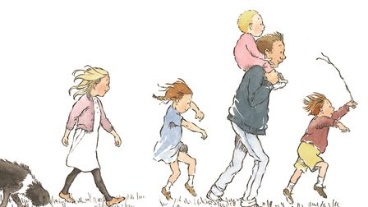
We’re going on a __________ ___________,
We’re going to catch a _________ __________.
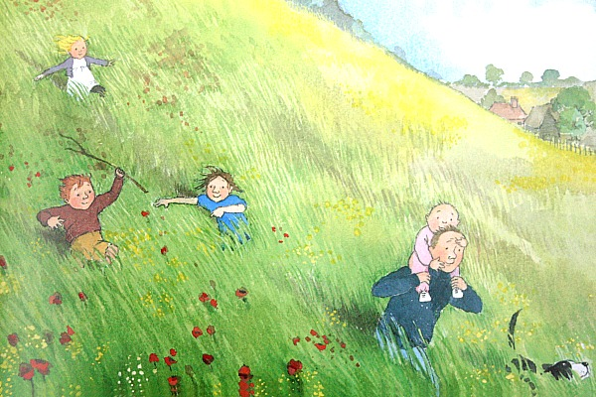
Uh-uh! _________.
Long _________ _________
We can’t go __________ it,
We can’t go ___________ it.
We’ve got to go
_______________ it!
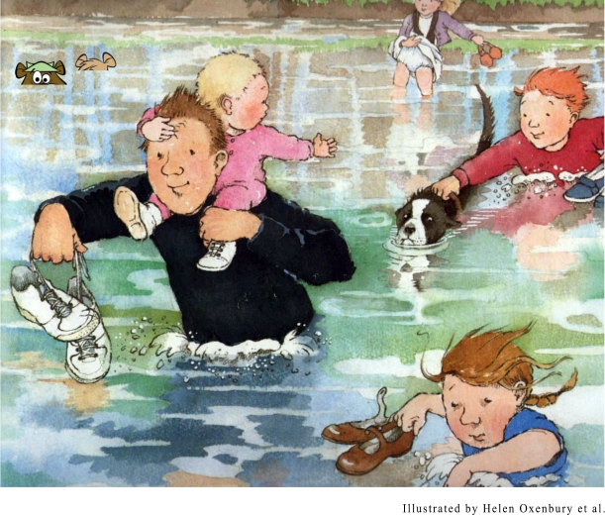
A __________.
A deep cold river.
What noise does it make,
when we go through the river?
___________ ___________

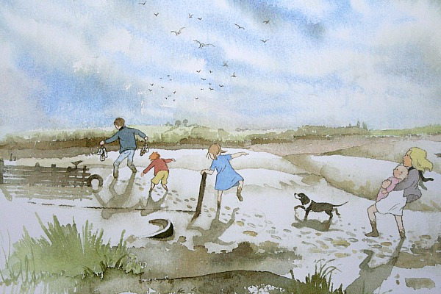
Uh-uh! Mud, thick oozy mud…
We can’t go over it, We can’t go under it.
Oh no! We’ve got to go through it…
___________ ___________
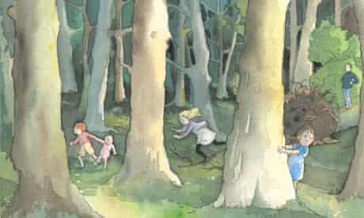
Uh-uh! A ____________.
A big ________ __________.

Stumble _________.

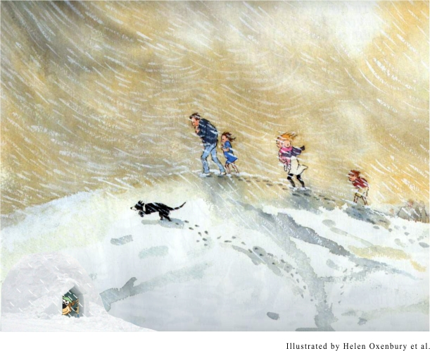

Hoooo Woooooo Hoooooo woooooo
It’s a ____________________
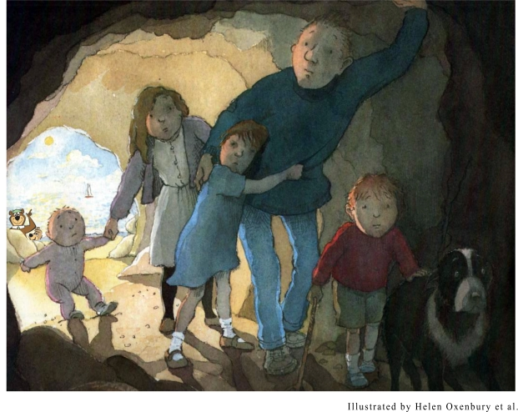

Uh-uh! A cave… A narrow gloomy cave!
What do we do in the cave?
________________

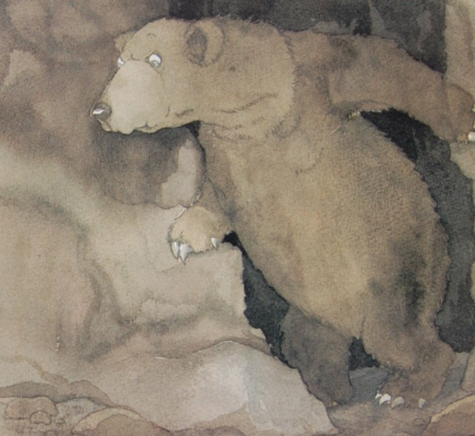
One shiny ______ ________
Two big _______ _________
Two big _______ ________
It’s ___ ________!

