Year 5 Learning from Home Grid
Week Beginning 8.2.2021
Learning Behaviours
In school we are really thinking about:
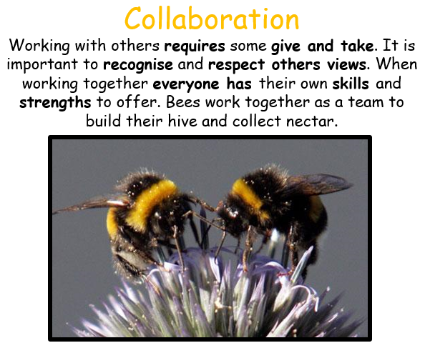

Reading – This week we are going to try a new website called Get Epic, please click on the link to take you to an audio version of one of my favourite stories - The Invention of Hugo Cabret - which you can listen to at any time! Copy and paste the link below in to your web browser to get going: https://www.getepic.com/audiobook/15907300/the-invention-of-hugo-cabret?utm_source=t2t&utm_medium=link&utm_campaign=content&share=31358209423
Once you reach the page with the cover of the book on, click on Class Code on the bar at the top and then enter this code:
Jla6766
Next click on your character, this will then ask you to get a grown up to enter their email address to allow you to continue. Once you have done this enjoy listening to the book.

Please ensure that you monitor any YouTube clips for ads and ensure that your children only click on the links to the videos that I have included.
Monday | Collective Worship:  Follow the link to Mrs Padbury’s Collective Worship on Google Classroom  PE:  A Joe Wicks work out from last Summer!  https://youtu.be/mhHY8mOQ5eo  Or an alternative!  https://youtu.be/L_A_HjHZxfI  Nothing beats getting outdoors! If you have a garden, or can get outside have a run, cycle, set up your own obstacle course. The beach would be great too!  Reading  The Listeners  https://classroom.thenational.academy/lessons/to-learn-about-a-poet-and-engage-with-the-poem-for-first-impressions-6hhk0t  Maths:  Times Table practice. Can you beat last week’s score? What time limit did you set yourself last week? Rather than try to complete them all (That would be good though, but not to worry if you can’t). Go for a set time. For example, 20 minutes, but no more than 30 minutes. You can also focus on the Times Table you find the most tricky, particularly those ‘Table enemies’, such as x6, x7, x8, x9… I will include the sheet again in the paper pack and on Google Classroom.  You can also play the Times Table video below. You can play it all, or skip to the times table you need practice with.  https://youtu.be/C3PojOwjHcc  Living things and their habitats:  Continue with either your back to back book, or your Power Point focusing on your creature(s) and their life cycles. Refer back to previous guidance on the Home Learning Grid and Google Classroom. Please have them ready for when you return to school, or put them in your completed Home learning which you can return to school for Tuesday 23rd February. (Power points we can look at later on).  After half-term we will be doing something similar looking at the work of naturalists and animal behavourists, for example David Attenborough and Jane Goodall. Details to follow.  Science:  To understand Friction as a force.  Challenge- ‘Make a can roll down a slope as slowly as possible. Use your knowledge of mass, friction and forces to help you design a can which will roll down the slope slowly. Don’t totally crush the can, as it still needs to roll! A sheet will be included in the Home Learning paper packs to help you and attached on Google Classroom. As I will an ‘Advantages and Disadvantages’ of Friction activity.  https://youtu.be/P6_VUfHzaaM  This video should help.  French:  (Do make sure that you have finished the previous learning first).  Today we are learning vocabulary for pets.  The video will help you.  https://youtu.be/TW-9kzgyzN0  On a piece of paper, draw some pictures of the pets name and label. An activity sheet will also be included in the Home Leaning paper pack, as well as being attached to Google Classroom.
Tuesday | Reading:  The Listeners  https://classroom.thenational.academy/lessons/to-use-strategies-to-identify-key-vocabulary-and-begin-to-understand-the-poem-further-6cw38t  English:  To explore different sentence types  Follow the Loom Video link, watch the video and then select an activity from Google Classroom or in your paper pack – challenge yourself!  https://www.loom.com/share/4dde9b661d784023ba7ffabad31f5c03  Maths:  Find area of squares and rectangles in cm₂  - Follow the PowerPoint on Google Classroom or in your pack  - Choose your activity – Mild or Spicy (challenge yourself if you can!)  History:  An introduction to Tudor Crime and Punishment  Watch the clip on : https://www.bbc.co.uk/bitesize/topics/z8w3n9q/articles/z26w4xs  Now read the article – what do you think of Tudor punishments? Were they fair? Did they reflect the crime being committed? Why do you think that they didn’t have/need a police force? Answer these questions on the sheet that you can find on Google Classroom or in your paper pack.  PSHE:  Money Matters Lesson 2 Money, money, money  https://classroom.thenational.academy/lessons/money-money-money-61gked
Wednesday | Reading:  The Listeners  https://classroom.thenational.academy/lessons/to-use-the-text-to-answer-questions-75k30d  English:  To explore different adverbs  https://www.loom.com/share/1368a1ddfe2f4a9e88cf736f8fed70e6  Follow the Loom Video link, watch the video and then complete the activity which can be found on Google Classroom or in your paper pack  Collective Worship:  Exmouth Coastal Churches  https://www.youtube.com/watch?v=ibcdh2V0VtQ&list=PLqWt6-qhTKHF_Yb18Npn-Ni0kRTQ-9-yp  Look at the playlist on the side for the Collective Worship for this week  Maths:  Estimate the area of irregular shapes/Calculate area from scale drawings  - Follow the PowerPoint on Google Classroom or in your pack  - Choose your activity – Mild, Spicy or Hot, Hot, Hot (challenge yourself if you can!)  Art:  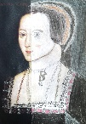  Look at this picture. Can you see what has been done? The picture has been cut in half and then one half of the picture has been recreated using sketching, shading and colour. Please choose one of the Tudor portraits and do the same, take a photo of your portrait and if you can send it back to me at Y5Teacher@littleham.devon.sch.uk  Mental Health:  Please follow the link to the school website and work through the PowerPoint/Activity you find there – this is also available on Google Classroom.  http://www.littleham.devon.sch.uk/website/mental_health/535426
Thursday | Reading:  The Listeners  https://classroom.thenational.academy/lessons/to-discuss-the-poets-choice-of-language-and-structure-71h6ac  English:  Write your own biography in the style of Women in Science – follow the Loom link and watch the video, then write your own biography use your plan from last Friday to help you.  https://www.loom.com/share/ec31f67c1ba14e0b9e47ff88e7e393d9  Collective Worship:  ICE Exeter  Maths:  Use negative numbers in context of temperature/Calculate rises and falls in temperature  - Follow the PowerPoint on Google Classroom or in your pack  - Choose your activity – Mild or Spicy (challenge yourself if you can!)  Outdoor Learning:  Try the Birdy Survey this week, which birds can you see from your home? Can you recognise them? Are there any that you don’t know? Use the sheet on Google Classroom or in your paper pack to complete your survey.  Y5Teacher@littleham.devon.sch.uk
Friday | Reading:  The Listeners  https://classroom.thenational.academy/lessons/to-identify-key-themes-in-the-poem-and-create-our-own-poem-with-a-similar-theme-65k66d  English:  Write your biography up in the style of Women in Science – remember to check your work for spelling mistakes first and to make sure that it makes sense and has capital letters, full stops etc. in the correct places. Use these pictures to help you decide how to publish your work.  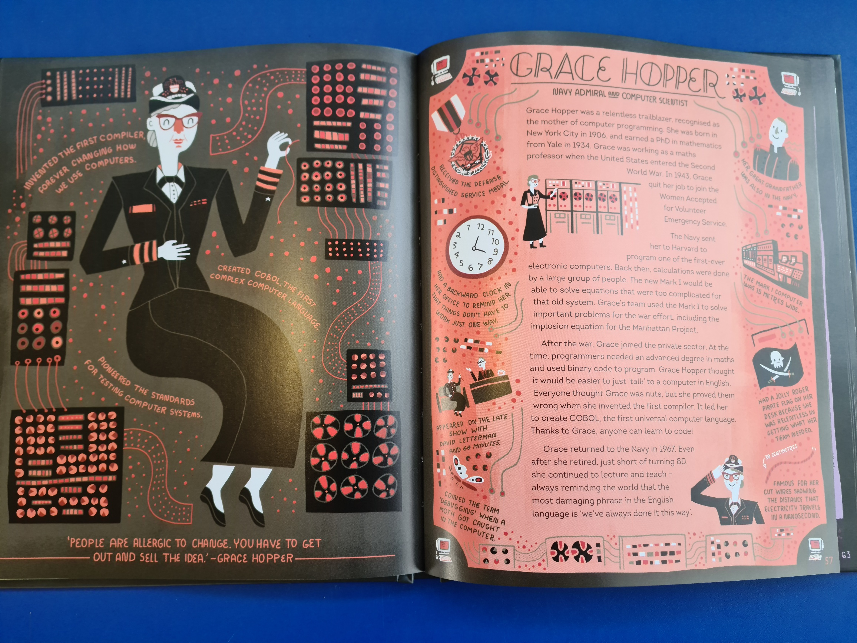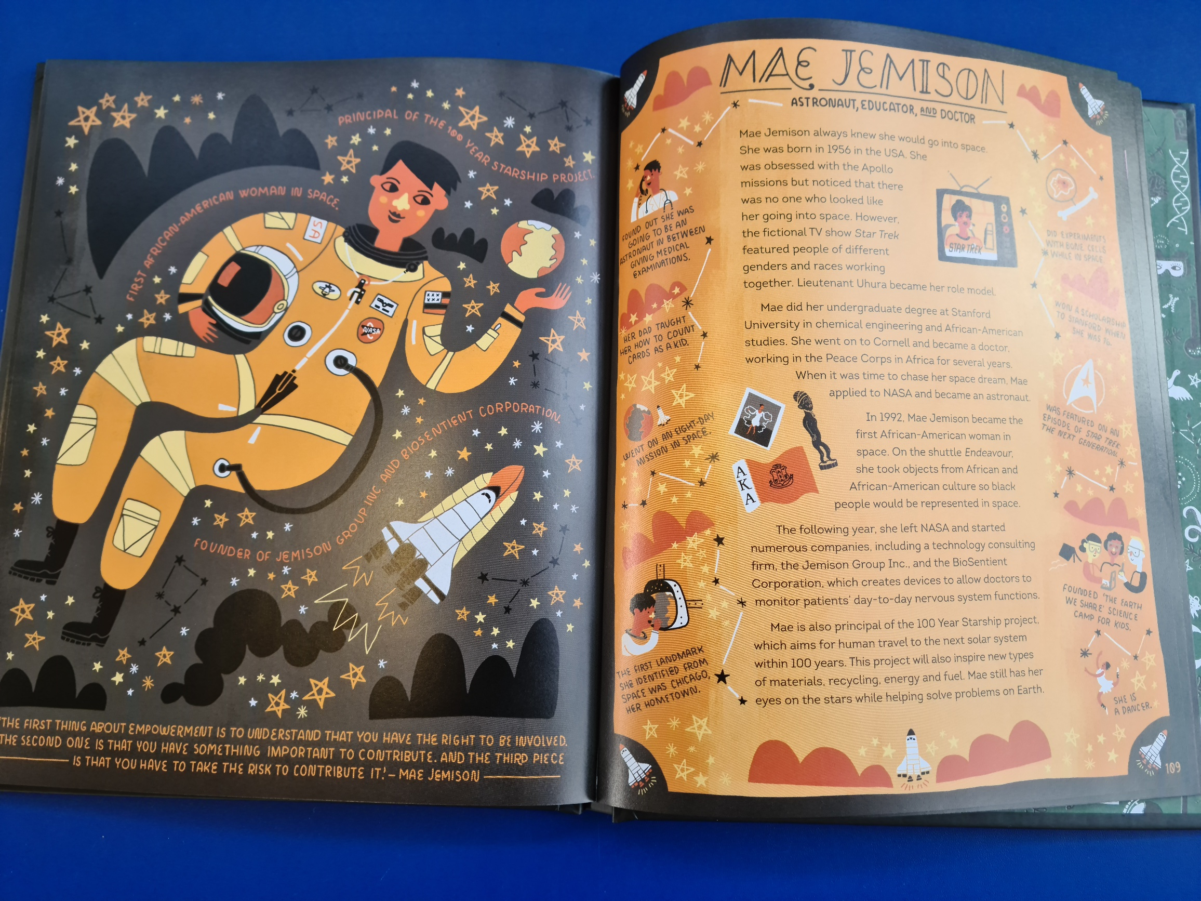  Maths:  Comparing Temperatures  - Follow the PowerPoint on Google Classroom or in your pack  - Complete the activity and then challenge yourself to complete the challenge!  ICT:  Video Evaluation  https://classroom.thenational.academy/lessons/video-evaluation-6rvp8r  RE:  What are the Christian celebrations?  https://classroom.thenational.academy/lessons/what-are-the-christian-celebrations-cnjk0d

