Unit 1: Exploring and playing with symmetry |  |  | AUTUMN Shape: Unit 1, Exploring and Playing
Play Activity 1: Peg patterns
Aims:  To create a symmetrical pattern | You will need: peg boards; pegs; mirrors (optional)
Preparation: You may wish to tape a line down the middle of each peg board to be the line of symmetry.
What to do:  - Children use coloured pegs on peg boards to make symmetrical patterns.  - You may wish to leave out some examples to help children to get the idea, or start some simple patterns for them to finish. |  | 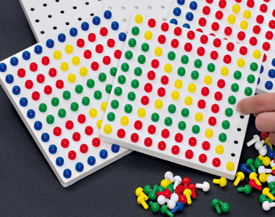
Talking points  - Can you say the colours – blue, green, ...?  - Tell me about your pattern.  - You’ve put a red peg there, so what colour does this peg need to be to keep your pattern symmetrical?  - Place a blue peg wherever you like. Now where do you need to place another blue peg? | Evidence of learning:  Listen to children talking. Do they say I need to put a red peg here.  Observe children. Do they look at one side and copy the pattern in reverse on the other side?
Outcomes: I can make a symmetrical peg pattern.

Unit 1: Exploring and playing with symmetry |  |  |  | AUTUMN Shape: Unit 1, Exploring and Playing
Play Activity 2: Symmetrical monsters
Aims:  To create a symmetrical pattern |  | You will need: gummed shapes; paper; mirrors (optional)
Preparation: Draw a vertical line down the centre of each piece of paper
What to do:  - Children use gummed shapes to make a symmetrical monster/ other picture relevant to a current theme.  - Explain that the same shape and colours should be on each side of the line in a symmetrical pattern to create the monster/ picture. You may wish to prepare one in advance to give children the idea. |  |  | 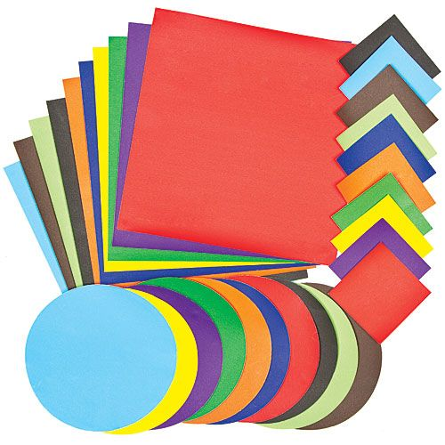
Talking points  - If the monster has two red eyes on this side of the line, what do you need to do on the other side of the line?  - You’ve put a green wing on that side, so what do you need to do on the other side? | Evidence of learning:  Listen to children talking. Do they say I need to put a red leg here because I put one on the other side.  Observe children. Do they look at one side and copy the shapes and colours in reverse on the other?
Outcomes: I can make a symmetrical picture.

Unit 1: Exploring and playing with symmetry |  |  |  | AUTUMN Shape: Unit 1, Exploring and Playing
Play Activity 3: Symmetrical houses
Aims:  To create a symmetrical pattern |  | You will need: small building bricks; doors and windows
Preparation: Display some pictures of some symmetrical houses to help children.
What to do:  - Children use bricks, doors and windows to build symmetrical houses. (To look symmetrical from the front.) |  |  | 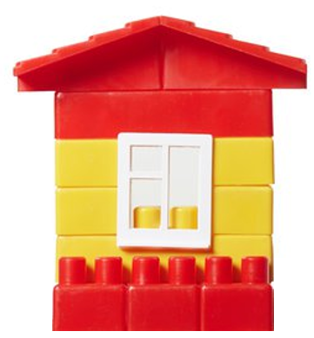
Talking points  - The door is in the middle. The are two windows on this side of the door. How many windows do you need to put in on this side of the door? | Evidence of learning:  Listen to children talking. Do they say, e.g. I am going to put two windows on each side.  Observe children. Do they build a house that looks symmetrical form the front? Do they make any alterations to achieve this?
Outcomes: I can build a symmetrical house.

Unit 1: Exploring and playing with symmetry |  |  |  | AUTUMN Shape: Unit 1, Exploring and Playing
Play Activity 4: Symme-tree
Aims:  To make symmetrical shapes | You will need: salt dough/playdough in different colours; modelling tools; mirrors; branches and ribbons (optional)
Preparation: None required
What to do:  - Children use salt dough/playdough to make symmetrical shapes. These could be geometric shapes, or leaves.  - They use a mirror to check that they are symmetrical.  - If using salt dough or clay, you could poke a hole through each, thread ribbon and hang to form part of a symmetry display. If children have made leaves, hang on branches to form a tree. |  |  | 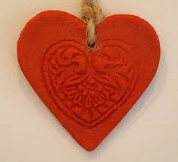
Talking points  - Where can you place a mirror on your shape so that it shows that your shape is symmetrical?  - Place the mirror in the middle of your shape. Does the other side look like the first side in the mirror – like a butterfly’s wings? |  | Evidence of learning:  Observe children. Do they check with the mirror and make any adjustments?
Outcomes: I can make symmetrical shapes.

Shape Unit 1
Exploring and playing with symmetry
Exploring and Playing

Teacher Notes
You will need:
- peg boards; pegs; mirrors (optional); gummed shapes; paper; mirrors (optional); small building bricks; doors and windows; salt dough/playdough in different colours; modelling tools; mirrors; branches and ribbons (optional)

KEY CONCEPTS
- Recognising reflective symmetry: This is the most basic form of symmetry – mirror symmetry across one line. Children need to understand that one half is a mirror image of the other half.
- Making or completing symmetrical shapes and patterns: Once children understand the concept of symmetry, the next stage is to copy/ complete/ create their own symmetrical shapes and patterns. Can children spot and correct an error, e.g. noticing a missing cube or swapped colours?

Watch out for children who:
- don’t understand that one side of a symmetrical shape/pattern is a reflection of the other, rather than a repeat in the same orientation.
Support them by:
- using mirrors so that they can see that the image is flipped.

