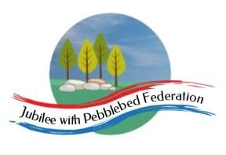
Learning
from Home

Year: Reception & Year 1  Wk beg: 26/4/2021 | Lesson One | Lesson  Two | Lesson  Three | Lesson  Four | Lesson  Five
Monday 26th April | Name Practice  Practice writing your name either on a piece of paper or your name card.  Please encourage correct pencil hold – ‘nip, flip and grip’.  Make sure your child can form every letter correctly and without a visual.  Extension Encourage your child to write the letters smaller and on a line. Once they can do this help your child to learn to write their surname also. | Reading  Log onto Bug Club and pick a book to read to your grown up. Ask your child questions about the story and to sound talk the words.  https://www.activelearnprimary.co.uk/login?c=0  Practice reading some of the sound button words in their home learning pack.  e.g. h-u-ff huff  Or read and write the tricky words on their key ring. | Maths  Practice writing numbers correctly.  https://www.youtube.com/watch?v=DzKqCmjVXLI  Chant numbers together to 50/100.  Show your child a 100-bead bar (see link below). Count the first group of beads in 1s together. How many beads?  How many beads do you think are in the next colour? (10) Count beads from the beginning together.  Carry on counting the beads until you get to 100.  Tell your child that there is a really quick way to count beads when they are in groups of 10 like this! Show them how to count in 10’s.  Repeat several times, asking them to join in.  https://mathsframe.co.uk/en/resources/resource/69/itp-beadstring | Phonics  Review all letter sounds learnt so far – see flash cards in home learning pack. Focus on learning the digraphs qu ch sh th ng ai ee igh oa oo(long) oo(short) ar ur ow oi ear air ure er  Revisit the sound oo  https://www.youtube.com/watch?v=McxGM5mU0uM  Then practice reading these words:  fool  stool  spoon  roof  cook  good  hood  hook  We have learnt all the sounds in these words so see if your child can sound talk them e.g. f-oo-l fool | PE  Practice throwing and catching a ball. Start by throwing in the air and catching it. How many times can you do this without dropping the ball? Try with a large and small ball.  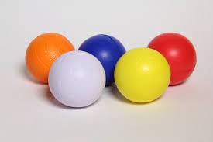  Next work with your grown up to throw and catch the ball. If doing well move further apart when throwing and catching.
Tuesday 27th April | Name Practice  Practice writing your name either on a piece of paper or your name card.  Please encourage correct pencil hold – ‘nip, flip and grip’.  Make sure your child can form every letter correctly and without a visual.  Extension Encourage your child to write the letters smaller and on a line. Once they can do this help your child to learn to write their surname also. | Reading  Log onto Bug Club and pick a book to read to your grown up. Ask your child questions about the story and to sound talk the words.  https://www.activelearnprimary.co.uk/login?c=0  Practice reading some of the sound button words in their home learning pack.  e.g. h-u-ff huff  Or read and write the tricky words on their key ring. | Maths  Practice writing numbers correctly.  https://www.youtube.com/watch?v=DzKqCmjVXLI  Chant numbers together to 50/100.  Click on this link or copy and paste into internet search.  https://www.topmarks.co.uk/learning-to-count/paint-the-squares  Open up the 1-100 grid. Colour 10,20,30,40,50,60,70,80,90 & 100.  Practise counting in tens together.  Extension  Count back in tens also.  Can you write the counting sequence? | Phonics  Review all letter sounds learnt so far – see flash cards in home learning pack. Focus on learning the digraphs qu ch sh th ng ai ee igh oa oo(long) oo(short) ar ur ow oi ear air ure er  Revisit the sound ar  https://www.youtube.com/watch?v=yVsmYlNXU-k  Then practice reading these words:  took  wool  book  wood  art  jar  park  start  We have learnt all the sounds in these words so see if your child can sound talk them e.g. t-oo-k | Literacy  Look at the beach picture. What can you see?  Write some simple sentences.  E.g. I can see the sand.  I can see a dog.  Extension  Use ‘and’ in your sentences. E.g. I can see the sand and a dog.  Check that sentences start with a capital letter, end with a full stop and that there are finger spaces between words.  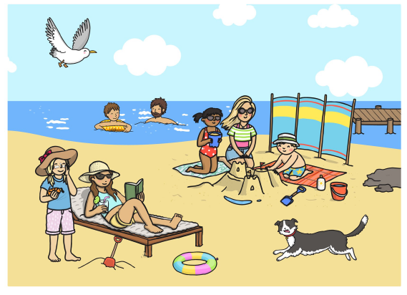
Wednesday 28th April | Name Practice  Practice writing your name either on a piece of paper or your name card.  Please encourage correct pencil hold – ‘nip, flip and grip’.  Make sure your child can form every letter correctly and without a visual.  Extension Encourage your child to write the letters smaller and on a line. Once they can do this help your child to learn to write their surname also. | Reading  Log onto Bug Club and pick a book to read to your grown up. Ask your child questions about the story and to sound talk the words.  https://www.activelearnprimary.co.uk/login?c=0  Practice reading some of the sound button words in their home learning pack.  e.g. h-u-ff huff  Or read and write the tricky words on their key ring. | RE Work with your child to learn these prayers or create one of your own.  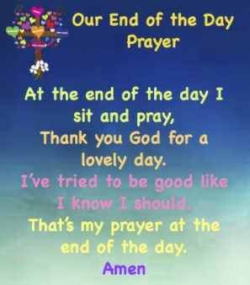  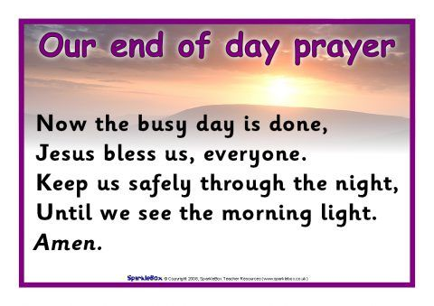 | Phonics  Review all letter sounds learnt so far – see flash cards in home learning pack. Focus on learning the digraphs qu ch sh th ng ai ee igh oa oo(long) oo(short) ar ur ow oi ear air ure er  Revisit the sound or  https://www.youtube.com/watch?v=68FTaim0FOQ  Then practice reading these words:  dart  bark  arm  star  for  pork  cord  corn  We have learnt all the sounds in these words so see if your child can sound talk them e.g. d-ar-t dart | Literacy  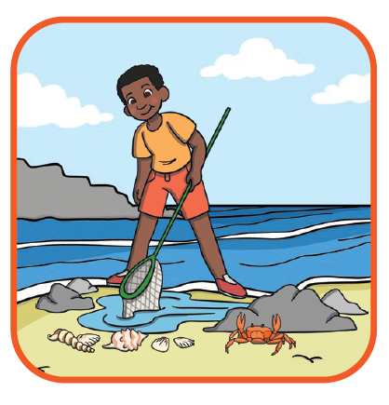  Write some sentences about this picture. What can you see?  E.g. I can see some rocks.  I can see a crab.  Extension  Use ‘and’ in your sentences. E.g. I can see rocks and a crab.  Check that the sentences start with a capital letter, end with a full stop and that there are finger spaces between words.
Thursday 29th  April | Name Practice  Practice writing your name either on a piece of paper or your name card.  Please encourage correct pencil hold – ‘nip, flip and grip’.  Make sure your child can form every letter correctly and without a visual.  Extension  Encourage your child to write the letters smaller and on a line. Once they can do this help your child to learn to write their surname also. | Reading  Log onto Bug Club and pick a book to read to your grown up. Ask your child questions about the story and to sound talk the words.  https://www.activelearnprimary.co.uk/login?c=0  Practice reading some of the sound button words in their home learning pack.  e.g. h-u-ff huff  Or read and write the tricky words on their key ring. | Maths  Practice writing numbers correctly.  https://www.youtube.com/watch?v=DzKqCmjVXLI  Place between 10 and 50 items (e.g. play people, cars, trains, conkers etc) in baskets, a different type of item in each basket.  Ask your child to do a ‘stocktake’ of the baskets. They count how many are in each and write the number on a sticky note, attaching it to the basket. Have a 1-100 number grid in case they want to copy how to write the number.  - How many are in this basket? How do we write 25? | Phonics  Review all letter sounds learnt so far – see flash cards in home learning pack. Focus on learning the digraphs qu ch sh th ng ai ee igh oa oo(long) oo(short) ar ur ow oi ear air ure er  Revisit the sound ur  https://www.youtube.com/watch?v=Q49YSWKPyVo  https://www.bbc.co.uk/iplayer/episode/b01q0pgj/alphablocks-series-3-21-the-end  Then practice reading these words:  cork  fort  torch  fork  fur  burst  hurt  turnip  We have learnt all the sounds in these words so see if your child can sound talk them e.g. b-ur-s-t | Handwriting  We are practicing to write zig zag letters v w y z  https://www.bbc.co.uk/bitesize/topics/zgjj6sg/articles/zydty4j  Practice writing zig zag letters outside using a paintbrush and water.
Friday 30th April | Name Practice  Practice writing your name either on a piece of paper or your name card.  Please encourage correct pencil hold – ‘nip, flip and grip’.  Make sure your child can form every letter correctly and without a visual.  Extension  See extension above | Reading  Log onto Bug Club and pick a book to read to your grown up. Ask your child questions about the story and to sound talk the words.  https://www.activelearnprimary.co.uk/login?c=0  Practice reading some of the sound button words in their home learning pack.  e.g. h-u-ff huff | Maths  Practice writing numbers correctly.  https://www.youtube.com/watch?v=DzKqCmjVXLI  - Children find/ colour in patterns on 1-100 grids, e.g. they could colour the 10s numbers, or all the numbers with a 5 in them, or all the numbers where the digits add up to 10…  Encourage them to look for and describe their own patterns. | Phonics  Review all letter sounds learnt so far – see flash cards in home learning pack. Focus on learning the digraphs qu ch sh th ng ai ee igh oa oo(long) oo(short) ar ur ow oi ear air ure er  Revisit the sound ow  https://www.youtube.com/watch?v=GJtvjxBYg7I  Then practice reading these words:  curl  turf  church  how  cow  town  growl | Art  We will drawing our own fish and creating colourful fish scales  Try cutting a toilet in half to create fish scales.  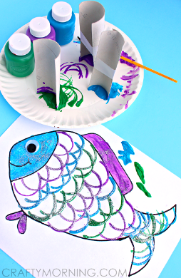
Please be aware that your home filter may allow unsuitable links to pop up when watching any YouTube video.

We would love to see any photos of the learning you are doing at home. Please send these to YRteacher@littleham.devon.sch.uk
Please let us know if you need any additional resources to help your child to complete their home learning with you at home.

