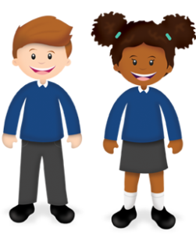
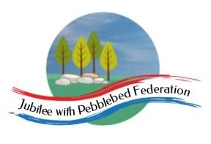
Year 1
Learning from Home

Year:  Week beg:  16/11/2020 | Lesson One | Lesson Two | Lesson Three | Lesson Four
Monday | Maths https://classroom.thenational.academy/lessons/applying-make-ten-to-differences-part-2-68t30e | English https://classroom.thenational.academy/lessons/to-box-up-for-purpose-64r64c | Reading  https://www.activelearnprimary.co.uk/login?c=0 | RE https://classroom.thenational.academy/lessons/why-did-the-three-wise-men-share-gifts-with-baby-jesus-6rtp4c
Tuesday | Maths https://classroom.thenational.academy/lessons/writing-equations-to-show-comparison-part-1-70uk6e | English https://classroom.thenational.academy/lessons/to-write-the-opening-of-a-recycled-story-6rwkgd | Reading  https://www.activelearnprimary.co.uk/login?c=0 | PSHE https://classroom.thenational.academy/lessons/health-is-wealth-6rukct
Wednesday | Maths https://classroom.thenational.academy/lessons/writing-equations-to-show-comparison-part-2-6nj3ec | English https://classroom.thenational.academy/lessons/to-write-the-middle-of-a-recycled-story-part-1-6wupcd | Reading  https://www.activelearnprimary.co.uk/login?c=0 | Science https://classroom.thenational.academy/lessons/which-materials-are-waterproof-cmrpad
Thursday | Maths https://classroom.thenational.academy/lessons/solving-comparison-problems-part-1-crw34r  Maths https://classroom.thenational.academy/lessons/solving-comparison-problems-part-2-75j3jr | English https://classroom.thenational.academy/lessons/to-write-the-opening-of-a-recycled-story-6rwkgd | Reading  https://www.activelearnprimary.co.uk/login?c=0 | Music https://classroom.thenational.academy/lessons/rhythm-and-pulse-c4tker
Friday |  | English https://classroom.thenational.academy/lessons/to-write-the-ending-of-a-recycled-story-and-perform-it-6rukgt | Reading  https://www.activelearnprimary.co.uk/login?c=0 | PE  https://www.youtube.com/watch?v=EZ2h6W4YVz0

