Unit 1: Counting and naming numerals |  |  | AUTUMN Understanding Number: Unit 1, Exploring and Playing
Play Activity 2: How many animals
Aims:  To count the number of objects in a set with accuracy | You will need:  small animals; animal pens
Preparation: None required
What to do:  - Children make pens for different toy farm animals.  - They count how many animals they have in their pen.  - Can they place a different number of animals in another pen?  - Encourage them to group animals of one type in a pen, e.g. How many cows in the cow pen? How many sheep?  - Encourage children to match one-to-one as they count. |  | 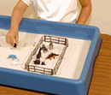
Talking points  - How many animals in your pen? Are they all the same type?  - How many cows? How many dinosaurs?  - Are there more cows or more sheep?  - Which pen has the most animals? The fewest? | Evidence of learning:  Listen to children talking. Can they say how many in a pen? Can they say which pen has most/fewest?  Observe children. Do they count accurately by pointing at each animal as they say the number?
Outcomes: I can count how many in a set by matching one-to-one as I say the numbers.
I can count accurately to 6 or 10.

Unit 1: Counting and naming numerals |  |  |  | AUTUMN Understanding Number: Unit 1, Exploring and Playing
Play Activity 3: Build a brick model
Aims: To choose a number to match a set  To count correctly the number of bricks used | You will need: LegoTM/DuploTM; sticky notes
Preparation: Write numbers 1 to 10 clearly on sticky notes.
What to do:  - Provide a set number of LegoTM/DuploTM bricks, e.g. 10.  - Children make models with up to 10 bricks.  - They choose a sticky note to label how many bricks they used.  - They make a different model with a different number of bricks. |  |  | 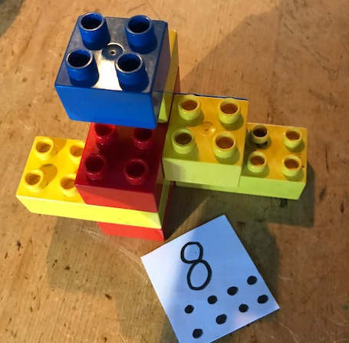
Talking points  - How many bricks have you used so far  - Can you count all the bricks in your model? How do you know you have counted accurately?  - Can you show me how you count the bricks in your model? What strategies do you use? |  | Evidence of learning:  Listen to children talking. Can they count with accuracy, turning their model round, and making sure that they do not count any brick twice?  Observe children. Do they try to touch each brick as they count it?
Outcomes: I can say the numbers in order, 1 to 10.
I can count objects by matching one-to-one with the numbers spoken.
I can count objects in in irregular 3-D arrays.

Unit 1: Counting and naming numerals |  | AUTUMN Understanding Number: Unit 1, Active Learning
Activity 3: How many bricks?
Aims: To count from 1-10  To match a number to a set.  To match spoken numbers to written numerals | You will need:  see-through plastic bags; LegoTM bricks; dotty number cards 1-10 (see resources)
Pedagogy: Small groups
Preparation: None required
What to do:
- Lay out the numbers 1 to 10 in a line.
- In unison, count 5 objects, e.g. small LegoTM bricks, into a see-through plastic bag. Check with children. How many bricks?
- Ask a child to point to the number in the line on the table. Peg the bag to that card.
- Repeat with other numbers to 10.
Support children by using just numbers 1 to 6.
Challenge children by using numbers 1 to 20.
Outcomes: I can count to 10.
I can recognise numerals 1 to 10 and match these to the spoken number.
I can match a number to a set.

Unit 1: Counting and naming numerals |  | AUTUMN Understanding Number: Unit 1, Active Learning
Activity 4: Toys out of the box
Aims: To match numbers to quantities  To match the spoken number to the written numeral | You will need: 10 small soft toys; a basket or box; Number cards (see resources)
Pedagogy: Small groups
Preparation: Place soft toys in the basket/ box.
What to do:
- Give a number card (1 to 10) to each child. Some children can have two numbers.
- Go around the group and ask each child to say what numbers they have.
- Take 5 soft toys out of box, one at a time with exaggerated movements, asking children to count them in their heads as you do so. Who has that number?
- The child with 5 waves their hand. Give them a soft toy.
- Put the remaining toys back and repeat taking out 4 toys.
- Keep playing until all the toys are gone.
Support children by using number tiles which have dots and numbers (see resources).
Challenge children by using 12 toys and number cards to 12.
Outcomes: I can count to 10.
I can recognise numerals 1 to 10 and match these to the spoken number.
I can match a number to a set.

