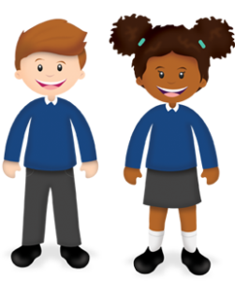
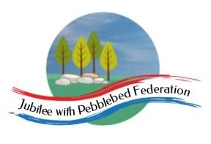
Learning
from Home

Year: 5  Wk beg: 14.12.20 | Lesson One | Lesson Two | Lesson Three | Lesson Four
Monday | SPAG  https://classroom.thenational.academy/lessons/to-explore-simple-and-compound-sentences-6hk3ed  practise some of your own sentences  EXTRA-CREATE COMPOUND SENTENCES LINKED TO EITHER OUR SCIENCE, OR ANCIENT EGYPTIAN TOPIC | MATH  https://classroom.thenational.academy/lessons/rounding-2-and-3-digit-numbers-to-the-nearest-10-6gu3er  Create problems to solve.  Practice your next times table. Remember the sort of games in class we do. | SCIENCE  www.bbc.co.uk/bitesize/clips/zsjd7ty  Watch the clip and try out some of the suggestions. What is going on? Be prepared to talk about what you have found out in class. | PE  Create your own workout programme, which you can present to the class, as a warm up session. E.g. Different pathways, star jumps, an imaginative 1 minute aerobic exercise. A stopping and starting routine. Be creative! There is always Joe Wicks to follow.
Tuesday | SPELLING  Christmas Crossword | ENGLISH  https://www.youtube.com/watch?v=DYPl3oO67wk  Then watch:  https://www.bbc.co.uk/bitesize/topics/zvwwxnb/articles/zshfdxs  Where would you use a semi-colon in the poem? | MATHS  https://classroom.thenational.academy/lessons/adding-and-subtracting-using-multiples-of-10-100-1000-10-000-and-100-000-60upcc | RE  https://classroom.thenational.academy/lessons/how-do-muslims-express-their-faith-6ngk2c
Wednesday | SPELLING  Create your own Christmas Crossword or Word Search | ENGLISH  https://classroom.thenational.academy/lessons/to-explore-expanded-noun-phrases-6hh36c?from_query=expanded+noun+phrases | MATHS  https://classroom.thenational.academy/lessons/rounding-to-estimate-ccr62d | ART  Design and make your own Christmas card.
Thursday | READING  Look at the beginning of a story. How does the story hook you in at the beginning? Make a list of words and phrases that you feel are effective in making you want to read on. | ENGLISH  Use the planning chart to plan your own poem – use my plan of the journey of the wise men to Bethlehem help you to plan your poem as if you were travelling to Bethlehem for the special event. | MATHS  https://classroom.thenational.academy/lessons/problem-solving-using-the-column-method-c8up6c | HISTORY  Hieroglyphic Codes – Complete the sheet and then write your own code!
Friday | READING  Reread a chapter of you book, pick out ten words which you think are powerful words that you could use in your own writing. Write them down in your own sentences. | ENGLISH  Write your own poem in the style of Bethlehem about your journey to Bethlehem – what did you see? Hear? Smell? | MATHS  https://classroom.thenational.academy/lessons/solving-multi-step-addition-and-subtraction-problems-ctk66d | CHRISTMAS  https://www.bbc.co.uk/bitesize/topics/ztkxpv4/articles/zdjjf4j

