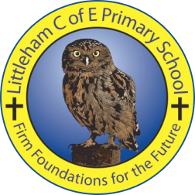
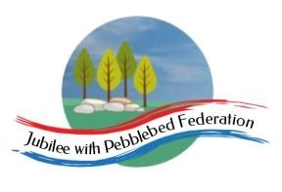
Learning
from Home

Year: Reception & Year 1  Wk beg: 17/5/2021 | Lesson One | Lesson  Two | Lesson  Three | Lesson  Four | Lesson  Five
Monday 17th May | Name Practice  Practice writing your name either on a piece of paper or your name card.  Please encourage correct pencil hold – ‘nip, flip and grip’.  Make sure your child can form every letter correctly and without a visual.  Extension/Year 1 Encourage your child to write the letters smaller and on a line. Once they can do this help your child to learn to write their surname also. | Reading  Log onto Bug Club and pick a book to read to your grown up. Ask your child questions about the story and to sound talk the words.  https://www.activelearnprimary.co.uk/login?c=0  Practice reading some of the sound button words in their home learning pack.  e.g. h-u-ff huff  Or read and write the tricky words on their key ring. | Maths  Practice writing numbers correctly.  https://www.youtube.com/watch?v=DzKqCmjVXLI  Watch this 3D shape song.  https://www.youtube.com/watch?v=2cg-Uc556-Q  Build towers using 3D shapes you find around the home. Encourage your child to name and talk about each shape they are using and why.  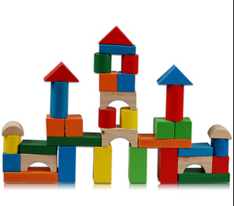 | Phonics  Review all letter sounds learnt so far – see flash cards in home learning pack. Focus on learning the digraphs and trigraphs qu ch sh th ng ai ee igh oa oo(long) oo(short) ar ur ow oi ear air ure er  Revisit the sound oo (long)  https://www.youtube.com/watch?v=VQxqTmiDmIQ  Then practice reading these words:  zoo  food  moo  boot  moon  cool  pool  spoon  roof  fool | PE  Nibs the Octopus | A Cosmic Kids Yoga Adventure! - YouTube
Tuesday 18th May | Name Practice  Practice writing your name either on a piece of paper or your name card.  Please encourage correct pencil hold – ‘nip, flip and grip’.  Make sure your child can form every letter correctly and without a visual.  Extension/Year 1 Encourage your child to write the letters smaller and on a line. Once they can do this help your child to learn to write their surname also. | Reading  Log onto Bug Club and pick a book to read to your grown up. Ask your child questions about the story and to sound talk the words.  https://www.activelearnprimary.co.uk/login?c=0  Practice reading some of the sound button words in their home learning pack.  e.g. h-u-ff huff  Or read and write the tricky words on their key ring. | Maths  Practice writing numbers correctly.  https://www.youtube.com/watch?v=DzKqCmjVXLI  Watch this 3D shape song.  https://www.youtube.com/watch?v=2cg-Uc556-Q  Explore the 2-D shapes that make up 3-D shapes. Do this by printing with paint the different faces of 3D shapes. For example you can print a square and rectangle face using a cuboid.  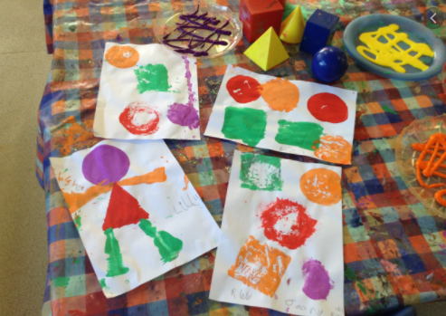 | Phonics  Review all letter sounds learnt so far – see flash cards in home learning pack. Focus on learning the digraphs and trigraphs qu ch sh th ng ai ee igh oa oo(long) oo(short) ar ur ow oi ear air ure er  Revisit the sound oo (short)  https://www.youtube.com/watch?v=McxGM5mU0uM  Then practice reading these words:  cook  good  hood  hook  look  foot  stood  shook  took  wool | Literacy  Talk about sea creatures and choose favourite one. Discuss adjectives to describe it.  Now draw this sea creature and choose a texture they would like to use to describe it. Add desired texture.  For example, you could draw a shark and give it shiny eyes. Or a crab and give it bumpy claws.
Wednesday 19th May | Name Practice  Practice writing your name either on a piece of paper or your name card.  Please encourage correct pencil hold – ‘nip, flip and grip’.  Make sure your child can form every letter correctly and without a visual.  Extension/Year 1 Encourage your child to write the letters smaller and on a line. Once they can do this help your child to learn to write their surname also. | Reading  Log onto Bug Club and pick a book to read to your grown up. Ask your child questions about the story and to sound talk the words.  https://www.activelearnprimary.co.uk/login?c=0  Practice reading some of the sound button words in their home learning pack.  e.g. h-u-ff huff  Or read and write the tricky words on their key ring. | RE  Share and discuss the story ‘A New King’ (see Google Classroom)  Practise our new lunchtime prayers.  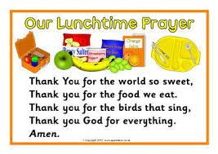  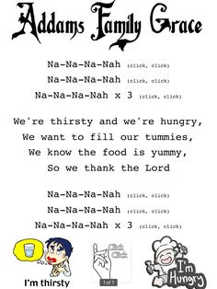 | Phonics  Review all letter sounds learnt so far – see flash cards in home learning pack. Focus on learning the digraphs and trigraphs qu ch sh th ng ai ee igh oa oo(long) oo(short) ar ur ow oi ear air ure er  Now practise reading and writing the phase 3 tricky words:  you  they  all  are  my  her  he  she  we  me  be  was | Literacy  Look at the sea creature you made yesterday and write the sentences to go with it.  E.g. That’s not my ……..  It’s …….. is/are too …….  Your child may be able to write both sentences or if they find writing tricky you may just get them to write the missing words.
Thursday 20th  May | Name Practice  Practice writing your name either on a piece of paper or your name card.  Please encourage correct pencil hold – ‘nip, flip and grip’.  Make sure your child can form every letter correctly and without a visual.  Extension/Year 1 Encourage your child to write the letters smaller and on a line. Once they can do this help your child to learn to write their surname also. | Reading  Log onto Bug Club and pick a book to read to your grown up. Ask your child questions about the story and to sound talk the words.  https://www.activelearnprimary.co.uk/login?c=0  Practice reading some of the sound button words in their home learning pack.  e.g. h-u-ff huff  Or read and write the tricky words on their key ring. | Maths  Practice writing numbers correctly.  https://www.youtube.com/watch?v=DzKqCmjVXLI  - Use construction materials or food packaging to make 3-D solid shapes.  - Challenge them to talk about the shape they have made and talk about some of its properties.  - How many different 3-D shapes can they make? | Phonics  Review all letter sounds learnt so far – see flash cards in home learning pack. Focus on learning the digraphs qu ch sh th ng ai ee igh oa oo(long) oo(short) ar ur ow oi ear air ure er  Revisit the sound ar  https://www.youtube.com/watch?v=yVsmYlNXU-k  Then practice reading these words:  took  wool  book  wood  art  jar  park  start  We have learnt all the sounds in these words so see if your child can sound talk them e.g. t-oo-k | Literacy  Look again at how we changed our class story. (Ask for photo of story map if appropriate)  Write another sentence/s linked to the animal to describe it. These sentences will be added to a class book.  ‘That’s not my ______. Its ____ is to _____.
Friday 21st May | Name Practice  Practice writing your name either on a piece of paper or your name card.  Please encourage correct pencil hold – ‘nip, flip and grip’.  Make sure your child can form every letter correctly and without a visual.  Extension/Year 1 Encourage your child to write the letters smaller and on a line. Once they can do this help your child to learn to write their surname also. | Reading  Log onto Bug Club and pick a book to read to your grown up. Ask your child questions about the story and to sound talk the words.  https://www.activelearnprimary.co.uk/login?c=0  Practice reading some of the sound button words in their home learning pack.  e.g. h-u-ff huff  Or read and write the tricky words on their key ring. | Maths  Practice writing numbers correctly.  https://www.youtube.com/watch?v=DzKqCmjVXLI  - Try to make different 3-D shapes using lolly pop sticks/straws using the play-dough to attach the sticks at the corners.  - Assist with this if they need help to complete their shapes.  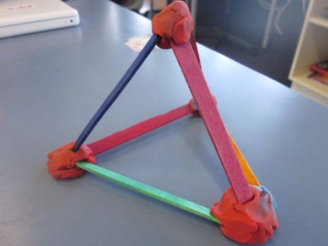 | Phonics  Review all letter sounds learnt so far – see flash cards in home learning pack. Focus on learning the digraphs qu ch sh th ng ai ee igh oa oo(long) oo(short) ar ur ow oi ear air ure er  Revisit the sound or  https://www.youtube.com/watch?v=68FTaim0FOQ  Then practice reading these words:  dart  bark  arm  star  for  pork  cord  corn | Handwriting  Practice drawing different shapes  Circle  Oval  Rectangle  Square  Triangle  Diamond  Heart  Star
Please be aware that your home filter may allow unsuitable links to pop up when watching any YouTube video.

We would love to see any photos of the learning you are doing at home. Please send these to YRteacher@littleham.devon.sch.uk
Please let us know if you need any additional resources to help your child to complete their home learning with you at home.

