Hub Weekly Challenges 4
Week beginning 11 May 2020
Get Building Challenge  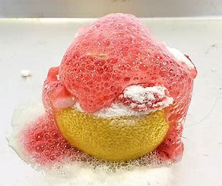  Lemon volcano!!  Lemons  Baking soda  Fairy liquid  Plate  Food colouring  Place half a lemon onto a plate & poke holes in it.  Place drops of (different coloured) food colouring around the different sections.  Pour some fairy liquid over the top of the lemon  Sprinkle a generous amount of baking soda onto the top of the lemon. Use a cocktail stick to press down on different sections of the lemon to get the eruption going!  Try this on various different citrus fruits. Which one works best?! | Arty Crafty Challenge  Can you make your very own aquarium in a jam jar?  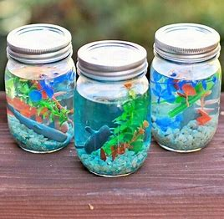
The Tasty Challenge  Can you make your name out of biscuits and decorate?  200 g butter/marg  200g sugar  1 large egg  400g plain flour  Optional - ½ tsp vanilla extract or 1  lemon zested  Mix butter and sugar together. Add beaten egg. Add flour. Form into a ball and chill for an hour. Roll out and cut into biscuits. Cook for 12 mins at 190. Cool & then have fun decorating! | Keep Fit Challenge  Indoor scavenger hunt:  Collect all of the following items in a bag or basket. Tick it off the sheet as you find each one!  A toy with wheels  A book with the first and last letter of your name in the title  A pair of matching socks  4 things that are green  Something very soft  An object/toy smaller than your hand  An object that is taller than you  Something old  Something that begins with the letter D  Something you can only use indoors
Can you find out Challenge?  Set by Freddie:  What was the tallest building in 1984? What is the tallest building now?  What is the oldest building in the world? | Pass the Parcel Challenge  Continue with your stories, poems and newspaper articles. You have a new one that has been passed onto you this week. You need to write the next paragraph or verse ONLY and then email it back to me. Each week, I’ll pass the stories around….amongst the adults as well! Our writing will grow each week.
Grill a Teacher Challenge  Alex asked me if I like the film Peter Rabbit?  Yes, Alex I did. I like James Corden who does the voice of Peter Rabbit as I think he is very funny. The rabbits’ team spirit is brilliant, all working together to steal the vegetables! I like the tightrope scene where they fall into the trousers on the washing line and come out at the bottom of each leg! Very funny!  This week’s teacher is Mrs Jones.  Email any questions you would like to ask her and I’ll give you the answers next week. Make sure you are polite! | Your turn!  Would you like to set any of the challenges next week? Email me any of your ideas. Maybe you would like to set a Tasty Challenge or the next Keep Fit Challenge. Be creative!  Thank you to Freddie for this week’s question.
I will email this out to you on a Monday. Please send me an email once a week with any of your responses, pictures etc. By Sunday 2.00pm please if you want your entries to be included. Send me an email to keepintouch@littleham.devon.sch.uk

Pass the Parcel Writing!
Freddie:
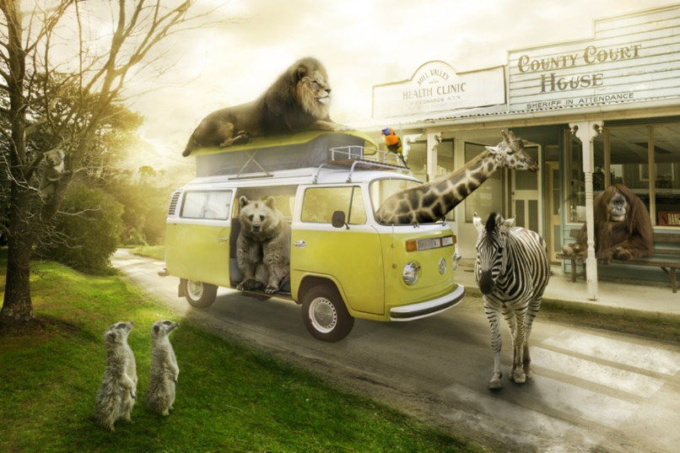
Most visitors are a little shocked (to put it mildly) when they arrive at Animal Town. Despite the fact that the name of the town gives a slight indication to passers-by that the inhabitants of the town are ‘not normal’, it’s as if people don’t believe things until they see them with their own eyes!
Once you get used to being in Animal Town – or so they say – seeing an orangutan behind a desk in a sheriff’s office and upholding the law to an impeccably high standard becomes relatively ‘normal’…
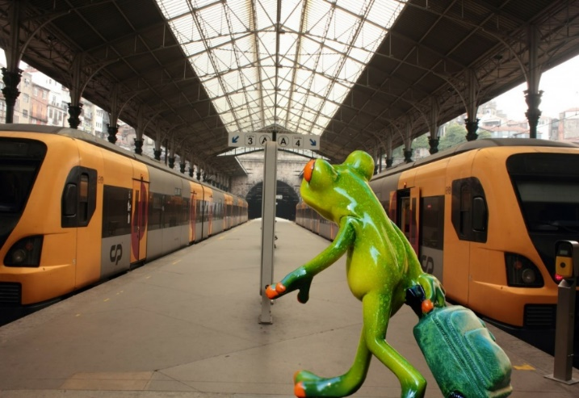
AF: There is even a train station that is run by a Rattlesnake called Lucy and her family. They help the other snakes to and from London, Zootropolis and Penzance.
GC: It is not unusual to see Zebras, in their black and white uniform of course, patrolling the streets, enforcing strict car parking measures, giving out the occasional parking ticket and obviously monitoring Zebra crossings! Don’t be fooled, these animals may look harmless and have on occasion, even been called cute, but they are feisty! There is literally nothing you can do to explain away why you had to park on the double black lines or why you decided to cross the Zebra crossing backwards. Fines and tickets are issued daily.
SH – The thing is, this Animal town appears relatively ‘normal’ of a day (once you get used to it of course!) Orangutangs behind desks, zebras handing out parking tickets, snakes running train stations, tigers riding bikes, cats being the best hair dressers in town and even the elephants have got their nail salon set to up to perfection. So good, their awarded best in town each year! The list really does go on, but what the visitors of Animal Town do not know, is that things drastically change of a night time. I mean, did they not tell you the Animals become humans when the sky is dark?!

Miss Hitchcock
There was an old man with a beard
Who said, “It’s just how I feared!
Two owls and a hen
Four larks and a wren
Have all built their nests in my beard

JC -There was a silly old cat,
He wore a coat, some gloves and a hat,
He ate all day long,
To be big and strong,
But ended up very fat!

A young witch called Nellie,
Made potions that were smellie,
The spells were not right,
As she was not bright,
And she ended up with a sore belly!

GC- There was an old teacher indoors,
Who had no children just chores,
She wanted to teach,
Get away from the bleach,
But she just kept cleaning the floors!

Mrs Cambridge:
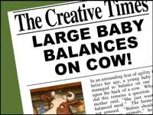
Reporter: Jacqui Clark

Yesterday, locals in the village of Hamlittle were shocked to see a giant baby sitting on a cow in a field that belonged to Farmer Jack McDonald (postcode , ei ei o).
Concerned for the baby's wellbeing, a local girl-Miss Muffett called the authorities and contacted us at the Fabled Times. Constable Dick Wittington was quick to attend the scene and deal with the situation. On speaking to Farmer Jack he was able to establish that there was no cause for concern as Jack informed him that the Beanstalk had grown back and that the baby belonged to the Giant family who lived in a castle in the clouds and they often came down to visit Jack and meet the cow that had brought the two families together. Mrs Giant was very positive about the friendship and said, " Although we are from different backgrounds, we get on famously.”

Alex reports that the giant was killed when the beanstalk was chopped down were false and he also does not like to grind peoples bones to make his bread. It appears that Jack made up these stories so he would not get told off for stealing the magic harp and the hen by his mum.

Alex:
I wish there was a law that said………

KJ: That adults aren't in charge of children 7 days a week.
For one day, children have free reign. They can choose what they want to do, and where they want to go, and the adult must adhere to the rules!

JC: That when it’s your birthday you can have a day of school/work and everything is paid for. You could take a day trip anywhere. Eat what you want and everyone you meet greets you with a smile and sings ‘Happy Birthday’!

Freddie and Forest school friends:
- All public transport over the whole country to be free for people over 70.

- Litter dropping especially plastic is to be fined. 1st time £ 110. 2nd time £ 310. 3rd time £ 1000. 4th time -1 month in prison

- Eating egg sandwiches in confined spaces to be banned.

- All students up to age 18 should have free public transport during term time.

Mrs Clark:
In six days there will be no more chocolate in the world….ever! That’s what it said on The Seven Show. Jelly had nearly reached the next level of Zombie Puppy Dash, but hearing this made her plunge the pink puppy into a huge tank of zombie dog food. “Woah! What was that about chocolate….”
KJ: Jelly could not believe what she was hearing! How can this be?! Chocolate is Jelly's most favourite thing in the world (closely followed by Zombie Puppy Dash)
Jelly dreamed that one day she would own a chocolate shop, filled with all of her favourite bars; Crunchie, Twirl, Lion, Milkybar, Mars bar, to name a few. A chocolate bar Buckingham Palace to attract the customers, but now Jelly will have to think of a new dream...........
Jelly had to start the level of Zombie Puppy Dash again, and Jelly better eat chocolate for breakfast, lunch, and dinner for the next six days.

Harry -you can add a paragraph to either of these entries!
Dear Diary,
Today, the doorbell rang, and I eagerly ran down the stairs. By the time I had opened the door, the delivery driver had vanished, but a giant box had been left on my doorstep.
​SH - The box was too heavy to lift and too big to get through the door. I opened it to find a smaller box inside, covered in chains and padlocks. A note was stuck on the top that said ‘this box of secrets has been hidden for hundreds of years. Look closely and follow the clues’
I sat next to the box for a while, reading the note, wondering how I was going to solve this mystery. A white feather with two black spots on fell from the sky and landed on my foot. I picked it up and looked at it closely. Was this my first clue?

KJ - Dear Diary,
Today, the doorbell rang, and I eagerly ran down the stairs. By the time I had opened the door, the delivery driver had vanished, but a giant box had been left on my doorstep.
What had I ordered during this lockdown period??
I opened the box and inside that a smaller box - wrapped in yellow and pink polka dot paper, but it was empty.....
I opened that box, to find an even smaller box - wrapped in green and blue polka dot paper, again the box was empty.....
I was wondering why all these boxes were empty, but as I looked again I saw a small package. I opened it to find a small frame which read "True friends are never apart, maybe in distance but never in heart"
This made me smile...........

Mrs Jones:
Bleary-eyed, I went downstairs for breakfast, the house was empty, even the furniture had gone.
GC -I rubbed my eyes. Am I dreaming? But as my eyes adjusted to the morning light creeping in through the slits in the curtains, I realised this was no dream. What was happening? Walking around, in a shocked daze, I noticed dents in the carpet where the furniture had been. There had sat my favourite rocking chair with my fluffy purple cushion; over there had lived my piano with one key missing and beyond had stood my slightly faded sofa. Suddenly, a chill ran down my spine, and turning sharply, I thought I noticed a slight scurry of movement in the corner of the room.
SH: As I turned, the piano key flew across the room and the piano started to play. What on earth was going on? I rubbed my eyes again, I couldn’t quite believe what I was seeing. I crept across the squeaky floorboards towards the piano key that was dangling in front of the living room window. As I reached out to get it, it flew straight past me and up the stairs. Now I really was nervous, but I slowly crawled up the stairs, following the piano key. It led me to the bathroom, but my bathroom was no more, there in front of me, was a spiralling circle, whizzing around so fast I went a bit dizzy! I sat on the floor, the piano suddenly stopped and a whispering voice said ‘Crawl through the whizzing tunnel, your adventure is about to begin’.

Hub Exhibition

w/b. 20.4.20 Alex’s bottle rocket, carrot cake and proudly wearing his new Blue Peter badge which arrived this week. FANTASTIC!
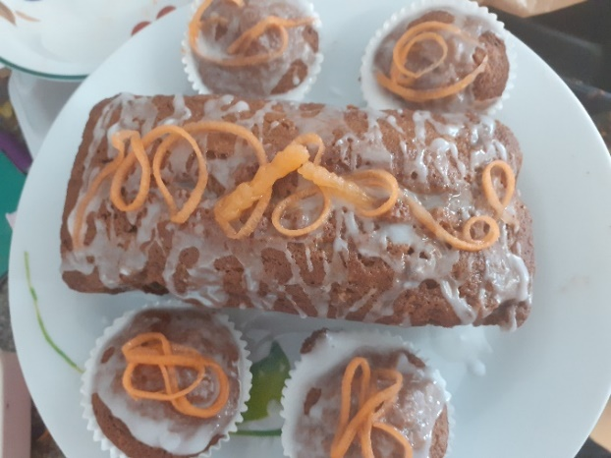
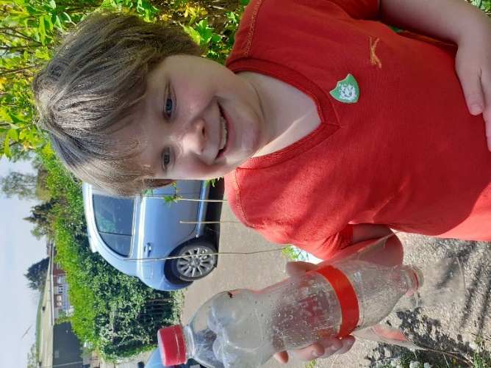
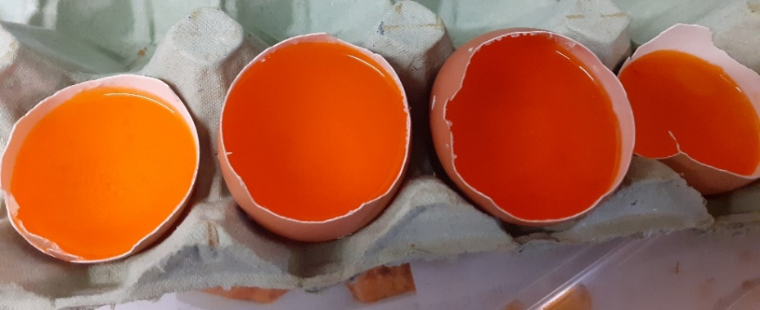
w/b. 27.5.20
Alex started to make his crystal geode eggs.
These look exciting! Can we have a picture once they have crystalised?

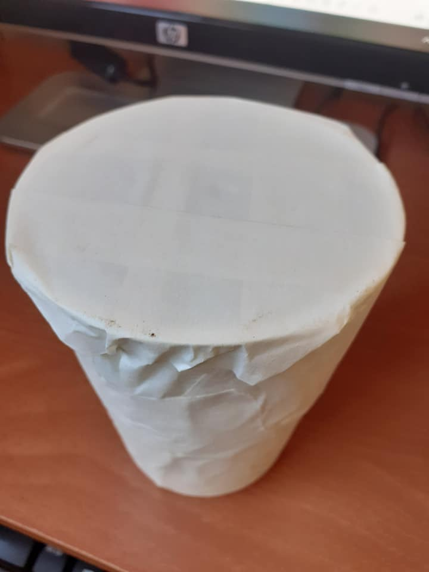
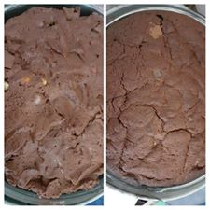
w/b 4.5.20 Alex’s chocolate concrete -before and after baking

Yoghurt pot drum
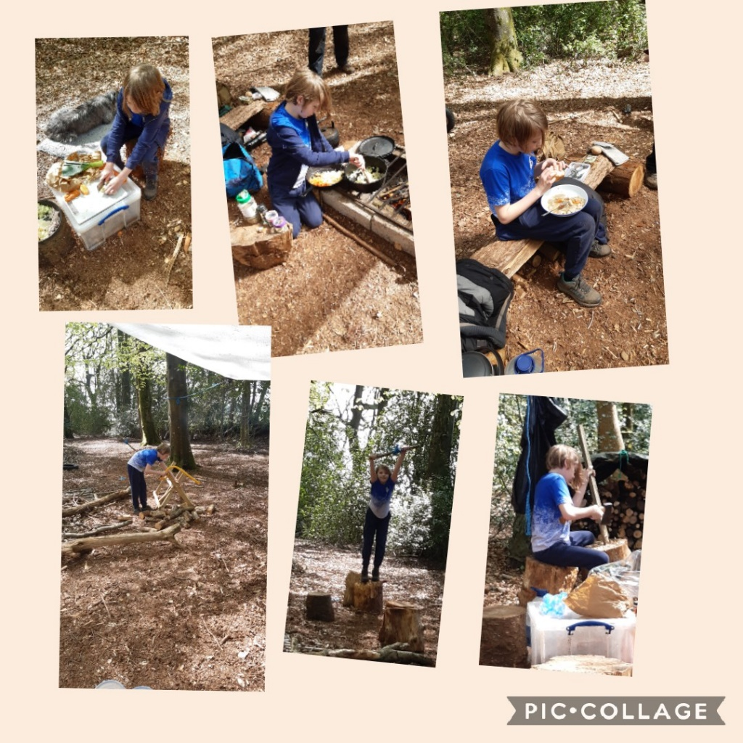
Fun at Forest school! That food looks delicious Freddie!

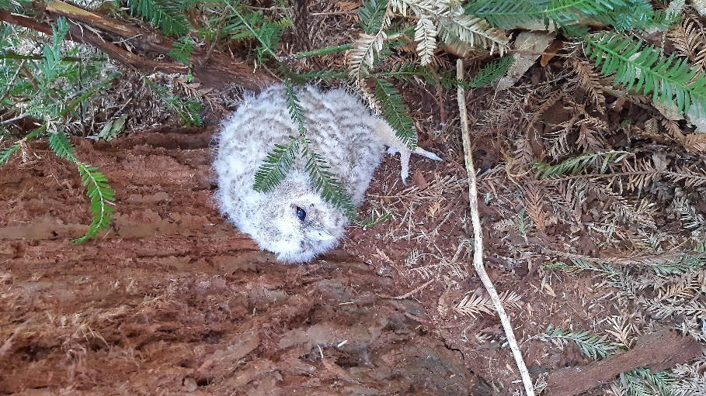
Beautiful baby tawny owl seen at Forest school -I bet you wanted to take it home with you Freddie!

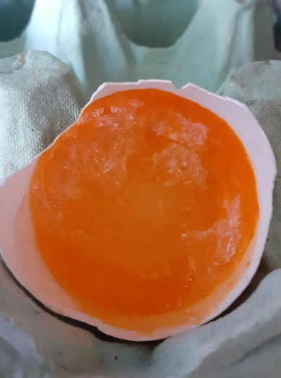
Alex Goode egg update…beginning to crystallize.

