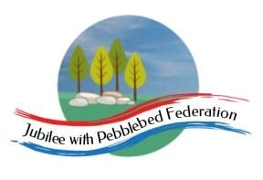
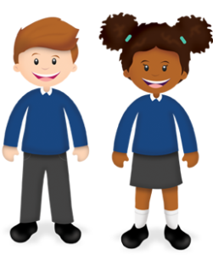
Play and Learn in Reception

Reception  February | As part of our Early Years Foundation Stage Curriculum we also learn lots through play! In school we will also be doing some of the following as part of our continuous provision. You are welcome to try some of these activities in addition to the home learning grid/Google Classroom
Play dough cakes  Use play dough to make cakes for Grandma. Can you count how many cakes you have made? How many will there be if Grandma eats 1? 2? | Skittles  Play skittles. If you don’t have skittles you can use plastic cups or something else you have at home. How many skittles can you knock down? What is your best score? | Construction  Use construction toys you have at home to make Grandma’s cottage/house or another building from a story you have read together. | Junk modelling  Save some of your recycling and use this to make Grandma’s cottage/house. You may want to paint your cottage/house. | Story Time  Share different stories at home. Can you join in with any of the repetitive language? Can you do voices for some of the characters? | Mask Making  Can you make a mask of a story character, e.g. The Big Bad Wolf? Use this to act out part of the story with your family.
Singing  Learn and sing some songs.  https://www.youtube.com/watch?v=754citytvAY  https://www.youtube.com/watch?v=Z0m6EKdluWg | Cooking  Make some cakes/treats that Little Red Riding Hood could take to Grandma. | Little Red Riding Hood Art  Paint or draw a picture of Little Red Riding Hood or the Wolf. Remember to include all of the body parts. | Pancakes  Make pancakes with the help of your grown up. Can you toss the pancake? You might even be able to have a pancake race with your family members. | Making Shapes  Cut up sticks or straws. Can you use these to make shapes?  Can you make a square, triangle and rectangle? | Card Making  Make a Valentine’s Day card for someone you love. Try to write inside. Can you spell the words To, love and from
We would love to see any photos of the fun things you are doing at home. Please send these to YRteacher@littleham.devon.sch.uk
Please be aware that your home filter may allow unsuitable links to pop up when watching any YouTube video.

