**Cuboid net 1**



**Cuboid net 2**



**Cuboid net 3**



**Pyramid net 1**



**Pyramid net 2**

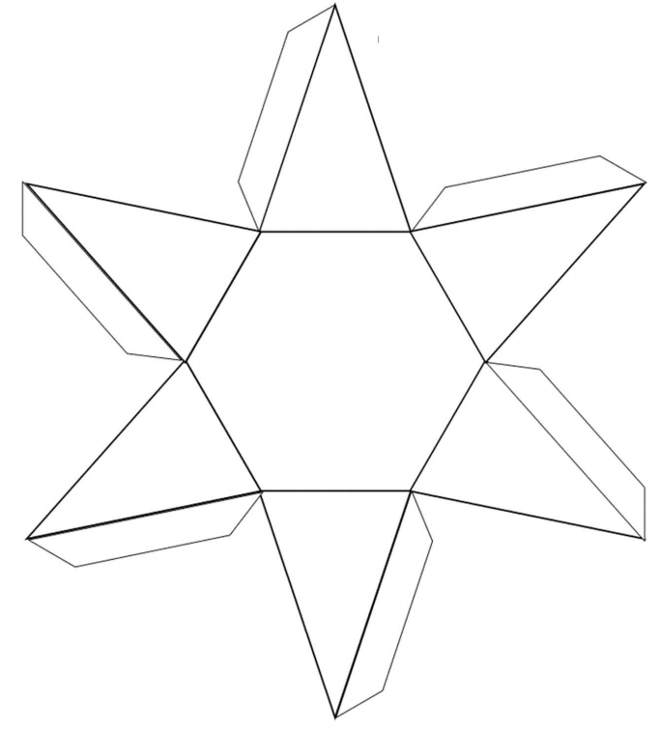

**Prism net 1**



**Prism net 2**

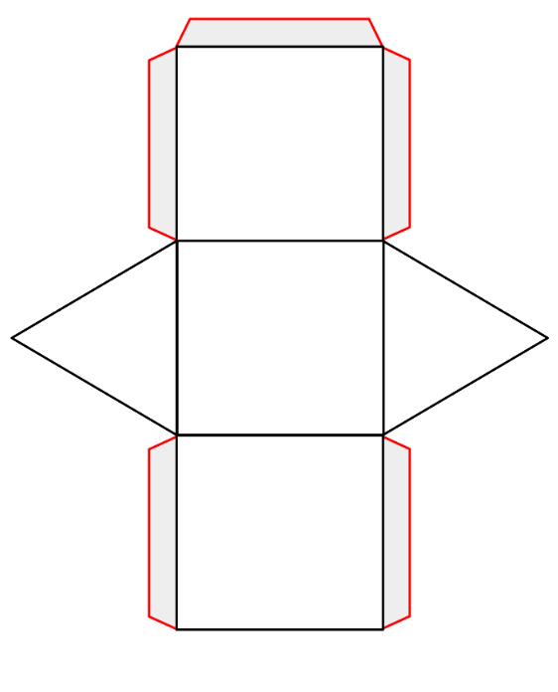

**Prism net 3**

