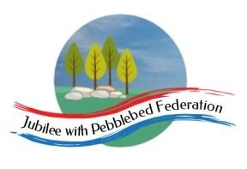
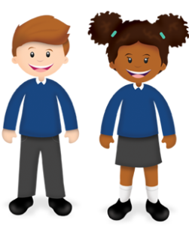
Learning
from Home

Year: 4  Wk beg:  10.5.21 | Lesson One | Lesson Two | Lesson Three
Monday | English  https://classroom.thenational.academy/lessons/to-explore-and-respond-to-john-lyons-poetry-dancing-in-the-rain-part-2-6xgkec | Maths  https://classroom.thenational.academy/lessons/reading-interpreting-and-comparing-pictograms-6tjkgd | Science  https://classroom.thenational.academy/lessons/what-are-organs-and-why-do-we-need-them-c8wk0c
Tuesday | English  https://classroom.thenational.academy/lessons/to-practise-and-apply-knowledge-of-suffixes-ous-including-test-c9gkgt | Maths  https://classroom.thenational.academy/lessons/construct-pictograms-64w3ce | PHSCE  https://classroom.thenational.academy/lessons/community-care-cctp8c
Wednesday | English  https://classroom.thenational.academy/lessons/to-perform-a-poem-70tp4t | Maths  https://classroom.thenational.academy/lessons/read-interpret-and-compare-bar-charts-cth3gd | Topic  https://classroom.thenational.academy/lessons/who-were-the-normans-6dh34c
Thursday | English  https://classroom.thenational.academy/lessons/to-analyse-carib-nightfall-6rrkae | Maths  https://classroom.thenational.academy/lessons/constructing-bar-charts-6th3er | Topic  https://classroom.thenational.academy/lessons/1066-and-the-succession-crisis-6crp2r
Friday | English  https://classroom.thenational.academy/lessons/to-analyse-dancing-in-the-rain-6gtked | Maths  https://classroom.thenational.academy/lessons/consolidation-lesson-bar-chart-6nk6at | PE  Joe Wicks workout  https://www.youtube.com/watch?v=YIB2SJnBHBQ

