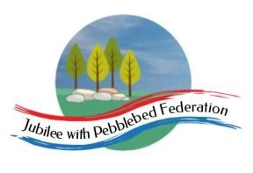
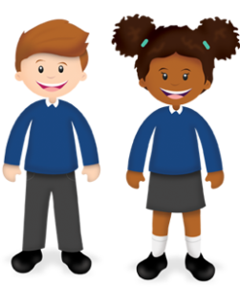
Learning
from Home

Year: 2  Wk beg: 12/10/20 | Lesson One | Lesson Two | Lesson Three | Lesson Four
Monday | Maths  https://classroom.thenational.academy/lessons/combining-sets-count-all-cru68d | English  https://classroom.thenational.academy/lessons/to-listen-to-an-information-text-and-answer-questions-6ctp2r | Reading  Please use Bug Club Password supplied to access texts set by Mrs Hooper for your child. | PE  https://www.youtube.com/watc h?v=L_A_HjHZxfI
Tuesday | Maths  https://classroom.thenational.academy/lessons/combining-sets-count-all-cru68d | English  https://classroom.thenational.academy/lessons/to-listen-to-an-information-text-and-answer-questions-6ctp2r | Reading  Please use Bug Club Password supplied to access texts set by Mrs Hooper for your child. | Geography  https://classroom.thenational.academy/lessons/how-do-people-move-around-in-london-68wkat
Wednesday | Maths  https://classroom.thenational.academy/lessons/combining-sets-count-all-cru68d | English  https://classroom.thenational.academy/lessons/to-listen-to-an-information-text-and-answer-questions-6ctp2r | Reading  Please use Bug Club Password supplied to access texts set by Mrs Hooper for your child. | Science  https://classroom.thenational.academy/lessons/which-materials-are-absorbent-6tk3er
Thursday | Maths  https://classroom.thenational.academy/lessons/combining-sets-count-all-cru68d | English  https://classroom.thenational.academy/lessons/to-listen-to-an-information-text-and-answer-questions-6ctp2r | Reading  Please use Bug Club Password supplied to access texts set by Mrs Hooper for your child. | History  https://classroom.thenational.academy/lessons/what-was-london-like-at-the-time-of-the-fire-6ru64c
Friday | Maths  https://classroom.thenational.academy/lessons/combining-sets-count-all-cru68d | English  https://classroom.thenational.academy/lessons/to-listen-to-an-information-text-and-answer-questions-6ctp2r | Reading  Please use Bug Club Password supplied to access texts set by Mrs Hooper for your child. | Music  https://classroom.thenational.academy/lessons/understanding-how-sound-is-represented-by-symbols-64w62t

