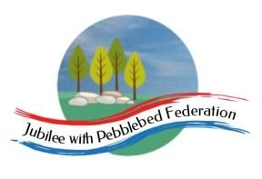
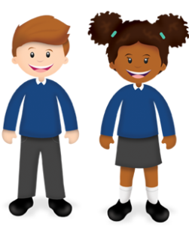
Learning
from Home

Year: 2  Wk beg: 02/11/20 | Lesson One | Lesson Two | Lesson Three | Lesson Four
Monday | Maths  https://classroom.thenational.academy/lessons/to-add-by-counting-on-using-a-number-line-ccukct | English  https://classroom.thenational.academy/lessons/to-listen-and-respond-to-a-set-of-instructions-crr64r | Reading  Please use Bug Club Password supplied to access texts set by Mrs Hooper for your child. | PE  https://www.youtube.com/watc h?v=L_A_HjHZxfI
Tuesday | Maths  https://classroom.thenational.academy/lessons/to-subtract-by-counting-back-using-a-number-line-cgr36d | English  https://classroom.thenational.academy/lessons/to-tell-a-set-of-instructions-from-memory-6rr32t | Reading  Please use Bug Club Password supplied to access texts set by Mrs Hooper for your child. | DTEC  Thinking about safe food prep make sandwich for lunch. Draw and label a picture of it and write instructions for how to make it.
Wednesday | Maths  https://classroom.thenational.academy/lessons/to-add-a-1-digit-number-to-a-teens-number-using-a-known-fact-69gkat | English  https://classroom.thenational.academy/lessons/to-role-play-a-set-of-instructions-64r64r | Reading  Please use Bug Club Password supplied to access texts set by Mrs Hooper for your child. | Science  Explore how some materials can be changed.  Mix different substances in water such as sugar, soil, syrup, washing up liquid. Record if they sink or float, dissolve, change the colour of the water.
Thursday | Maths  https://classroom.thenational.academy/lessons/to-subtract-a-1-digit-number-from-a-teens-number-using-a-known-fact-c4u3gc | English  https://classroom.thenational.academy/lessons/to-use-imperative-verbs-6wr6cd | Reading  Please use Bug Club Password supplied to access texts set by Mrs Hooper for your child. | Music  https://classroom.thenational.academy/lessons/exploring-different-ways-to-use-your-voice-6wrk8c
Friday | Maths  https://classroom.thenational.academy/lessons/to-subtract-a-1-digit-number-from-a-teens-number-using-a-known-fact-c4u3gc | English  https://classroom.thenational.academy/lessons/to-summarise-main-points-6wup6d | Reading  Please use Bug Club Password supplied to access texts set by Mrs Hooper for your child. | Music  https://classroom.thenational.academy/lessons/physicalising-pulse-in-different-ways-crt62t

