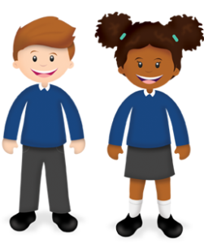
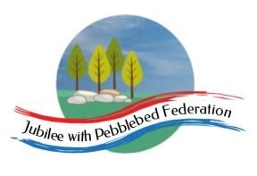
Year 1
Learning from Home

Year:  Week beg:  11/1/2021 | Lesson One | Lesson Two | Lesson Three | Lesson Four | Lesson Five
Monday | Maths  Google Classroom – Know how much each coin to 10p is worth. | English  Google Classroom – Draw your favourite present and write why it is good. | Reading  Log in to Bug Club and read a book from your ‘library’. https://www.activelearnprimary.co.uk/login?c=0  Google Classroom - Phonics | Phonics  Google Classroom – ‘ow’ written as ‘ou’ sound (cloud, sound) | RE  Draw a picture of a precious object, say what it is and why it is precious to them.
Tuesday | Maths  Google Classroom - Find totals of two coins from 1p, 2p, 5p and 10p. | English  Google Classroom – Watch the video of Boa’s Bad Birthday on Youtube and draw a story map. | Reading  Log in to Bug Club and read a book from your ‘library’. https://www.activelearnprimary.co.uk/login?c=0  Google Classroom - Phonics | Phonics  Google Classroom – Read words: now, prowl, ground, proud | DT  Choose healthy ingredients to make a sandwich or a salad!
Wednesday | Maths  Google Classroom - Use combinations of 1p, 2p, 5p and 10p coins to pay for items. | English  Google Classroom – Answer some ‘feeling’ questions. Why is Boa sad? How did the story make you feel? | Reading  Log in to Bug Club and read a book from your ‘library’. https://www.activelearnprimary.co.uk/login?c=0  Google Classroom - Phonics | Phonics  Google Classroom – ‘oi’ as ‘oy’ sound (enjoy, annoy) | PSHE  Google Classroom – draw and write differences between what babies, children and adults can do.
Thursday | Maths  Google Classroom – Money quiz. Which coin is round and silver? Which coin is brown?  Maths  Google Classroom - Know the value of each coin to 10p and recognise £1. | English  Google Classroom – Correct the sentence by adding capital letters and full stops. boa got a present | Reading  Log in to Bug Club and read a book from your ‘library’. https://www.activelearnprimary.co.uk/login?c=0  Google Classroom - Phonics | Phonics  Google Classroom – Read words oil, coins, destroy, oyster | PE  Google Classroom / Youtube, PE with Joe Wicks
Friday |  | English  Google Classroom – Draw your friends and write their names, with a capital letter. | Reading  Log in to Bug Club and read a book from your ‘library’. https://www.activelearnprimary.co.uk/login?c=0  Google Classroom - Phonics | Phonics  Google Classroom – Read and write the sentence ‘Roy has lots of toys’.  different toys,  but Joy has not  got many. | Art  Draw a picture of a family celebration.

