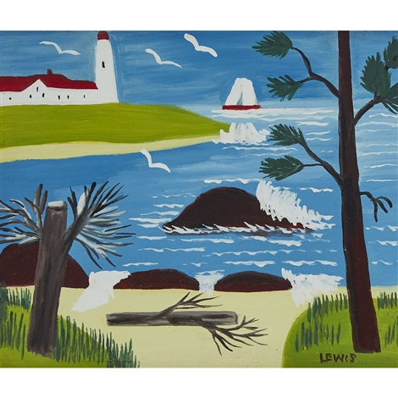
Maud Lewis Lighthouse and Yacht c1965

