Year 1
Learning from Home

Year:  Week beg:  01/3/2021 | Lesson One | Lesson Two | Lesson Three | Lesson Four | Lesson Five | Lesson Five
Monday | Maths  Google Classroom - Find change from 10p | English  Google Classroom – To separate words with spaces. | Reading  Log in to Bug Club and read a book from your ‘library’. https://www.activelearnprimary.co.uk/login?c=0  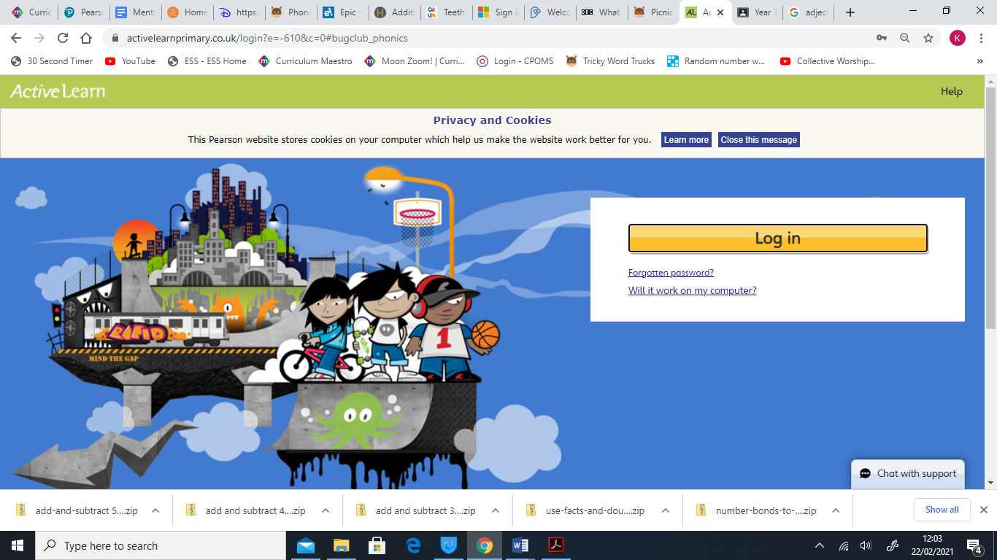 | Phonics  Phoneme /l/ written as 'le' such as apple and table. | RE Google Classroom - To think about the Shabbat and links between objects that are related to Shabbat.  are related to Shabbat.  Thinking about Shabbat. | PE https://youtu.be/VHbQD7aZQxA
Tuesday | Maths - Finding the difference between amounts of money or Investigation - Use ‘Find the Difference’ from NRICH: https://nrich.maths.org/6227 | English  Google Classroom – To begin to punctuate sentences using a capital letter, full stop or exclamation mark. |  | Phonics  Phoneme /m/ written as 'mb' such as thumb and lamb. | PSHE - Google Classroom - I know what being jealous means. https://www.bbc.co.uk/teach/class-clips-video/pshe-eyfs-ks1-feeling-jealous/zr6ngwx  Science  Google Classroom – To identify different types of teeth. | Mental Health  http://www.littleham.devon.sch.uk/website/mental_health/535426
Wednesday | Maths  Google Classroom – Know number bonds to 8. Recognise that addition can be done in any order. | English  Google Classroom – To compose sentences out loud. |  | Phonics  Phoneme /n/ written as 'kn' and 'gn' such as knock and sign. |  | History  Google Classroom - To order events on a timeline.
Thursday | Maths  Google Classroom – Know number bonds to 9. Recognise that addition can be done in any order.  Maths  Google Classroom – Find doubles (up to double 6). | English  Google Classroom – To check for punctuation such as full stops and capital letters. |  | Phonics Phoneme /r/ written as 'wr' such as wrong and wrist. | PE  https://youtu.be/VHbQD7aZQxA | Mental Health –  http://www.littleham.devon.sch.uk/website/mental_health/535426
Friday |  | English  Google Classroom – To say my sentences out loud. |  | Phonics Read the sentence ‘Tiger chased a cat and landed in a pond’. | Collective Worship  Google Classroom | Story time  Google Classroom – choose a video of Miss Thornton reading a story.

Please be aware that your home filter may allow unsuitable links to pop up when watching any YouTube videos.
How have you worked like a Squirrel this week? Send me a photo for our display at school!

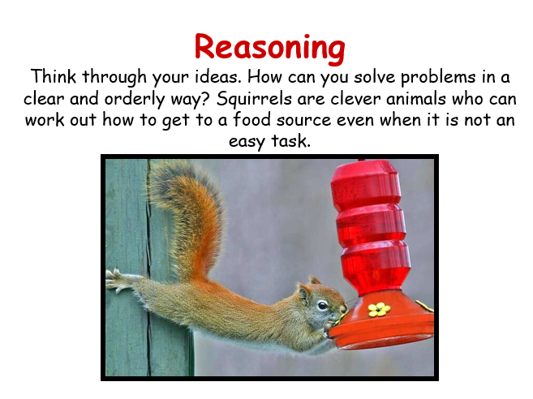

__________has behaved like a ‘Squirrel’ at home by…..

