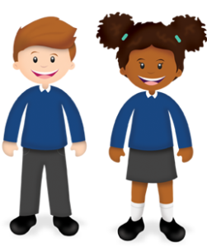
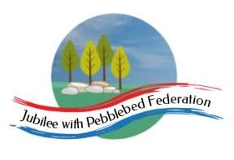
Year 1
Learning from Home

Year:  Week beg:  1/2/2021 | Lesson One | Lesson Two | Lesson Three | Lesson Four | Lesson Five | Lesson Five
Monday | Maths  Google Classroom – Tell the time to the hour. Play ‘What’s the time Mr Wolf?’ | English  Google Classroom – To compose sentences orally. Read your new story out loud, using story map. | Reading  Log in to Bug Club and read a book from your ‘library’. https://www.activelearnprimary.co.uk/login?c=0  Google Classroom - Phonics | Phonics  S sound written as letter ‘c’ followed by e, i and y: such as ‘mice, | RE  Google Classroom – Think of a phrase that is special to you, such as ‘Spread a smile’. | PE  https://youtu.be/VHbQD7aZQxA
Tuesday | Maths  Google Classroom – Know the times of key events in the day, for example – lunch time, bedtime. | English  Google Classroom – Understand how words combine to make sentences. Write start of story. | Reading  Log in to Bug Club and read a book from your ‘library’. https://www.activelearnprimary.co.uk/login?c=0  Google Classroom - Phonics | Phonics  S sound written as ‘sc’ such as scent and scene. | Music  Listen to and learn a nursery rhyme such as ‘I can sing a rainbow’, or ‘the alphabet song’. | Mental Health –  Stay connected to those you care about by phone or letter. http://www.littleham.devon.sch.uk/website/mental_health/535426
Wednesday | Maths  Google Classroom – Order days of the week. Read ‘The Very Hungry Caterpillar’. | English  Google Classroom – use capital letters for names. Write middle of story. | Reading  Log in to Bug Club and read a book from your ‘library’. https://www.activelearnprimary.co.uk/login?c=0  Google Classroom - Phonics | Phonics  ‘S’ and ‘Z’ written as ‘se’/ Such as horse, mouse, cheese and please. | PSHE  Discuss what ‘unique’ means and draw themselves/ watch ‘Odd Dog out’ on Youtube and design a dog. | History  Google Classroom – order events on a timeline.
Thursday | Maths  Google Classroom – Order months of the year. Link to the four seasons, e.g. what season is December?  Maths  Google Classroom – Quiz! (Find missing day/month, order events of the day). | English  Google Classroom – Use capital letters and full stops. Write end of story. | Reading  Log in to Bug Club and read a book from your ‘library’. https://www.activelearnprimary.co.uk/login?c=0  Google Classroom - Phonics | Phonics  learn to read and spell irregular words “great” and “clothes”. | PE  Youtube, PE with Joe Wicks | Mental Health –  Be proud of yourself – write post-its of your achievements for a jar. http://www.littleham.devon.sch.uk/website/mental_health/535426
Friday |  | English  Google Classroom – Read my writing to check it makes sense. Read through whole story to an audience. | Reading  Log in to Bug Club and read a book from your ‘library’. https://www.activelearnprimary.co.uk/login?c=0 | Phonics  Read the phase 5 tricky words and sounds from home learning pack. | Collective Worship  Google Classroom | Story time  Google Classroom – choose a video of Miss Thornton reading a story to watch.

Please be aware that your home filter may allow unsuitable links to pop up when watching any YouTube videos.
What have you made links between this week? Send me a photo for our display at school!

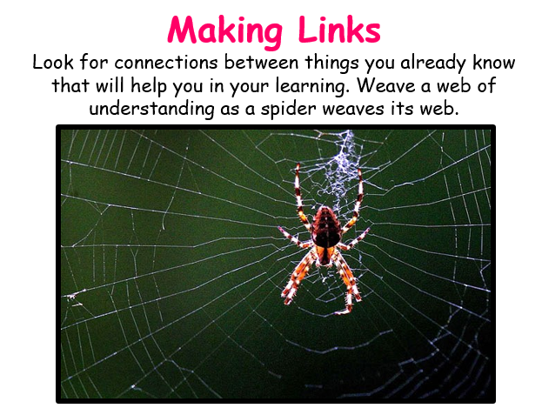

__________has behaved like a ‘Spider’ at home by…..

