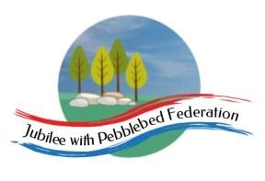
Learning
from Home

Year:  Wk beg: | Lesson One | Lesson Two | Lesson Three | Lesson Four
Monday | INSET | INSET | INSET | INSET
Tuesday | Spelling  Learn your spellings | English  https://classroom.thenational.academy/lessons/to-identify-the-features-of-an-explanation-text-6tgk2r | Maths  https://classroom.thenational.academy/lessons/adding-and-subtracting-1-digit-numbers-tofrom-3-digit-numbers-68uk4e | Computing  https://www.bbc.co.uk/newsround/44074704  https://www.bbc.co.uk/newsround/26136189
Wednesday | Spelling  Learn your spellings | English  https://classroom.thenational.academy/lessons/to-explore-compound-words-6wwpat | Maths  https://classroom.thenational.academy/lessons/adding-multiples-of-10-to-3-digit-numbers-cgwp6d | History  https://classroom.thenational.academy/lessons/how-was-ancient-greece-organised-6mv3jr
Thursday | Reading  Read library book or allocated bug club books | English  https://classroom.thenational.academy/lessons/to-explore-using-apostrophes-for-plural-possession-cgvk2d | Maths  https://classroom.thenational.academy/lessons/subtracting-multiples-of-10-from-3-digit-numbers-61k34t | Science  https://classroom.thenational.academy/lessons/what-is-an-adaptation-cmw6ct
Friday | Reading  Read library book or allocated bug club  books | English  https://classroom.thenational.academy/lessons/to-understand-and-sequence-how-bees-make-honey-cgwk2c | Maths  https://classroom.thenational.academy/lessons/adding-and-subtracting-multiples-of-100-tofrom-3-digit-numbers-crw62d | Geography  https://classroom.thenational.academy/lessons/what-are-the-countries-of-europe-69k6cr

