Google classroom instructions
Step 1:
Log into Google Classroom using your child’s assigned email and password.
(You can log in by googling ‘Google classroom login’ which will take you to the google classroom homepage after clicking the top link)
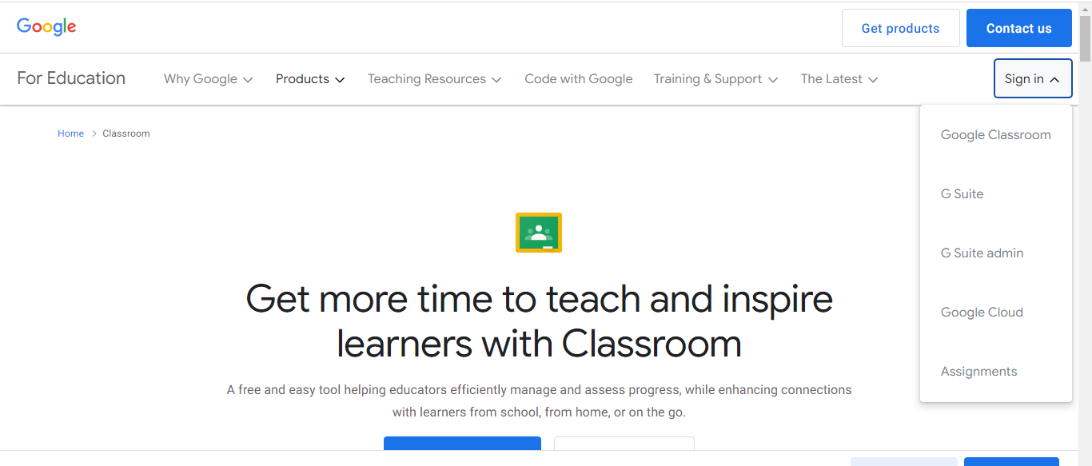Step 2: Once logged into Google classroom join/select the correct class.
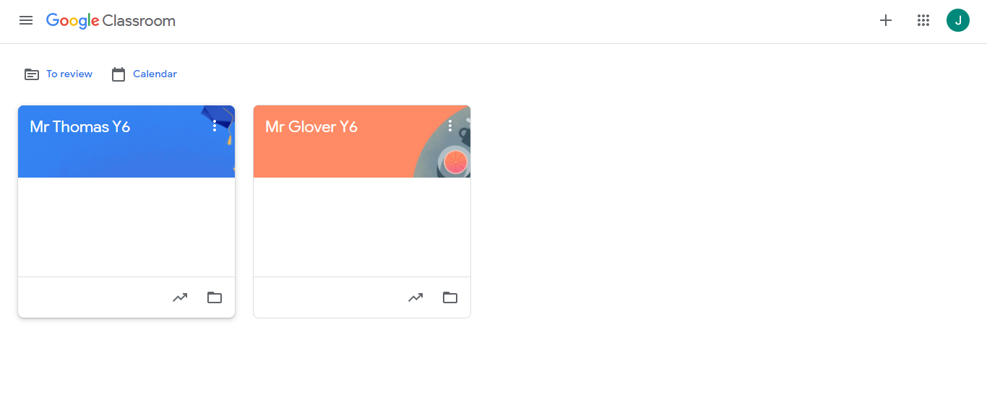Step 3: Once you have selected the correct class, please click on ‘Classwork’.

Step 4: When in ‘Classwork’, please click the home learning assigned you would like to complete.
It will be dated from the day it is set and will have the due date next to itStep 5: Read the instructions given on how to complete the home learning and then click the attached document.
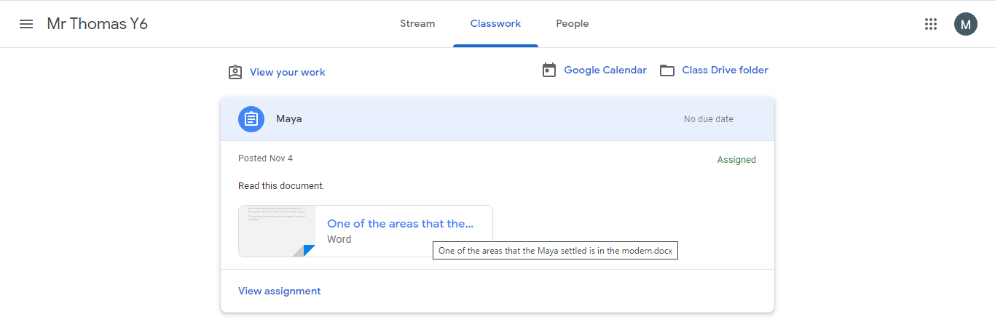
Step 6: The document will open – then click ‘Open with Google Docs’ at the top of the page in order to edit the document. This will open the document in a new tab.
Step 7: Begin answering the questions on the sheet. A Google document automatically saves as you work. Once completed, close the tab.
Step 8: Once back to the work page, click the ‘add or create’ panel on the right. Then click ‘Google Drive’ from the sub menu.
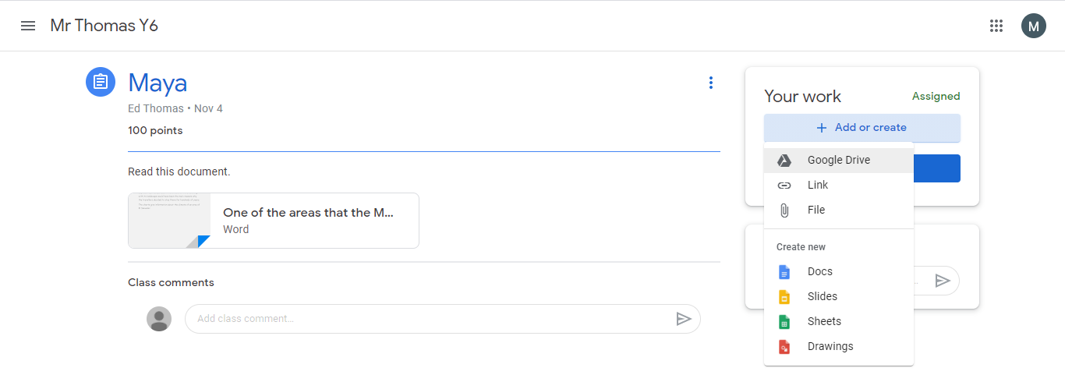

Step 9: Once the Google Drive menu opens, you should see the work you have just completed in the recent menu. Click the documents you have just edited and then click insert.
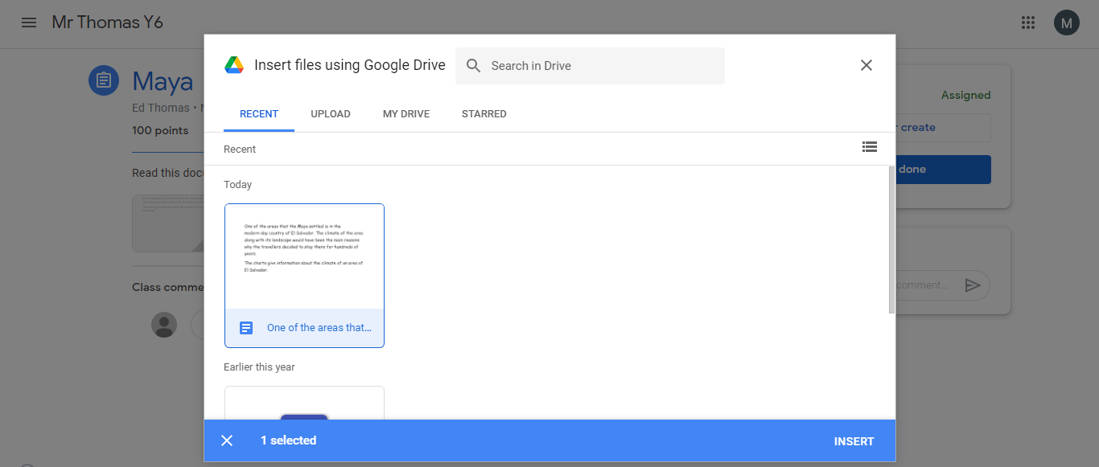
However, if you have to create your own document you can use Google Docs, Slides, Sheets and Drawings. Google Docs is similar to Microsoft Word, Slides is similar to Powerpoint, Sheets is similar to Excel and Drawings is similar to paint.
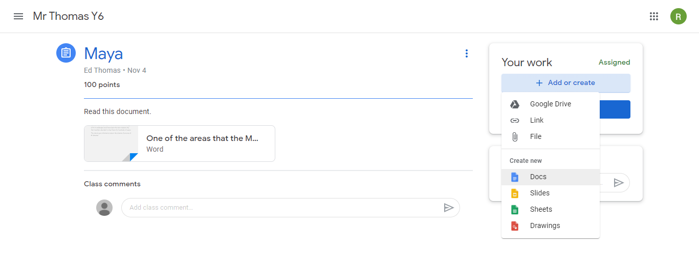

Step 10
Click turn in! Click ‘mark as done’! Do not worry about the original documents being on there too.

